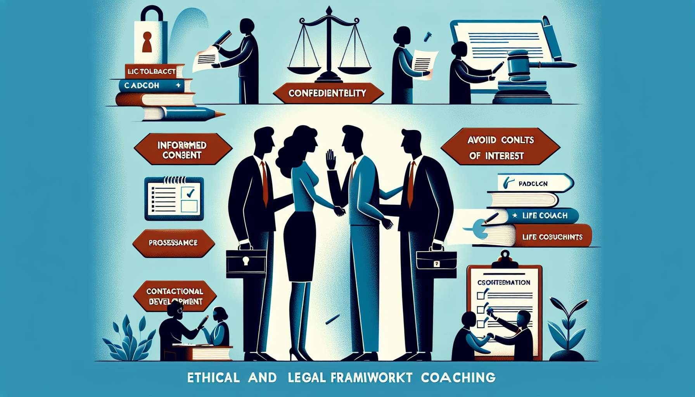

Submodule 8.2 - Ethical and Legal Framework of Coaching  
  
The ethical and legal framework of coaching is essential in establishing the profession's credibility and trustworthiness. It sets clear standards for conduct, ensuring that coaches operate with responsibility, respect, and integrity. Understanding these frameworks is not just about compliance; it's about committing to the highest standards of practice that protect both clients and coaches alike.  
  
Ethical Standards serve as the moral compass that guides coaching practices. This includes maintaining confidentiality, obtaining informed consent, and avoiding conflicts of interest. Coaches may illustrate these standards with scenarios highlighting the consequences of ethical lapses, such as a breach of confidentiality leading to legal action or loss of professional credibility.  
  
Legal Responsibilities of coaches encompass a thorough knowledge of the laws and regulations that pertain to life coaching. Depending on the jurisdiction, these may include business licensing, data protection, and privacy laws. Coaches can share experiences of navigating these legal considerations, emphasizing the importance of staying informed to mitigate risks and operate lawfully.  
  
Contractual Agreements between coach and client are legally binding documents that clarify the terms of the coaching relationship. Coaches are responsible for ensuring that contracts are comprehensive, clear, and fair. Real-life examples from the coaching field might include scenarios where well-structured contracts provided clarity and resolved potential disputes.  
  
Diversity and Inclusion are also integral to ethical coaching. This involves cultivating an awareness of cross-cultural issues and maintaining a practice that is respectful of all clients' backgrounds and identities. An anecdote could be used to reinforce the value of diversity training and its impact on a coach's ability to connect with a broader client base.  
  
Professional Development and staying informed about ethical and legal changes in the coaching industry are ongoing responsibilities for life coaches. By engaging in continued education, coaches not only refine their skills but also ensure their methodologies align with current ethical guidelines and legal standards.  
  
Lastly, the framework emphasizes the importance of Referral Systems. Coaches should recognize when a client's needs exceed the scope of coaching and have a reliable network for referring clients to other professionals, such as therapists or legal advisors. Coaches might recount instances wherein a referral not only served the client's best interest but also upheld the ethical integrity of the coach's practice.  
  
Key Takeaways:  
- Ethical standards are the backbone of a trusted coaching practice, emphasizing confidentiality, informed consent, and integrity.  
- Legal responsibilities require coaches to be well-versed in the laws pertaining to their practice.  
- Contractual agreements must be clear, comprehensive, and reflective of the coaching engagement's terms.  
- Diversity and inclusion are critical to an ethical coaching practice, ensuring respect and equity for all clients.  
- Ongoing professional development is crucial for coaches to remain ethically and legally informed.  
- A referral system is important for situations that fall outside the coach's area of expertise.