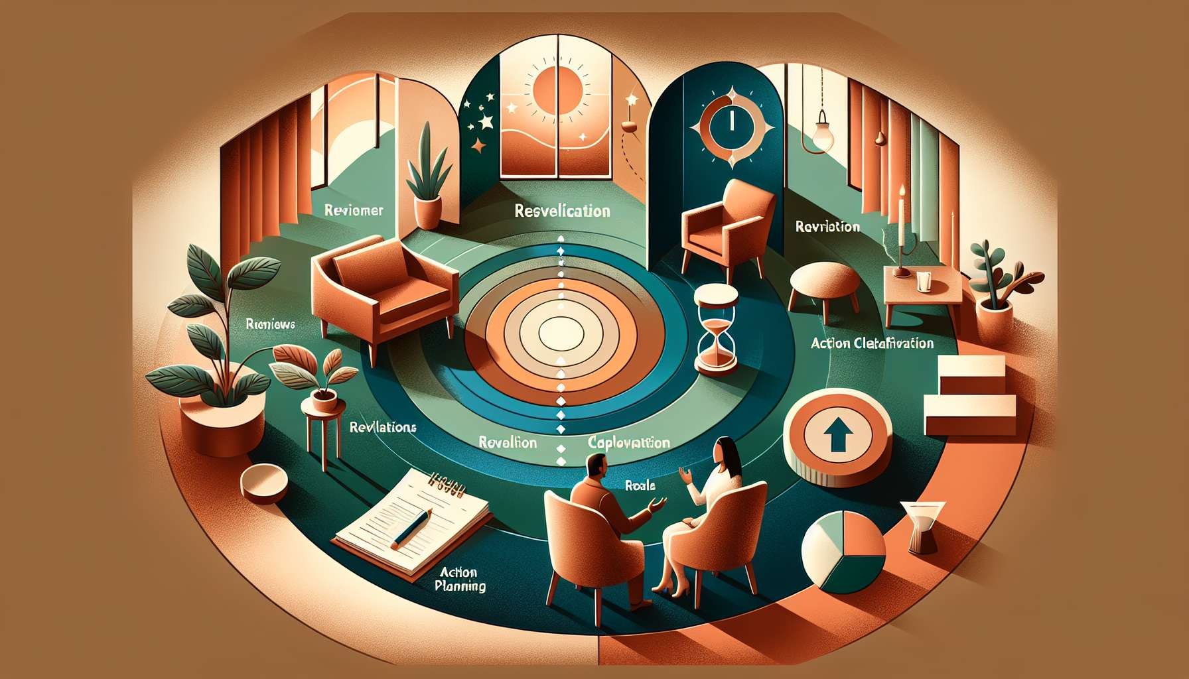

Submodule 10.2 - Different Phases of a Coaching Session  
  
A proficiently conducted coaching session follows a strategic series of phases, each designed to transition the client through an experience of self-discovery and actionable planning. These stages are orchestrated to maximize the session's efficiency, ensuring that clients leave with heightened clarity and motivation. This submodule outlines the key phases of a typical coaching session, providing structure and flow to the client's journey.  
  
The Opening Phase sets the tone for the session. It is where the coach welcomes the client, establishes rapport, and creates a safe space robust enough to weather the deep work ahead. A narrative might illustrate how a coach uses the first few minutes to ground the client with thoughtful open-ended questions, promoting openness and focus from the outset.  
  
Assessment and Review follow, where the coach and client touch base on progress since the last meeting. This involves reviewing homework, discussing achievements and challenges, and evaluating what's been working. Real-world accounts could follow a client who, with the coach's guidance, learns to acknowledge their strides and struggles, which serves to empower subsequent goal setting.  
  
Goal Clarification comes next, identifying the specific purpose for the present session. This phase sharpens the direction of the conversation and ensures that discussions remain productive and on track. Exemplary cases demonstrate how a coach facilitates the client in pinpointing precise session goals that align with broader aspirations, adding invaluable structure to their interactions.  
  
Exploration and Core Work constitute the heart of the session, where client and coach engage deeply around the identified focus area. Techniques such as powerful questioning, reflective listening, and strategic interventions are employed. A poignant example may involve a coach supporting a client in exploring underlying fears, leading to vital revelations and development of solutions.  
  
In the Action Planning Stage, the coach encourages the client to translate insights into tangible steps. Goals are broken down into achievable tasks, and commitment to action is clarified. A success story could feature a client mapping out a week's worth of specific, measurable actions, directly arising from session insights, fueling real change.  
  
Wrapping Up and Closure conclude the session, summarizing key insights, reaffirming the commitment to action, and scheduling follow-up. Coaches may incorporate a brief reflection on the session's impact and address any final thoughts the client might have. An anecdote could recount the effectiveness of a well-crafted closure that reinforced a client’s confidence and clarified their next steps.  
  
Key Takeaways:  
- Begin with opening the session to establish rapport and set a positive tone.  
- Conduct assessment and review to reflect on progress and set the groundwork for the current session.  
- Engage in goal clarification to focus the session and target specific client needs.  
- Lead exploration and core work through techniques tailored to the client's issues.  
- Formulate actionable plans built upon the session's insights and discussion.  
- Close the session by summarizing achievements and reaffirming action commitments.