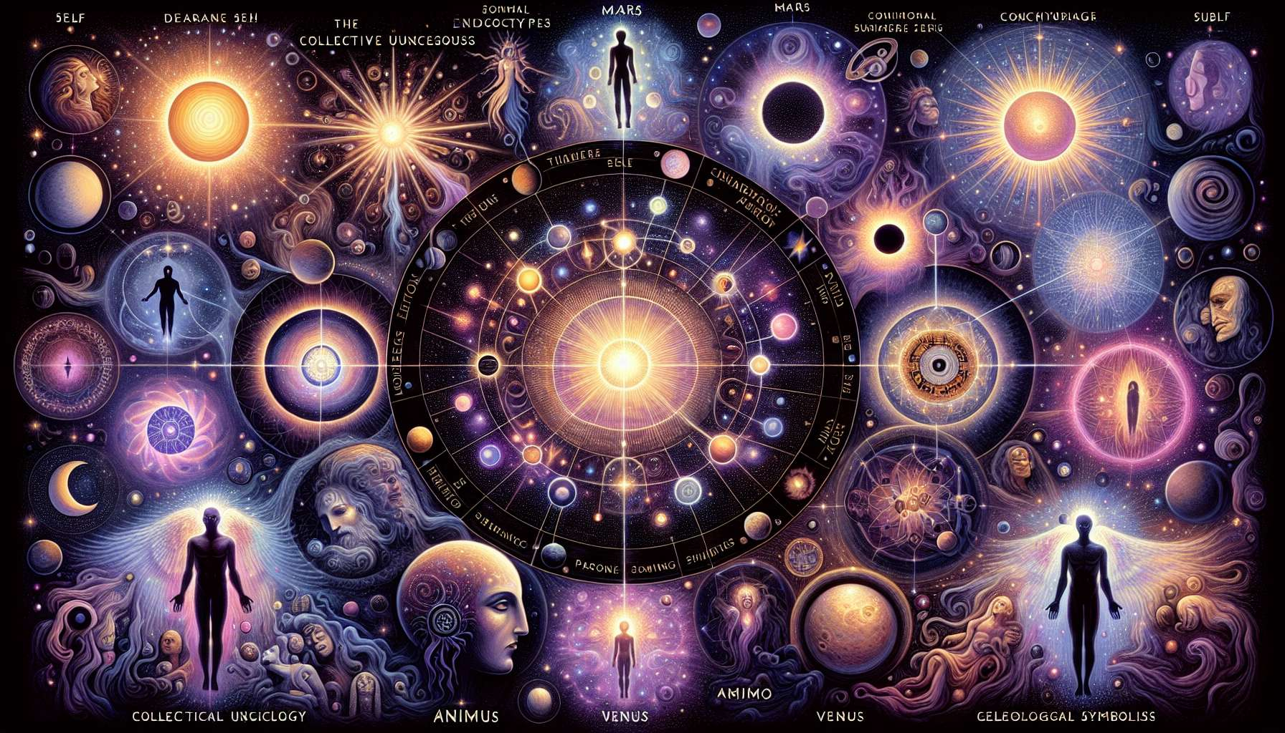

Jungian Archetypes and Their Relationship with Astrology  
  
Chapter 4.3 delves into the profound intersection of Carl Jung's analytical psychology with the rich symbolism of astrology, illuminating how archetypal energies play out within our psychic life and astrological natal charts.  
  
The Collective Unconscious and Astrology  
  
Carl Jung's concept of the collective unconscious posits a universal reservoir of archetypes—innate, universal psychic dispositions. In astrology, these archetypes are vividly represented through the planets and signs of the zodiac, each symbolizing fundamental human experiences and characteristics. For instance, the Moon in astrology resonates strongly with Jung's archetype of the Great Mother, highlighting instinctual wisdom, nurturing, and emotional responsiveness.  
  
Archetypes and Planetary Symbols  
  
Jung’s main archetypes—the Self, the Shadow, the Anima and Animus, and the Persona—can be explicitly correlated with astrological symbolism. The Self can be associated with the Sun, encapsulating our core identity and consciousness, while the Shadow, denoted by planets like Pluto, captures our repressed and hidden desires. The Anima and Animus may find connections with Venus and Mars, respectively, reflecting the inner feminine and masculine within us all.  
  
Synchronicity and Astrological Phenomena  
  
The theory of synchronicity, or meaningful coincidences, underscores much of Jung’s alignment with astrological practice. For example, notable life events occurring under significant transits or progressions reflect synchronicity's manifestation—revealing an alignment between inner psychological states and outer celestial movements.  
  
Psychological Complexes and Planetary Aspects  
  
Jung introduced the term 'complexes' for unconscious psychic content clumped together, frequently influenced by archetypal energy. In astrological terms, these can be seen through challenging aspects such as squares and oppositions. For instance, a square between Mars and Neptune might reveal a complex involving the assertion of one's desires and confusion or illusion.  
  
Active Imagination and Astrological Visualization  
  
Jung’s method of active imagination—a meditative technique used to engage with the unconscious—parallels the astrological practice of visualization and meditation as means of accessing the deep symbolism of planetary positions and integrating their energies more consciously into everyday life.  
  
Astrology as a Tool for Individuation  
  
Jung's ultimate goal of individuation—the process of becoming the most authentic version of oneself—is echoed in the journey through one’s natal chart. Each astrological aspect and transit provides an opportunity for understanding, integrating, and expressing these different facets of the psyche.  
  
Key Takeaways:  
  
- The collective unconscious and its archetypes in Jungian psychology have strong analogs in astrological symbols and the zodiac.  
- Key Jungian archetypes can be mapped onto the planets and signs, offering a framework for interpreting psychological drives in the natal chart.  
- Planetary aspects can represent psychological complexes, pointing to the inner tensions and conflicts that fuel personal growth.  
- The concept of synchronicity between psychological states and astrological timings underlines the value of astrology in forecasting and counseling.  
- Techniques such as active imagination strengthen the link between astrological practice and Jungian therapy, facilitating psychological integration.  
- The process of individuation in Jungian psychology is reflected in the astrological journey across the natal chart, emphasizing personal authenticity and development.