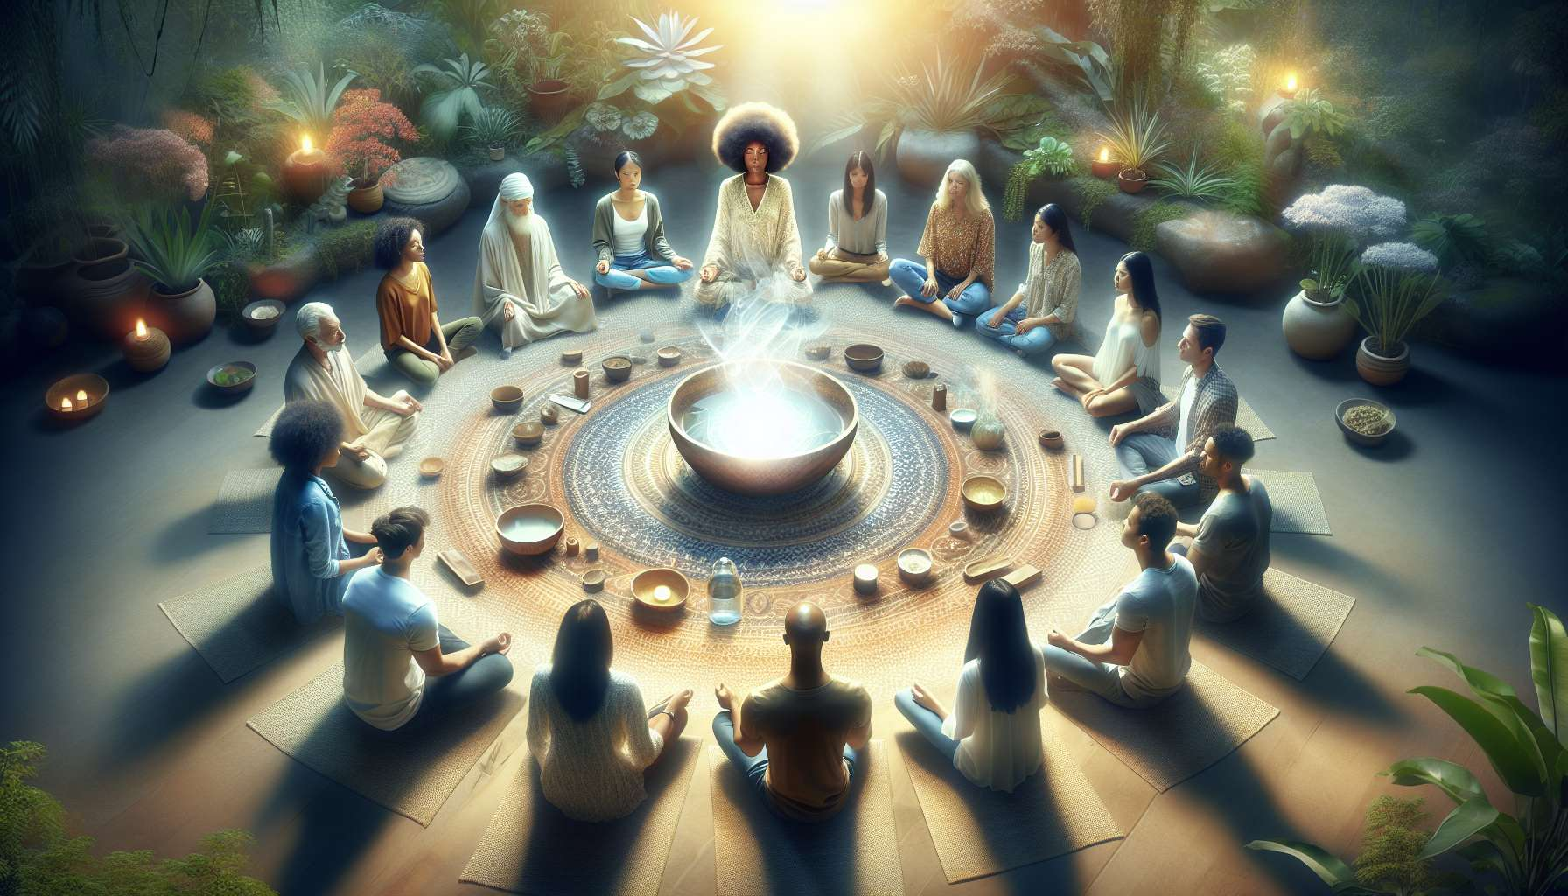

Module 4.3: The Core Ho'oponopono Ritual  
  
The central ritual of Ho'oponopono is where the essence of the practice comes to life, encompassing the core principles and the 'cleaning' process. This chapter dives into the heart of the practice, guiding both coach and client through the transformative core ritual of Ho'oponopono.  
  
Invoking the Mantra  
  
The core ritual begins with the invocation of the Ho'oponopono mantra. This invocation is not merely the repetition of the phrases "I'm sorry, Please forgive me, Thank you, I love you," but a deep and resonant communication with the self and the Divine. Practitioners draw upon the mantra's power to open up pathways of forgiveness and cleansing. Stories abound of its profound effect, such as a businessman who, after consistently using the mantra in times of stress, found himself responding to challenges with greater ease and equanimity.  
  
Visualization for Healing  
  
Visualization is a potent tool in this ritual. Participants are encouraged to visualize the person, situation, or emotion they are 'cleaning' and directly apply the Ho'oponopono phrases. One memorable example is of an individual visualizing a strained relationship healing with each repetition of the mantra, eventually leading to a real-world reconciliation.  
  
Internal Dialogue  
  
Engaging in an internal dialogue with the issues at hand is an important aspect of the core ritual. Practitioners often recount experiences where an internal conversation with a part of themselves that harbored pain or resentment led to significant breakthroughs and release.  
  
Integration of Physical Actions  
  
Physical actions can accentuate the core ritual, such as writing down the phrases of the mantra or the issue being addressed and then symbolically disposing of the paper. This can represent the release of the problem, as acknowledged by a coach who witnessed clients finding closure with past issues using this method.  
  
Group Ritual Dynamics  
  
When the core ritual is practiced in a group, the collective energy can amplify the 'cleaning'. Sharing experiences afterwards often solidifies the process for each participant, as in a group session where members expressed a collective sense of lightness and forgiveness post-ritual.  
  
Elements to Remember:  
  
- The invocation of the Ho'oponopono mantra is central to the core ritual and integral to 'cleaning'.  
- Use visualization to apply the mantra more directly to the issues being addressed.  
- An internal dialogue with one's problems can facilitate deeper understanding and healing.  
- Physical actions, such as writing and symbolic disposal, can serve to solidify the release during the 'cleaning' process.  
- The dynamic of a group performing the core ritual together can create a powerful healing energy and foster shared experiences.  
   
Embracing the core Ho'oponopono ritual opens up a profound space for transformation, where deep-seated issues can be acknowledged and released. This ritual empowers individuals to align themselves with the healing power of forgiveness, gratitude, and love, thereby fostering personal growth and inner peace.