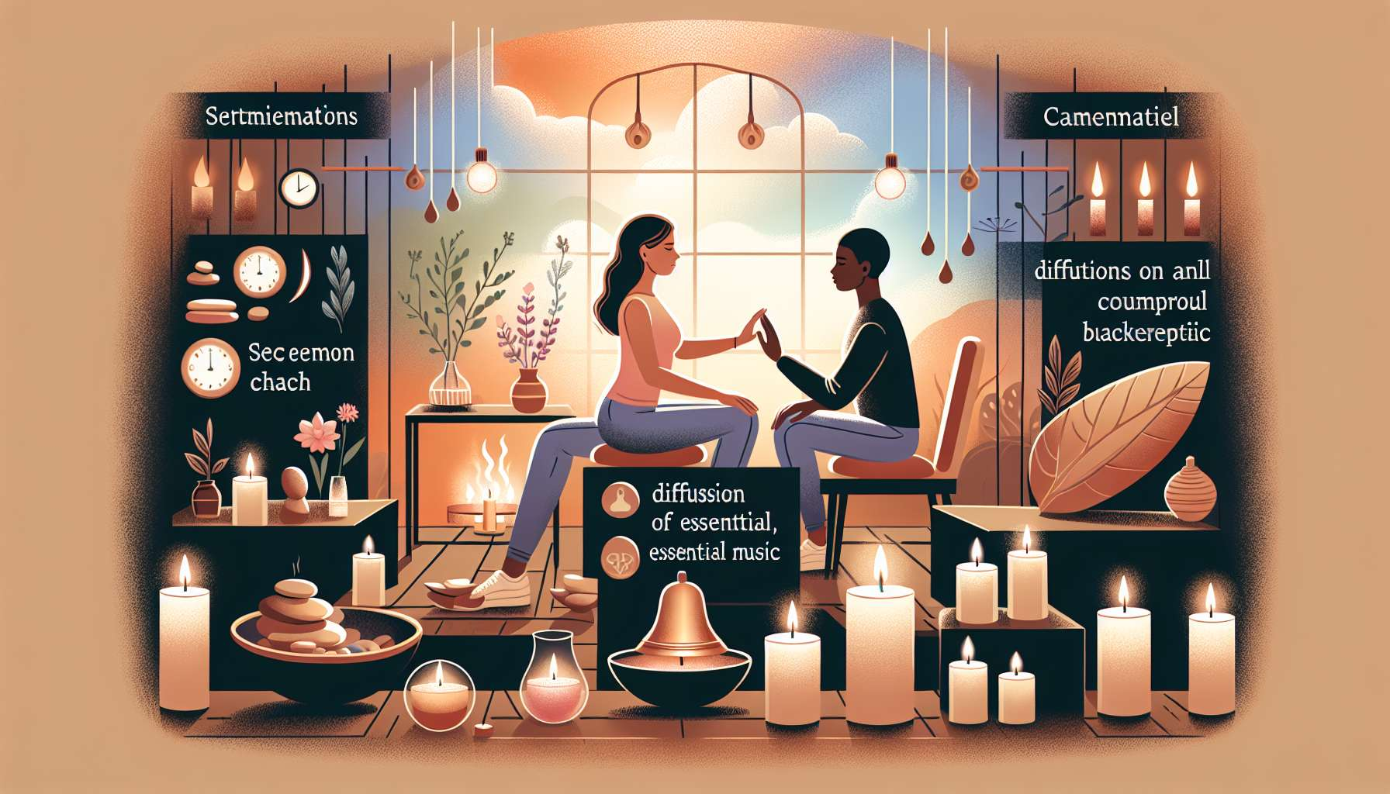

Module 8.1: The Opening of a Ho'oponopono Session  
  
The inception of a Ho'oponopono session is a critical moment, setting the stage for the healing work ahead. In Module 8.1, we examine the subtleties of starting a session effectively, laying the groundwork for a safe and transformative experience for the client.  
  
Creating a Welcoming Atmosphere  
  
A session begins the moment a client steps into the space. The coach's first task is to create a welcoming and comforting atmosphere. This might involve attention to the environment—such as soothing lighting, gentle background music, or the aroma of calming essential oils. Anecdotes from experienced practitioners speak to clients feeling immediately at ease in a thoughtfully arranged space, fostering a quicker and deeper engagement in the process.  
  
Intention-Setting and Rituals  
  
Intentions are the compass that guide the session. A coach might commence by lighting a candle or ringing a bell, symbols that signify the beginning of a sacred time. They then lead the client in a verbal or silent intention-setting exercise, grounding the session in purpose. A story recounts a breakthrough with a resistant client who found clarity and focus after a collaboratively set intention resonated deeply with their personal desires for healing.  
  
Establishing Trust and Safety  
  
Ensuring the client feels trust and safety is essential. The coach can establish this by being present, making eye contact, and employing active listening. Demonstrating a non-judgmental and open stance can help clients feel secure enough to share vulnerably. A case where establishing trust transformed a session involved a client who revealed a long-held secret, catalyzing a major healing breakthrough.  
  
Guided Relaxation for Receptivity  
  
Incorporating a brief guided relaxation or breathing exercise can help clients transition from the busyness of their minds to a more receptive state. Success stories include accounts of clients achieving deeper levels of relaxation and openness, making the 'cleaning' process more effective.  
  
Clarification of Process and Boundaries  
  
It's important to clarify the Ho'oponopono process and the session's boundaries. Clients should know what to expect and understand the framework within which the session operates. Sharing a clear outline can alleviate anxiety and build confidence, empowering clients to fully engage in their healing journey.  
  
Elements to Remember:  
  
- Create a welcoming physical environment for clients to feel comfortable and at ease.  
- Utilize intention-setting rituals to anchor the session's purpose.  
- Establish trust and safety early to support open and honest communication.  
- Introduce guided relaxation exercises to facilitate client receptivity to the process.  
- Offer clear explanations of the Ho'oponopono process and session boundaries.  
  
Opening a Ho'oponopono session skillfully can significantly influence its effectiveness, creating the optimal conditions for the powerful work of self-healing to unfold. A well-rounded beginning can set the tone for a deeply meaningful and productive experience.