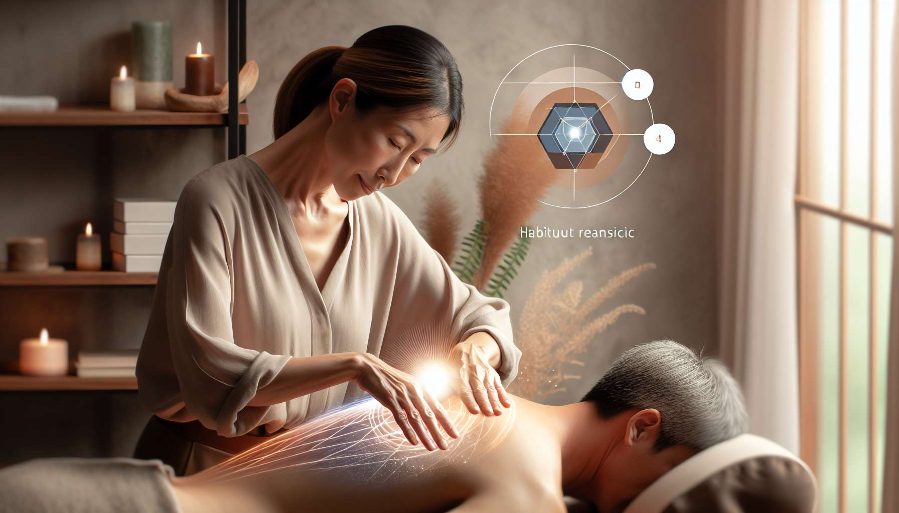

Chapter 5.1: Hands-on Healing and Therapeutic Touch  
  
In Chapter 5.1, we delve into the responsible application of hands-on healing and therapeutic touch, traditional energy healing methods that emphasize the physical connection between healer and client to facilitate the flow of healing energy. These practices rest on the belief that the body's subtle energy systems can be balanced through intentional, compassionate touch, stimulating the body's innate ability to heal itself.  
  
Hands-on healing, often referred to as the laying on of hands, is a technique as old as human instinct. When we experience pain, the first response is to hold or touch the area of discomfort — a practice converted into a healing art over centuries. This method ranges from gentle holding to more structured movements intended to direct energy to specific areas of the body. Accounts from healers often include instances where individuals felt immediate warmth and relief in areas where the healer's hands were placed, suggesting a transfer of energy that aids in alleviation and recovery.  
  
Therapeutic touch (TT), developed in the 20th century, is a consciously directed process of energy exchange during which practitioners use their hands as a focus for facilitating healing. Rooted in the theory that human beings are fields of energy that are in constant interaction with the environment, TT is a structured, five-phase approach encompassing centering, assessing, clearing, treating, and evaluating the energy field. Success stories of TT include dramatic improvements in postoperative recovery times and reductions in anxiety and stress levels, lending credibility to its therapeutic claims.  
  
A key aspect of hands-on healing is the significance of the healer’s intention. It’s understood that the healer’s thought and focus amplify the healing potential. One remarkable case involved a healer whose intense focus on healing a client's chronic back pain helped reduce their discomfort significantly, even when physical therapies had little effect.  
  
Sensitivity training is also an essential topic covered in this chapter, as the ability of the healer to perceive subtle changes in the energy field improves the efficacy of the treatment. Veteran healers often emphasize the value of developing a fine-tuned sensitivity to the client's energy field, which allows them to direct healing more accurately and to areas that require attention.  
  
The practice of hands-on healing also aligns with modern understandings of biofield science, which studies the complex energy fields that govern the human body. Cutting-edge research into the biofield underpins hands-on healing techniques, suggesting that practices once considered purely esoteric now have a basis in scientific inquiry.  
  
Key Elements to Remember from Chapter 5.1:  
- The laying on of hands is a fundamental aspect of hands-on healing.  
- Therapeutic touch is a structured, five-phase modality that facilitates healing through energy exchange.  
- The healer's intention is pivotal in the effectiveness of hands-on healing.  
- Sensitivity to the energy field is crucial for targeting areas that require healing.  
- Hands-on healing techniques are increasingly supported by biofield science research.  
- Anecdotes and case studies illustrate the practice's real-world effects on pain relief and recovery.