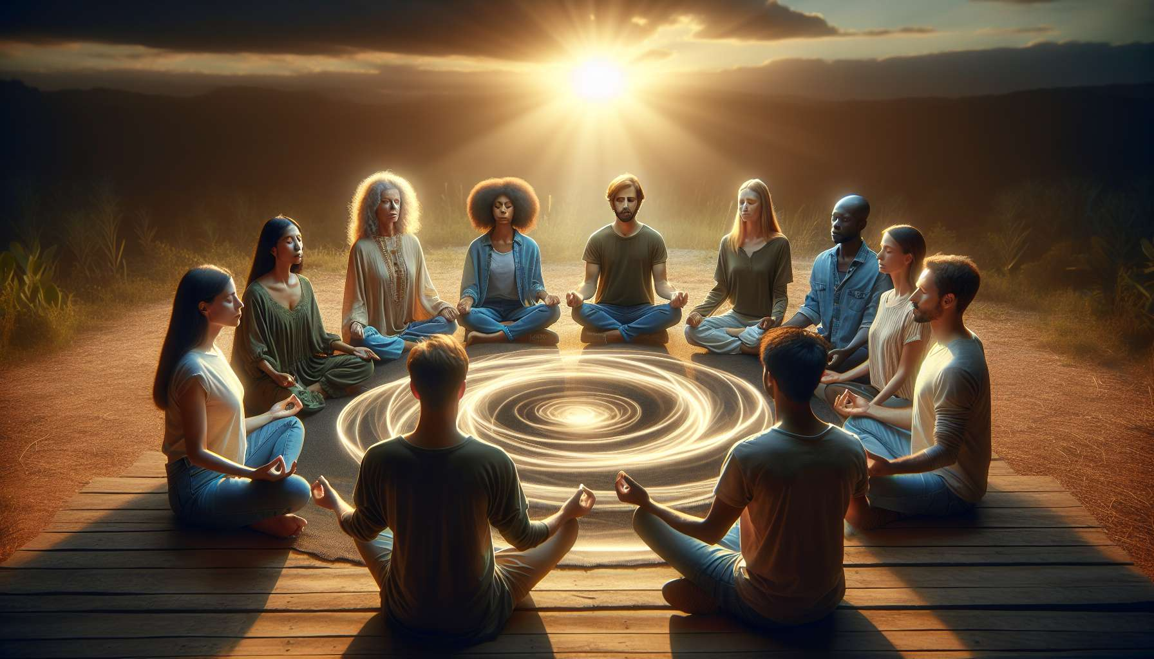

Module 6.2: Creating Effective Group Dynamics with Ho'oponopono  
  
While Ho'oponopono is a powerful individual practice, its principles can be profoundly influential in a group setting. Chapter 6.2 explores how to channel the energy and intention of multiple individuals to create collective healing experiences.  
  
Fostering a Shared Intention  
  
In a group dynamic, it's crucial to establish a shared intention. This collective focus sets the tone and direction for the Ho'oponopono session. For example, a facilitator of a grief support group might steer participants to focus their mantra on releasing pain associated with loss. This shared intention has been reported to create a strong bond and amplify the group's healing energy.  
  
Ground Rules for Respect and Confidentiality  
  
Setting ground rules is another key element in building effective group dynamics. Each participant must feel safe to share, which requires a mutual understanding of respect and confidentiality. Case studies have shown that groups that adhere to clear ground rules tend to experience deeper, more authentic sharing, leading to more significant breakthroughs for individual members.  
  
Guided Collective 'Cleaning'  
  
A guided collective 'cleaning' can harmonize individual efforts into a cohesive practice. The facilitator might lead participants through a visualization that enhances their collective 'cleaning,' much like a choir director unifying disparate voices into one harmonious melody. Recollections from group sessions indicate that these collective experiences can often lead to a stronger sense of community and connected healing.  
  
Embracing Diverse Experiences and Backgrounds  
  
Recognizing and valuing the diversity of experiences and backgrounds within the group enriches the process. Each person's unique perspective and 'cleaning' process can shed light on new insights and foster greater empathy. Success stories often involve groups that embraced diversity, finding that the varied insights contributed to the overall growth of each member.  
  
Building on Collective Energy for Support  
  
Leveraging the collective energy of the group, participants can support and uplift each other throughout the Ho'oponopono practice. Experiences show that individuals often feel a heightened sense of compassion and empathy when practicing in groups, aiding in their personal healing journey.  
  
Elements to Remember:  
  
- Establish a clear and shared intention to guide the group's healing focus.  
- Set ground rules for respect and confidentiality to create a safe and supportive environment.  
- Use guided collective 'cleaning' to unite individual efforts and amplify healing energy.  
- Value each person's unique experiences to enrich the group dynamic and foster empathy.  
- Utilize the group's collective energy for mutual support and encouragement.  
  
The group dynamics of Ho'oponopono offer a unique container for collective healing. By carefully crafting a respectful, empathetic, and focused environment, facilitators can guide groups towards powerful shared experiences that echo beyond the confines of the session, leaving lasting impressions on each participant's life.