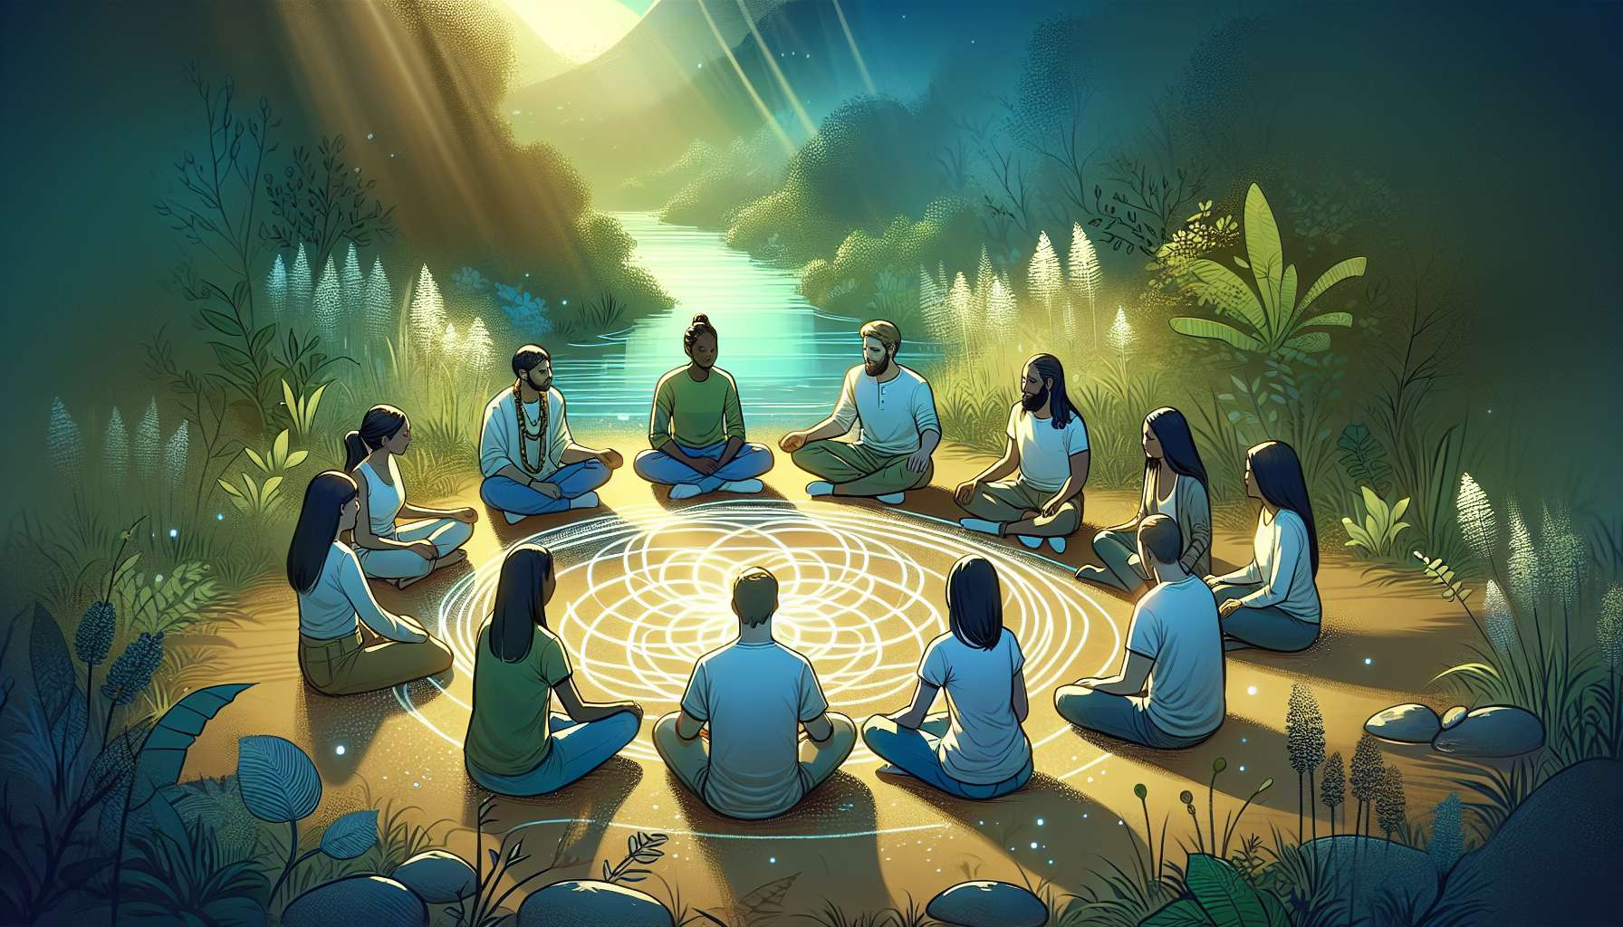

Module 7.3: Community and Group Healing through Ho'oponopono  
  
Chapter 7.3 delves into the broader application of Ho'oponopono beyond the individual and interpersonal level—addressing its powerful potential to foster healing and harmony within communities and groups.  
  
The Collective 'Cleaning' Process  
  
Within any group or community, shared challenges and historical grievances can hinder collective growth. Ho'oponopono offers a 'cleaning' process facilitated not only for the individual but for the collective psyche. For example, a community deeply affected by a natural disaster utilized group Ho'oponopono to address the prevailing sense of loss and helplessness, leading to communal empowerment and collective action towards reconstruction.  
  
Ho'oponopono as a Tool for Reconciliation  
  
One critical aspect of community healing is reconciliation, which can revitalize a broken community's spirit. There are recorded instances where fractured communities grappling with internal strife or societal injustice turned to Ho'oponopono rituals to cultivate reconciliation. These rituals allowed individuals to express and release historical pain, manifesting greater understanding and a path forward towards healing past wounds.  
  
Creating Spaces of Empathy and Connection  
  
Ho'oponopono practices can help create spaces where empathy flourishes, connecting individuals within a group through their shared humanity. A case in point involves a school where Ho'oponopono was introduced to address bullying. The practice facilitated an environment where students found common ground, resulting in a notable decrease in bullying incidents and an increase in peer support.  
  
Contributions to Sustained Peace and Understanding  
  
Long-term peace and understanding in communities are often byproducts of the consistent use of the Ho'oponopono process. For instance, a multi-cultural neighborhood experiencing tension due to cultural misunderstandings benefitted from regular group-based Ho'oponopono sessions, catalyzing sustained peace and mutual respect among its diverse inhabitants.  
  
Trainings and Workshops for Skills Transfer  
  
Transfer of skills is essential for Ho'oponopono to take root within a community effectively. Workshops and practical training can equip members with the skills needed to continue the practices independently, bolstering ongoing healing and 'cleaning'. A report from a grassroots organization highlighted how Ho'oponopono workshops significantly contributed to the community's resilience and capacity for self-facilitated conflict resolution.  
  
Elements to Remember:  
  
- Collective 'cleaning' helps to address shared challenges within communities.  
- Ho'oponopono serves as an effective tool for reconciliation in fractured communities.  
- The practice can increase empathy and connection, even in diverse group settings.  
- Consistent Ho'oponopono sessions can lead to sustained peace and understanding.  
- Offering Ho'oponopono trainings ensures the skills transfer necessary for independent practice and long-term communal healing.  
  
By fostering the practice of Ho'oponopono within groups, communities can rise above mutual grievances and embrace a future where harmony, understanding, and collaborative growth are the foundations of their collective experience.