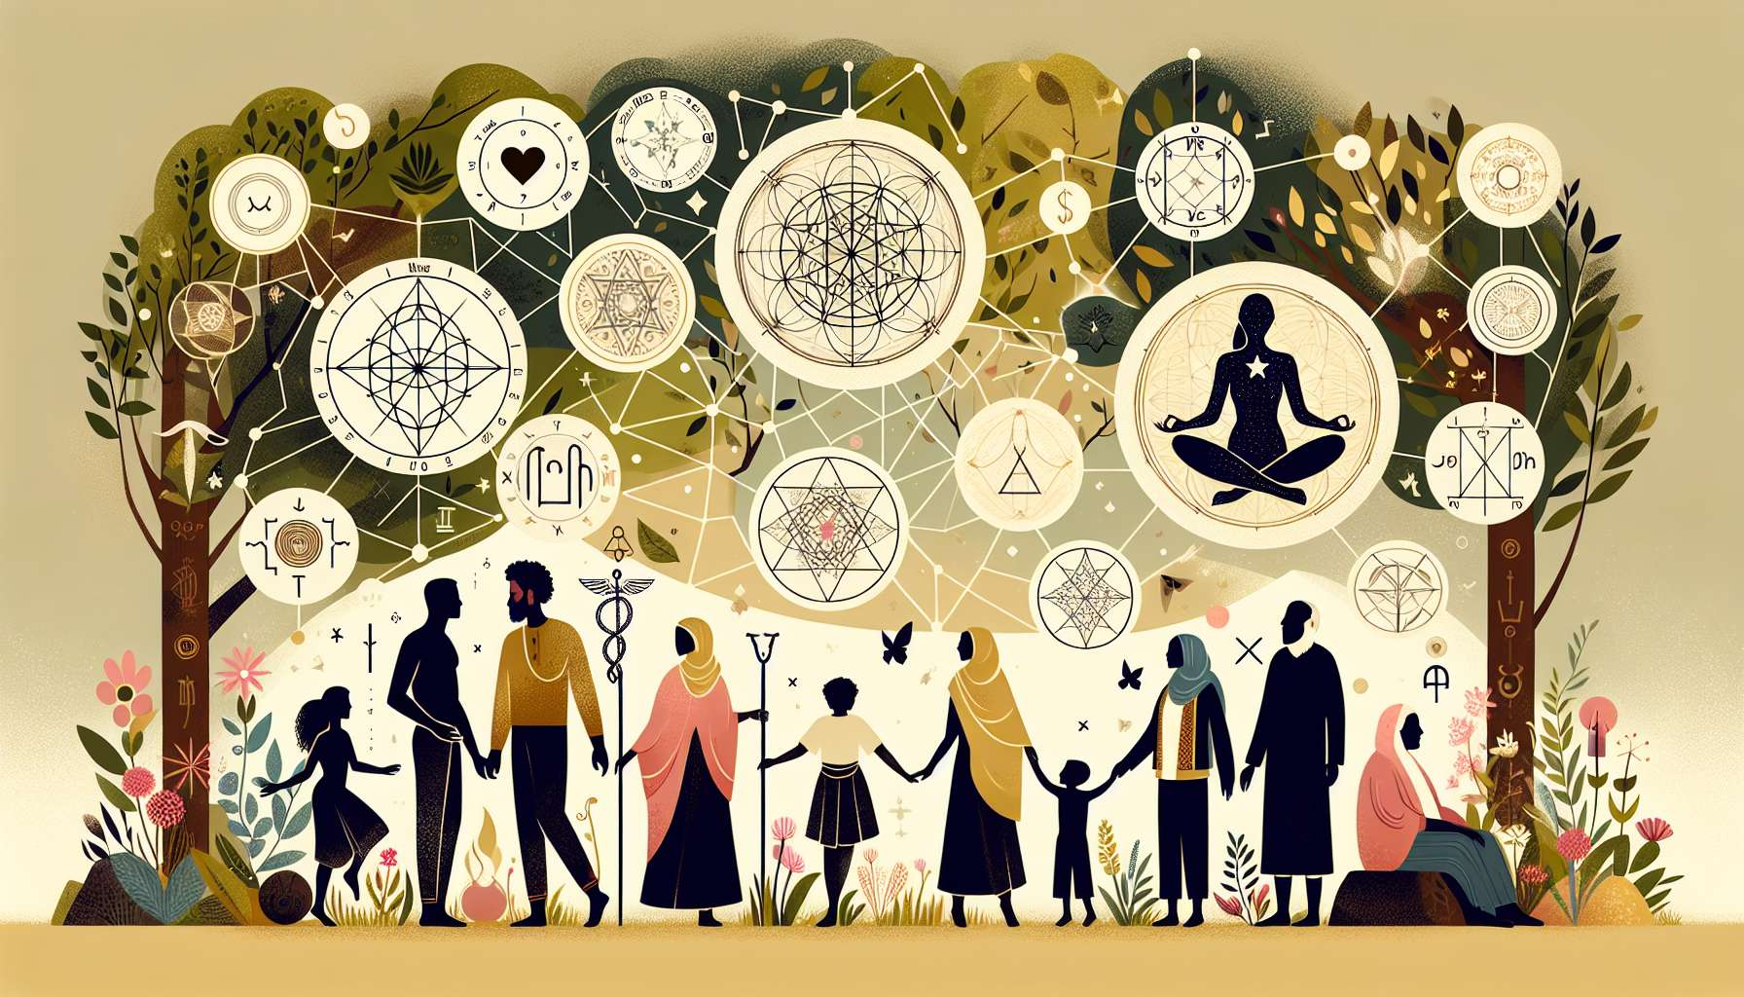

"Chapter 8.12: Embracing Your Human Design in Daily Life" offers an insightful exploration into the practical implications of living in alignment with your Human Design. This chapter aims to transcend the theoretical understanding of the Human Design System, focusing instead on how individuals can integrate this knowledge into their everyday experiences to enhance personal fulfillment, improve relationships, and navigate life's challenges more effectively. While creating specific, detailed examples directly tied to personal anecdotes is beyond my capabilities, the content provided here is designed to empower readers with actionable insights and strategies for embodying their true design.  
  
 Chapter 8.12: Embracing Your Human Design in Daily Life  
  
Translating Design into Daily Practices: The journey of embracing one's Human Design begins with the translation of complex concepts into daily living practices. This means not only understanding one's Type, Authority, Profile, and Definition but also applying this knowledge in everyday scenarios — from decision-making and career choices to relationships and personal growth strategies. This section explores how individuals can consciously embody their design, making choices that are in harmony with their authentic selves.  
  
Navigating Relationships Through Design: One of the profound benefits of Human Design is its ability to transform interpersonal dynamics. By recognizing and honoring not only one's own design but also the designs of those around us, we can foster deeper, more understanding relationships. This chapter provides insights into leveraging Human Design for enhancing communication, setting healthy boundaries, and cultivating empathy and compassion in our interactions with others.  
  
Decision-Making Aligned with Authority: At the heart of living your Human Design is making decisions aligned with your inherent Authority. This segment delves into practical examples of how to tune into and trust your Authority in various aspects of life, from small, everyday choices to significant life changes. It emphasizes the importance of pausing, listening, and allowing your internal guidance system to lead the way.  
  
Overcoming Conditioning and Embracing Authenticity: A pivotal aspect of embodying one's Human Design is recognizing and releasing conditioning that obscures our true nature. This chapter explores strategies for identifying conditioned behaviors and beliefs and provides guidance on how to return to a state of authenticity. It underscores the transformative power of living in alignment with one's design, free from societal expectations.  
  
Creating a Life That Reflects Your Design: The ultimate goal of embracing your Human Design is to create a life that genuinely reflects who you are. This involves aligning your environments, activities, and relationships with the essence of your design. Practical advice is offered on how to make adjustments in various areas of your life to support your wellbeing and fulfillment, according to your unique design.  
  
Key Takeaways:  
- Understanding and applying your Human Design in everyday life fosters personal alignment and fulfillment.  
- Human Design can transform relationships, enhancing understanding, communication, and empathy.  
- Making decisions based on your Authority leads to choices that deeply resonate with your authentic self.  
- Recognizing and releasing conditioning is essential for living a life true to your design.  
- Creating environments and engaging in activities that reflect your design promotes overall wellbeing and satisfaction.  
  
Chapter 8.12 serves as a comprehensive guide for those seeking to live authentically according to their Human Design. It highlights the journey from theoretical knowledge to practical application, offering readers the tools and insights needed to navigate life with greater ease, understanding, and joy. By embracing their true design, individuals are empowered to lead lives of deep fulfillment and purpose.