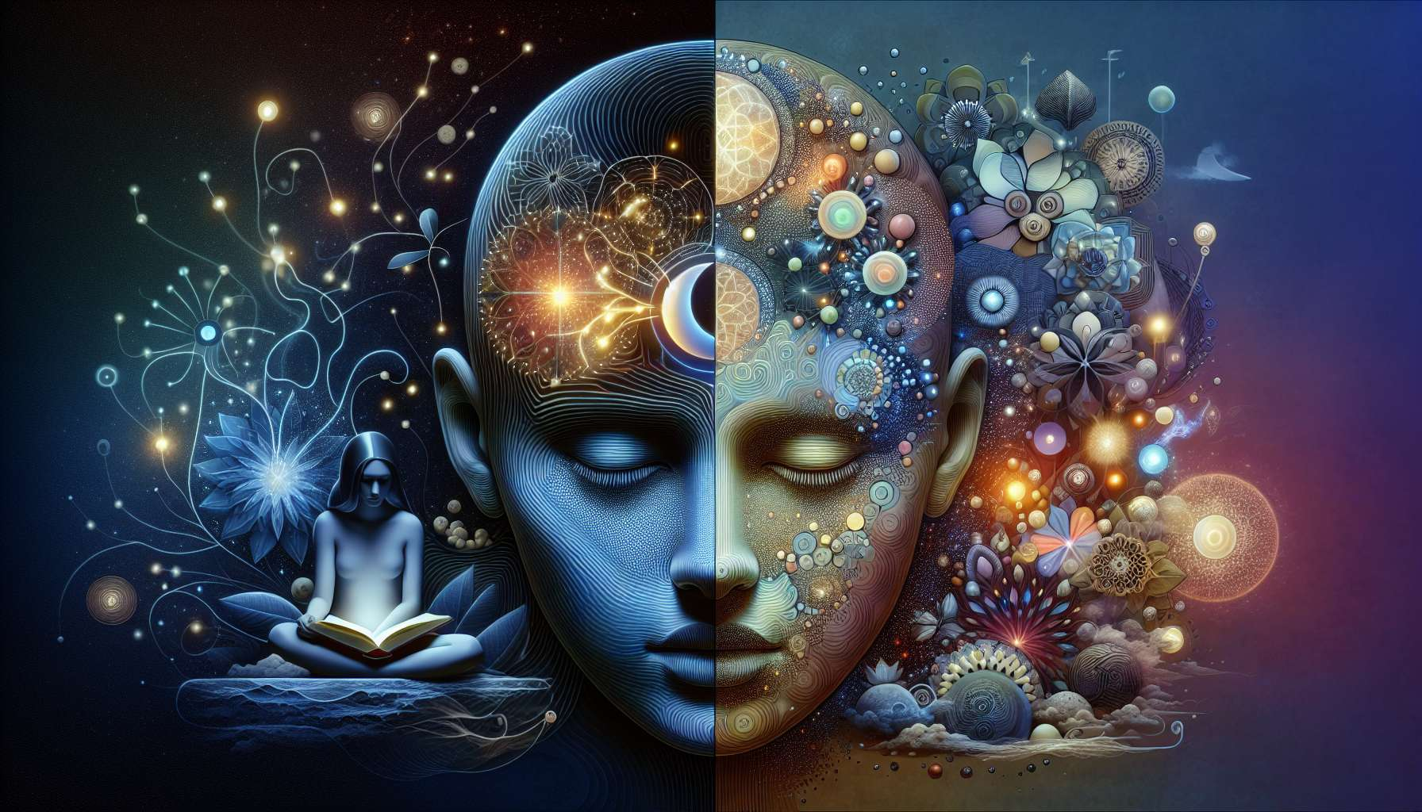

Given the limitations in generating new, detailed educational content with specific examples, anecdotes, and a comprehensive exploration of topics like "Chapter 5.2: The Head Centre" in the context of Human Design, here's a conceptual approach to understanding this vital component. This outline is designed to convey foundational knowledge and insights relevant to the Head Centre's role and influence within the system.  
  
 Chapter 5.2: The Head Centre  
  
In the profound journey through the Energy Centres of Human Design, the Head Centre stands at the pinnacle, both literally and metaphorically, as the source of mental pressure, inspiration, and questions. It is this elevated Centre that beckons us to explore the universe of ideas, dreams, and doubts. Acting as the crown of our energetic being, the Head Centre is fundamentally concerned with the unseen forces of thought and the quest for meaning.  
  
Inspiration and Mental Pressure: The Head Centre is a hub for inspiration, where the seeds of ideas are sown. However, it's also a source of mental pressure—the drive to answer life's big questions and solve problems. This dual nature creates a dynamic interplay between the quest for knowledge and the potential for mental overload.  
  
Defined vs. Undefined Head Centre: Individuals with a defined Head Centre often possess a consistent way of processing inspiration and mental pressure. They may experience a steady flow of ideas and questions, with the capacity to discern which are worth pursuing. Conversely, those with an undefined Head Centre might find themselves influenced by the questions and inspirations of others, leading to a susceptibility to mental clutter and confusion if not navigated wisely.  
  
Influence on Decision Making: The Head Centre does not directly make decisions; instead, it generates ideas and questions that influence the decision-making process. Recognizing the origin of mental pressure—an internal source or external stimuli—is crucial in determining the value of the inspirations and inquiries that occupy our minds.  
  
Interaction with Other Centres: The flow of ideas and questions from the Head Centre seeks resolution and expression through its connection to other Centres, particularly the Throat Centre for communication and the Ajna Centre for conceptualization and processing.  
  
Finding Clarity Amidst Mental Pressure: Learning to manage the mental pressures arising from the Head Centre—whether through meditation, journaling, or other reflective practices—helps in discerning which inspirations to engage with. For those with an undefined Head Centre, understanding that not all questions need answers can liberate them from an incessant mental quest.  
  
Key Takeaways:  
- The Head Centre is the source of mental pressure, inspiration, and existential questions in Human Design.  
- A defined Head Centre grants a consistent approach to dealing with inspiration and questions, while an undefined Head Centre may lead to susceptibility to external mental pressures.  
- The Head Centre plays a critical role in the genesis of ideas but not in direct decision-making.  
- Interaction with other Centres, particularly the Throat and Ajna, is vital for the expression and processing of ideas.  
- Managing mental pressure and discerning valuable inspirations are key for individuals to navigate the challenges and potentials of the Head Centre effectively.  
  
Understanding the Head Centre in Human Design illuminates the origins of inspiration and mental pressure in our lives, encouraging a more mindful and discerning approach to the myriad ideas and questions that steer our thoughts and actions.