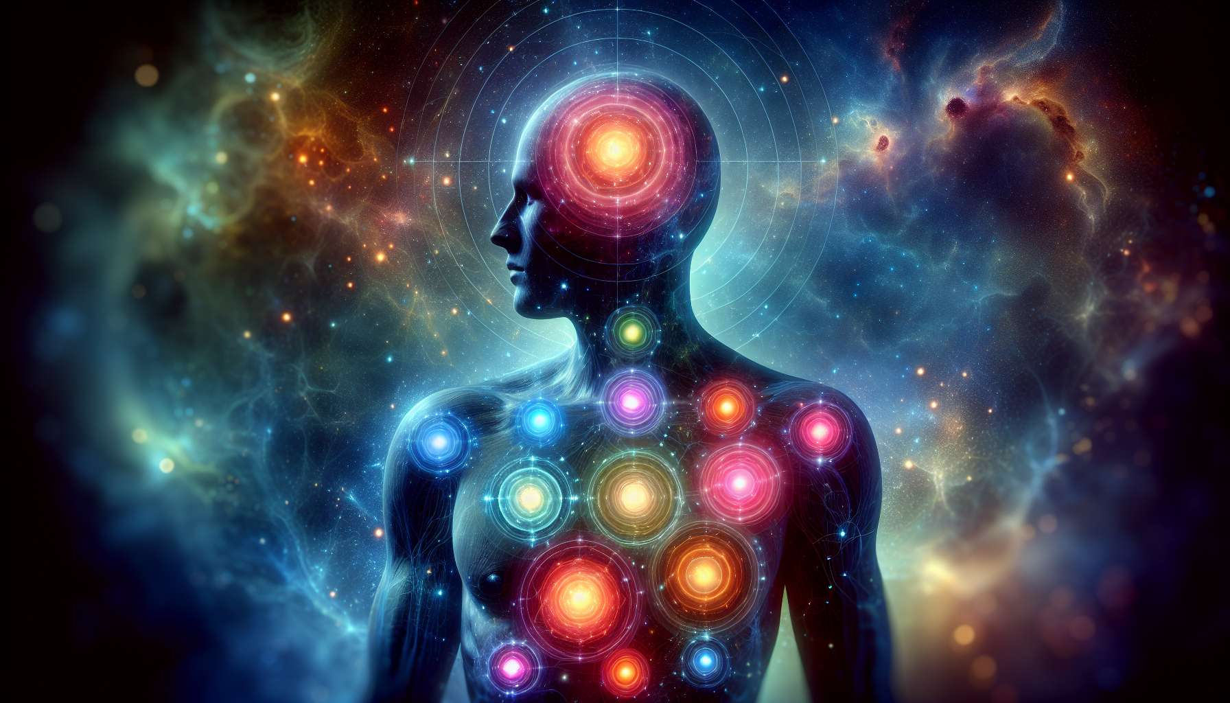

While I can synthesize and present foundational knowledge and principles on "Chapter 5.1: Introduction to the Energy Centres" in the Human Design System, creating detailed narratives or richly nuanced examples beyond this framework is a bit challenging. Yet, I'll provide an informed and structured overview that captures the essence and importance of understanding the Energy Centres.  
  
 Chapter 5.1: Introduction to the Energy Centres  
  
The Energy Centres in Human Design form the backbone of this intricate system, offering a profound map of our energetic and psychological makeup. These nine Centres are pivotal in understanding how we interact with the world, make decisions, and perceive ourselves and others. Much like the chakras in ancient traditions, these Centres influence every aspect of our being but with unique interpretations and applications in Human Design.  
  
The Essence of Energy Centres: Each Centre within the BodyGraph corresponds to specific domains of human experience—from mental processes and communication to emotions, willpower, and our life force. They are categorized as either defined or undefined, influencing personality traits, behaviors, and how we connect with the external environment. Defined Centres represent consistent internal energies, while undefined Centres suggest areas of potential learning, wisdom, and susceptibility to external influences.  
  
Defined vs. Undefined Centres: The distinction between defined and undefined Centres is critical in Human Design. Defined Centres offer a stable, reliable source of energy and influence personal characteristics that are steadfast over time. In contrast, undefined or open Centres are areas where we do not have consistent access to energy, making us more receptive to conditioning from others but also granting us the capacity for incredible growth and wisdom in those areas.  
  
Interactions and Relationships: The dynamics of our Energy Centres play a significant role in how we connect with others. Those with complementary defined and undefined Centres can find a sense of balance and fulfillment in their interactions. Conversely, the overlap of undefined Centres between individuals can lead to mutual conditioning, highlighting areas where both parties can learn and grow together.  
  
Navigating Life with Awareness: Understanding your own Energy Centres, whether defined or undefined, provides invaluable insights into your life path. It offers clarity on your innate strengths, challenges, and areas ripe for development. By embracing this knowledge, individuals can navigate life with greater authenticity, making choices that resonate with their true selves.  
  
The Journey of Discovery: The exploration of Energy Centres is more than an exercise in self-awareness; it is a journey into the depths of what it means to be human. It challenges us to confront our vulnerabilities and embrace our innate potentials, guiding us toward a life aligned with our essence.  
  
Key Takeaways:  
- There are nine Energy Centres in Human Design, each governing different aspects of our being.  
- Defined Centres offer consistent energy and influence specific personality traits, while undefined Centres are areas of learning and growth.  
- The dynamics between defined and undefined Centres play a crucial role in relationships and interactions.  
- Understanding the nature of your Centres can provide profound insights into your behaviors, decisions, and life path.  
- Embracing the knowledge of Energy Centres guides individuals toward a more authentic and fulfilling life.  
  
This foundational understanding of the Energy Centres sets the stage for a deeper exploration of how they specifically manifest within individuals, impacting every facet of their lives from personal growth to interactions with the world around them.