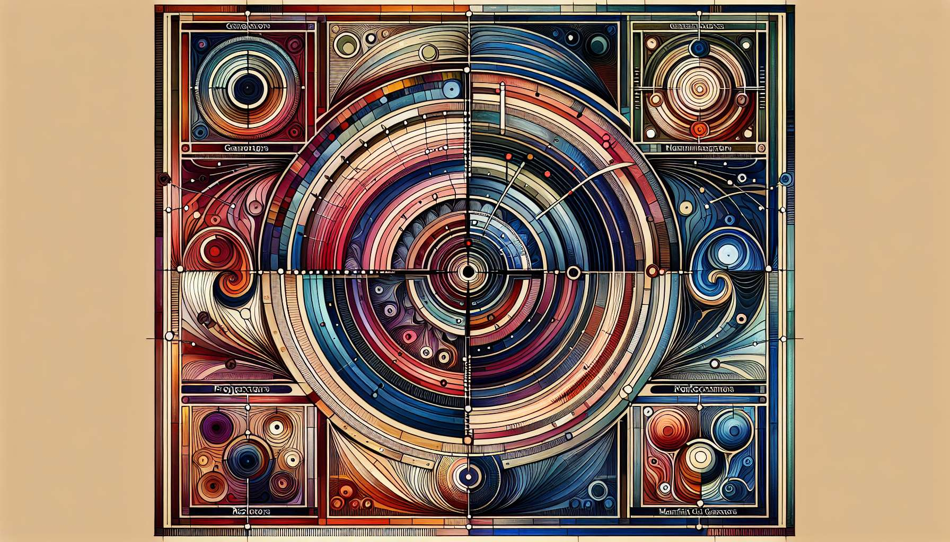

Delving into "Chapter 8.1: Introduction to Design Variables," we're introduced to a cornerstone concept within the Human Design System that plays a pivotal role in defining the unique energetic makeup of each individual. Design Variables offer us a profound toolkit for understanding not just who we are, but how we best interact with the world around us. This exploration lays the groundwork for a deeper dive into the intricacies of Human Design, emphasizing the importance of these variables in personal alignment and fulfillment.  
  
 Chapter 8.1: Introduction to Design Variables  
  
The Human Design System, with its rich tapestry of wisdom, introduces us to Design Variables as key components in decoding our unique energetic blueprint. These variables—Type, Authority, Profile, and Definition—act as the defining elements that guide us toward understanding our inherent nature, how we make decisions, and how we navigate our life path. Each variable contributes a distinct piece to the puzzle of our design, reflecting the complexity and uniqueness of our individual beings.  
  
Type: The Role We Play   
Type outlines the fundamental role we play in life, categorized into Generators, Projectors, Manifestors, Reflectors, and Manifesting Generators. Understanding your Type reveals the strategy you should follow to align with your natural energy flow, enhancing your interactions with the world and the way you initiate or respond to life's circumstances.  
  
Authority: Our Decision-Making Process   
Authority sheds light on the most reliable aspect of our design for making decisions. Ranging from Emotional to Sacral Authority, it teaches us to tune into our inner wisdom, ensuring that the choices we make genuinely serve our highest good and personal truth.  
  
Profile: The Costume We Wear   
Profile represents the unique combination of I Ching lines that outline our personality's nuances and our soul’s purpose. It's akin to the costume we wear in this life, shaping how we experience our journey, interact with others, and grow along our path.  
  
Definition: The Consistency of Our Being   
Definition details the aspects of our design that consistently define us. It highlights where we have reliable energy and where we are open to conditioning from others, offering insights into our strengths and potential areas for growth and wisdom.  
  
Embracing Your Design Variables   
Embracing these variables as essential aspects of your Human Design empowers you to navigate life with increased awareness and authenticity. Whether it's making decisions that honor your true self, engaging in relationships that respect your nature, or finding fulfillment in your life's purpose, understanding your Design Variables is the key to unlocking your full potential.  
  
Key Takeaways:  
- Design Variables play a critical role in uncovering the complexities of our individual energetic makeup.  
- Type determines the fundamental role and strategy we have for engaging with the world.  
- Authority provides guidance on our most reliable internal mechanism for decision-making.  
- Profile adds depth to our understanding of our life path and interactions.  
- Definition outlines the consistent energies within us and areas where we are prone to external influence.   
  
This introduction to Design Variables opens the door to a deeper exploration and understanding of ourselves through the Human Design System. It invites us on a transformative journey toward living a life that truly resonates with our innermost being, equipped with the knowledge and tools needed for personal alignment and fulfillment.