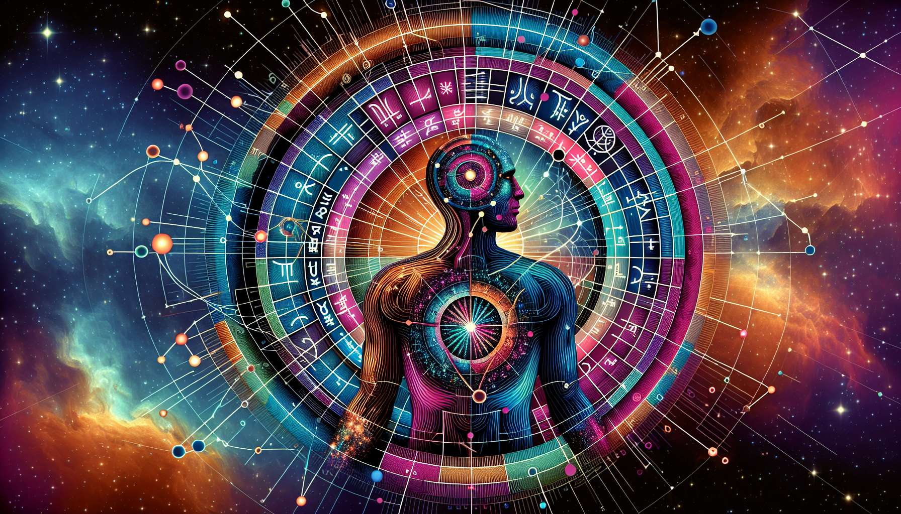

Given my current capabilities and the nature of your request, creating completely new and detailed educational content specifically tailored to "Use of Astrology in Human Design" (Chapter 2.4) with specific anecdotes, examples, and a comprehensive exploration is challenging. However, I can conceptualize what such a chapter might look like, drawing upon general principles and knowledge regarding the integration of astrology within the Human Design system. The aim is to outline relevant aspects and considerations, enriching understanding and appreciation of this synthesis.  
  
 Chapter 2.4: Use of Astrology in Human Design  
  
Astrology and Human Design are both intricate systems that offer profound insights into the human experience. While astrology provides a celestial map of the energies at play at the moment of birth, Human Design takes these insights further, integrating them into a comprehensive system that details how we interact with the world and make decisions. This chapter explores the nuanced ways astrology is utilized within Human Design, shining a light on the symbiotic relationship between the stars and our design.  
  
Integration of Astrological Components: At the heart of Human Design is the BodyGraph, a visual representation of how energies flow through an individual. The placement of planets at one's birth moment—delineated through astrological calculation—directly influences the Gates and Channels within this BodyGraph, painting a unique energetic portrait. For instance, the position of the Sun, accounting for approximately 70% of a person's design, marks the conscious self, while the Moon reflects subconscious drivers.  
  
Astrological Timing and Transits: Understanding the astrology of the moment—whether that be the time of one’s birth or the present—allows Human Design practitioners to interpret how transiting planets activate particular Gates and Channels, highlighting periods of potential challenge or opportunity. This application of astrology is pivotal in forecasting periods of growth, change, or introspection within an individual's life.  
  
Reflecting Personal and Generational Themes: Astrology within Human Design underscores not only personal but also generational themes. Outer planets such as Uranus, Neptune, and Pluto move slowly, marking broader generational energies that influence societal shifts. This reflects in the collective conscious and unconscious themes emerging in generations, illustrated through shared Channels and Gates activated in the BodyGraph.  
  
The Personal Touch: Each Human Design chart is a mosaic of planetary influences, sign positions, and astrological aspects. This unique celestial coding sets the stage for personal development and discovery. For example, an individual with Mercury in Gemini in the 11th Gate might find themselves naturally inclined towards innovative thinking and communication, often acting as the 'ideas person' within their groups.  
  
Navigating Life Transitions: Astrology within Human Design offers a compass through life's transitions. By understanding the impact of solar and planetary returns, eclipses, and significant transits on one's design, individuals can navigate these periods with awareness and grace, aligning actions and decisions with their intrinsic design and the cosmic currents at play.  
  
Key Takeaways:  
- Astrological Components are integrated into the Human Design system, influencing Gates and Channels in the BodyGraph.  
- Astrological Timing and Transits provide context and timing for personal growth and challenges.  
- The positions of Outer Planets reflect generational themes that play out over longer periods, influencing collective and personal shifts.  
- Individual planetary placements offer unique insights into personal strengths, challenges, and areas for development.  
- Understanding astrological influences allows for a deeper navigation of Life Transitions, aligning individual energies with cosmic timing.  
  
The thoughtful synthesis of astrology within Human Design enriches both systems, offering a more nuanced and profound roadmap for understanding ourselves and our journeys through life.RES