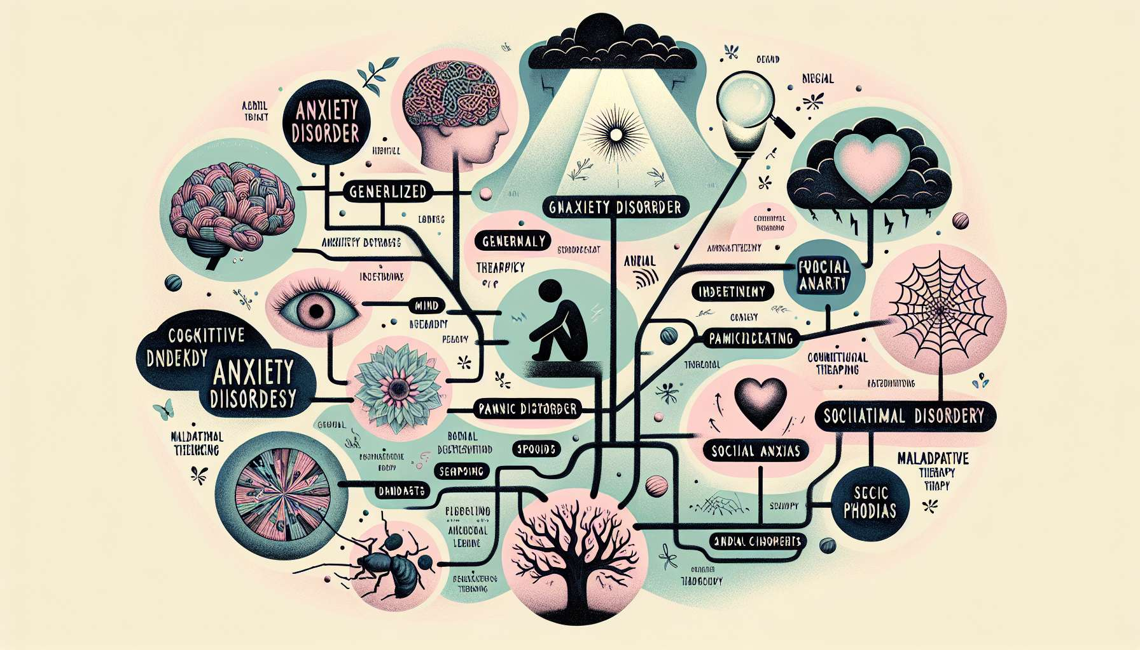

Anxiety disorders, characterized by excessive fear and anxiety, are among the most prevalent mental health conditions worldwide. Understanding the multifaceted nature of these disorders is pivotal for both individuals experiencing them and mental health professionals aiming to provide effective treatment. This chapter section, Understanding Anxiety Disorders, seeks to unpack the complexity of anxiety disorders, laying a solid foundation for exploring the therapeutic interventions that Cognitive Behavioral Therapy (CBT) offers.  
  
Anxiety disorders encompass several distinct diagnoses, each with unique features yet sharing the core element of excessive, often debilitating, fear or anxiety. Generalized Anxiety Disorder (GAD), for instance, is marked by persistent, excessive worry about various domains of life, such as health, work, or relationships, often disproportionate to the actual likelihood of the feared event. Panic Disorder is characterized by sudden episodes of intense fear or discomfort, known as panic attacks, accompanied by physical symptoms like heart palpitations, dizziness, or chest pain. Social Anxiety Disorder involves a pervasive fear of social or performance situations, driven by concerns of being negatively evaluated or embarrassed. Meanwhile, Specific Phobias are intense fears provoked by specific objects or situations, such as heights, flying, or seeing blood.  
  
Understanding the symptoms of anxiety disorders is crucial. These can range from cognitive symptoms, like persistent worry or fear of losing control, to physical symptoms, such as elevated heart rate, trembling, or sweating. The impact of these symptoms can significantly impair an individual's functioning, restricting their ability to work, attend school, or engage in social and familial activities.  
  
The causes of anxiety disorders are believed to be multifactorial, involving a combination of genetic, environmental, psychological, and developmental factors. A person with a family history of anxiety disorders may be more predisposed to developing one. Life experiences, such as trauma or significant stress, can also trigger the onset of an anxiety disorder, especially in individuals with certain temperamental traits, like neuroticism.  
  
The role of cognitive distortions in fueling anxiety cannot be overstated. Anxious individuals often exhibit patterns of thinking that exaggerate danger, underestimate their ability to cope, and predict negative outcomes, thereby perpetuating the cycle of anxiety. CBT targets these maladaptive thought patterns, providing individuals with strategies to challenge and change them.  
  
In addition to cognitive symptoms, anxiety disorders often lead to avoidance behaviors. Individuals may go to great lengths to avoid situations or objects that trigger their anxiety, which, although providing short-term relief, reinforces the anxiety in the long run. Understanding this cycle of anxiety is essential for breaking it, which is a central goal of CBT.  
  
Key Takeaways:  
- Anxiety disorders encompass a range of conditions characterized by excessive fear and anxiety.  
- Symptoms can be both cognitive (e.g., persistent worry) and physical (e.g., trembling, sweating).  
- The causes of anxiety disorders include genetic, environmental, and psychological factors.  
- Cognitive distortions play a critical role in the maintenance of anxiety disorders, often exaggerating perceived danger and predicting negative outcomes.  
- Avoidance behaviors provide short-term relief but ultimately reinforce anxiety.  
- Understanding the complex nature of anxiety disorders is the first step toward effective treatment with CBT.