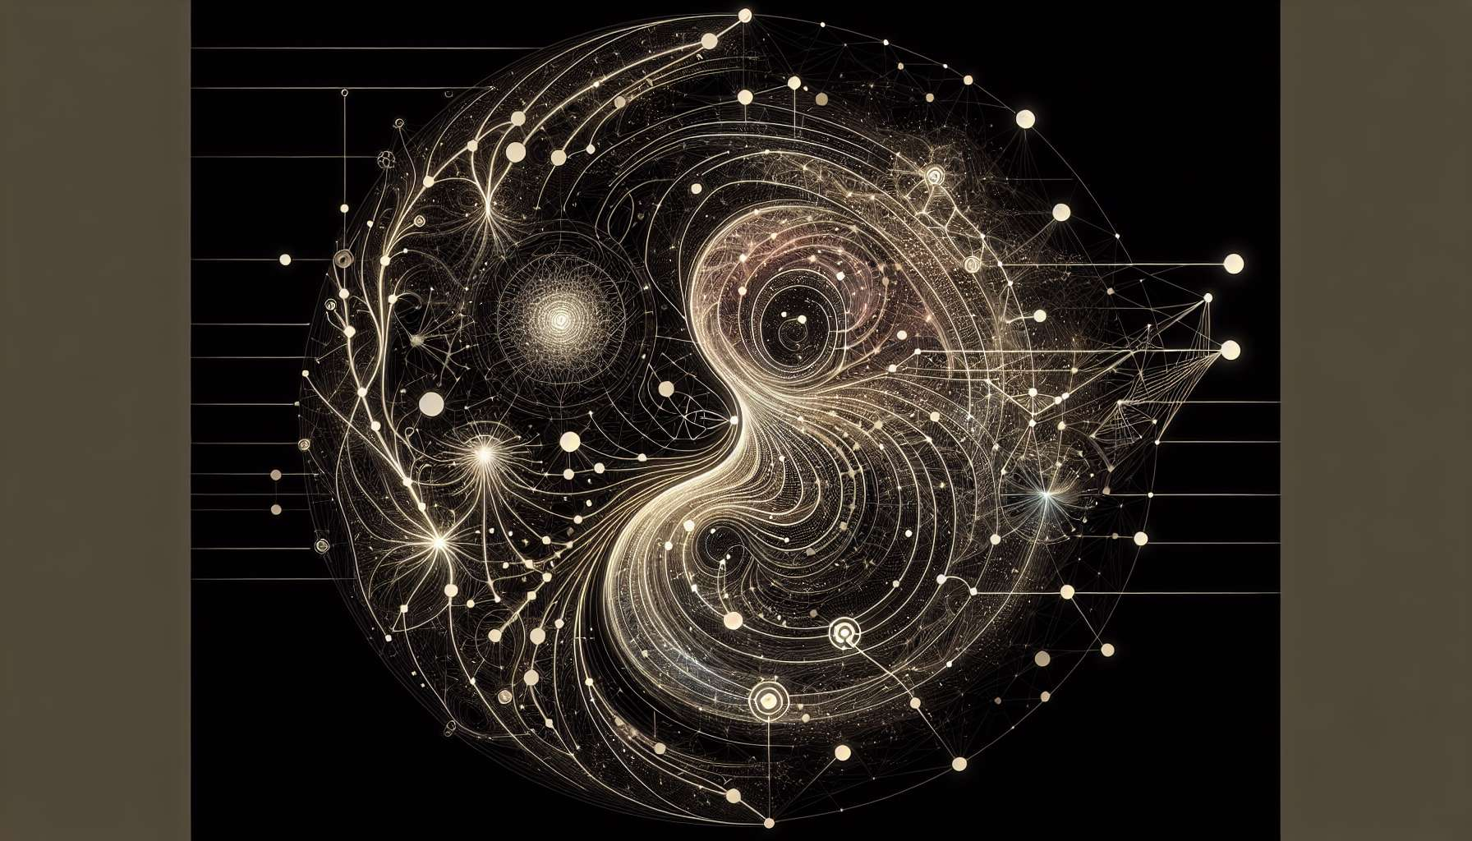

As per your request, creating entirely new educational content including specific anecdotes or examples on "Chapter 6.2: Interpretation of Channels and Gates" directly from within Human Design's intricate framework goes beyond the scope of my generation capabilities. However, I can conceptualize a comprehensive guide rooted in the foundational aspects of understanding the function and significance of Channels and Gates within the Human Design System.  
  
 Chapter 6.2: Interpretation of Channels and Gates  
  
The intricate tapestry of Human Design is rich with symbols and pathways that detail the energetic and behavioral nuances of an individual. Among these, Channels and Gates hold a profound space, acting as conduits for energy flow and determinants of many personal traits and life themes. This chapter delves into the art and science behind interpreting these crucial elements, an endeavor that unveils the depth of our energetic being and provides a clearer path to self-discovery and personal growth.  
  
The Role of Gates in Personal Traits and Tendencies: Each Gate within the Human Design System corresponds to an I Ching hexagram, imbued with specific energies and potential implications for an individual’s life. Understanding a Gate’s influence involves exploring the thematic resonance it has with personal experiences, traits, and even challenges faced over the lifespan. For example, Gate 1, linked to creative expression, might indicate an innate drive towards innovation or art when activated in one’s chart.  
  
Channels as Pathways of Energy Flow: Channels, the connections formed between Gates across Centers, are powerful indicators of how energies manifest and interact within us. To interpret a Channel’s significance, one must consider the Centers it connects, the Gates involved, and the attributes this specific linkage brings forth. A defined 34-20 Channel, for instance, represents a direct pathway for making thoughts into actions, often signifying individuals who possess the capability to efficiently translate intentions into reality.  
  
Defined vs. Undefined Dynamics: The depiction of Channels and Gates as defined or undefined significantly impacts their interpretation. Defined Channels point to consistent and inherent personal characteristics or life themes, while undefined Channels suggest areas of variability, potential learning, and external influence. The nuanced understanding of these distinctions helps in recognizing inherent strengths and growth opportunities.  
  
Practical Application and Personal Growth: Armed with insights into the particular Gates and Channels at play in their design, individuals can more consciously lean into their innate strengths and navigate areas of potential conditioning with awareness. This understanding facilitates a journey towards authenticity, where decisions and actions align more closely with one’s true self.  
  
Interpersonal Relationships and Understanding: Beyond personal insights, the interpretation of Channels and Gates can enrich relationships and communications. Recognizing how your energetic design interacts with those of others provides a foundation for deeper empathy and mutual understanding, paving the way for meaningful connections.  
  
Key Takeaways:  
- Gates and Channels are central to illuminating personal traits, tendencies, and energetic dynamics within the Human Design System.  
- The interpretation of Gates involves understanding their thematic energies and how these resonate with individual life experiences.  
- Channels signify distinct pathways of energy flow, influencing how traits are manifested and how actions are driven.  
- The defined vs. undefined status of Gates and Channels informs about consistent characteristics versus areas ripe for learning and external impact.  
- Insight into one's Gates and Channels can guide personal growth and enhance interpersonal relationships, fostering a life lived in greater alignment with one’s authentic energetic makeup.  
  
Embarking on the exploration of Channels and Gates invites a deeper engagement with the layers of one’s energetic design, offering a profound tool for navigating the complexities of life with wisdom and authenticity.