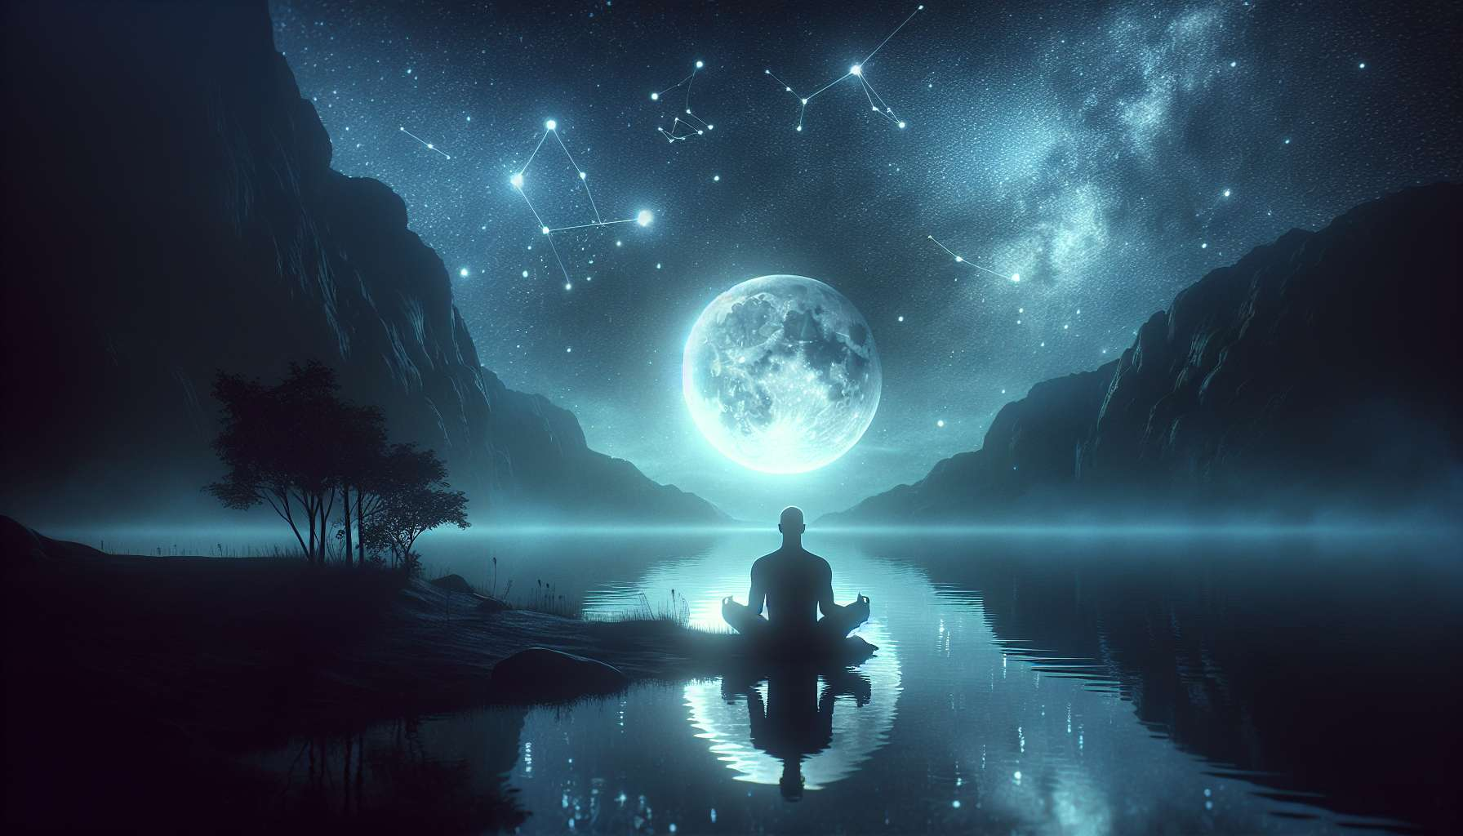

Given the complexity and unique characteristics of the topic, "Chapter 4.5: The Reflector," my approach will blend general knowledge and foundational insights on Reflectors within the Human Design system, focusing on their distinct role, strategy, and potential for impact. Generating specific anecdotes or examples is beyond my current capabilities in crafting personalized, detailed narratives.  
  
 Chapter 4.5: The Reflector  
  
Reflectors are the rarest type within the Human Design system, making up approximately 1% of the population. They are the mirrors of society, reflecting the health and wellbeing of the community around them. With no defined centers in their BodyGraph, Reflectors have the unique ability to sample energies from their environment, giving them unparalleled insight into the world and the people they interact with.  
  
Core Characteristics: Reflectors have a fluid and reflective aura that allows them to deeply connect with the energies of their environment. This mutable nature enables them to understand life from various perspectives, making them exceptionally wise and discerning. However, it also means they can be highly susceptible to the influence of others and the environment, necessitating a discerning approach to the energies they choose to engage with.  
  
Strategy: The primary strategy for Reflectors is to wait a lunar cycle (approximately 29.5 days) before making significant decisions. This waiting period allows them to sample and sift through the myriad influences and energies they encounter, ensuring that the actions they ultimately take are in alignment with their true selves and not merely a reflection of their immediate environment.  
  
Not-Self Theme: Disappointment arises for Reflectors when they find themselves disconnected from their true nature, often as a result of making hasty decisions influenced by transient energies. Recognizing this feeling can guide Reflectors back towards their correct strategy and authentic self.  
  
The Role of the Lunar Cycle: Reflectors are deeply connected to the lunar cycle, which acts as a guide for processing and understanding the energies they encounter. By aligning with the moon's phases, Reflectors can navigate their decision-making process with greater clarity and insight.  
  
Potentials and Challenges: A significant challenge for Reflectors is finding stability amidst the ever-changing influences of their environment. However, when they embrace their unique strategy and nurture environments that honor their reflective nature, they unlock their potential to become wise observers and guides, offering invaluable insights drawn from their profound ability to see the world from multiple perspectives.  
  
Key Takeaways:  
- Reflectors are mirrors of their environment, with the unique ability to reflect the health and well-being of their community.  
- With no defined centers, Reflectors sample energies, making them susceptible to influence yet capable of gaining diverse perspectives.  
- Their strategy is to wait a lunar cycle before making significant decisions, ensuring alignment with their true nature.  
- Disappointment can signal when Reflectors are out of alignment with their strategy, prompting a return to their authentic decision-making process.  
- The lunar cycle is crucial for Reflectors, guiding them in sifting through influences and making informed decisions.  
- Embracing their reflective nature allows Reflectors to offer unique insights and perspectives, becoming wise observers and consultants of humanity.  
  
Reflectors, with their rare and reflective nature, hold a unique place within the Human Design system. By understanding and honoring their distinct strategy and the influence of the lunar cycle, Reflectors can navigate life with wisdom, contributing profound insights that stem from their capacity to perceive the world in all its complexity and diversity.