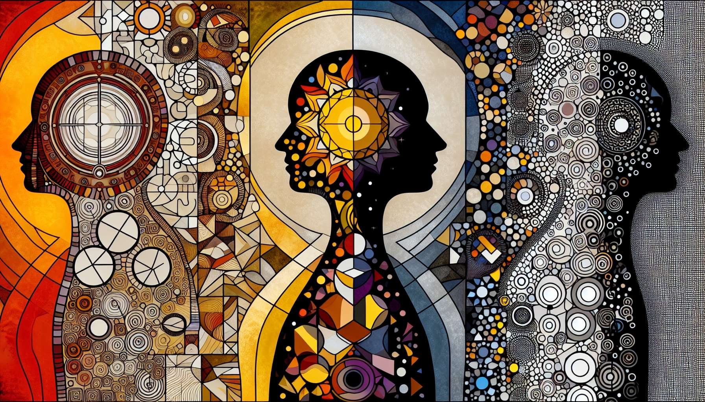

"Chapter 8.8: Third Revolution - The Transition to Conscious Design" navigates the intricate process of embracing one's Human Design with intentional awareness, marking a significant phase in the personal evolution journey. As individuals gain deeper insight into their design, they encounter the profound opportunity to live in alignment with their inherent nature, thereby actualizing the essence of who they truly are. This chapter delves into understanding and integrating the myriad aspects of one's design into daily living, highlighting the transformative potential that emerges from aligning with one's authentic self.  
  
 Chapter 8.8: Third Revolution - The Transition to Conscious Design  
  
Embarking on the Conscious Design Journey: The transition to conscious design represents a pivotal moment in the Human Design journey. It occurs when an individual, armed with the knowledge of their design, begins to apply this understanding intentionally in their life. This process involves a shift from passive existence within one's design to an active embodiment of its principles, effectively marking the beginning of living in true alignment with one's innate blueprint.  
  
The Role of Self-Awareness:  
Self-awareness serves as the foundation of this transition. It involves a nuanced comprehension of one’s design, including Type, Authority, Profile, and Centers, and the courage to honor these elements in every decision. This chapter explores practical strategies for cultivating self-awareness, such as reflective practices and mindfulness, emphasizing their importance in recognizing and transcending conditioning.  
  
Overcoming Conditioning and Embracing Authenticity:  
One of the significant hurdles in the path to conscious design is the conditioning from society, family, and personal experiences that may obscure one's authentic self. This section offers insights into identifying and dismantling these conditioned layers, encouraging individuals to embrace their unique design even when it contradicts conventional wisdom or expectations.  
  
Practical Application in Daily Life:  
Transitioning to conscious design is not merely philosophical but deeply practical. This part of the chapter focuses on the real-life application of Human Design principles, from decision-making processes to cultivating relationships and navigating professional endeavors. It highlights how living in alignment can lead to increased satisfaction, fulfillment, and harmony in various aspects of life.  
  
The Impact of Conscious Living:  
The benefits of living a conscious design extend beyond personal well-being. This section discusses the ripple effects of such alignment, including enhanced relationships, more meaningful contributions to community and society, and the potential to inspire others towards their journey of self-discovery and authentic living.  
  
Key Takeaways:  
- The transition to conscious design is a crucial phase in the Human Design journey, emphasizing active rather than passive engagement with one's design.  
- Self-awareness is foundational to this transition, enabling recognition and transcendence of conditioning.  
- Overcoming conditioning is essential for embracing one's authenticity and the unique aspects of their design.  
- Practical application of Human Design principles in everyday life fosters satisfaction and fulfillment.  
- Living in alignment with one’s design not only enhances personal well-being but also positively impacts relationships and community.  
  
Chapter 8.8 guides individuals through the transformative process of consciously living their Human Design, highlighting the journey from knowledge to application, from awareness to authenticity. It champions the profound impact of aligning one's life with their intrinsic design, a journey that promises not just personal fulfillment but also a deeper connection to the collective human experience.