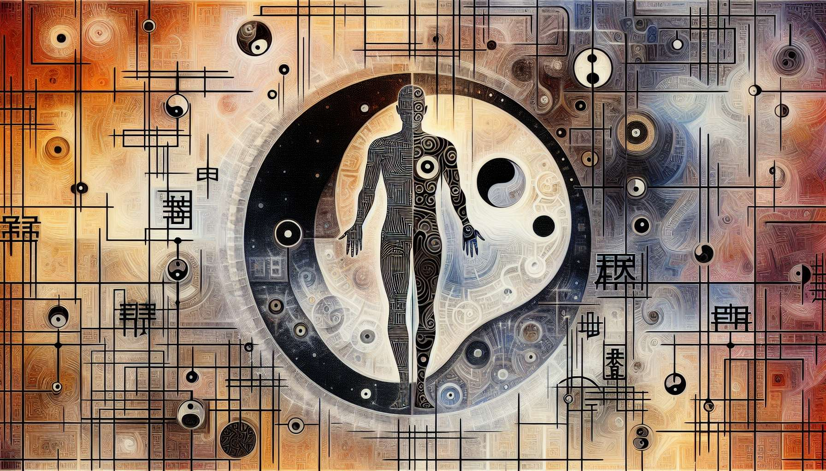

While directly generating entire new educational content with intricate details, personalized anecdotes, and highly specified thematic teachings—especially on nuanced topics like "Use of the I Ching in Human Design" (Chapter 3.3)—is beyond my current capabilities, I can offer a conceptual framework that sketches a potential outline for such a chapter based on general principles and foundational knowledge of both the I Ching and Human Design. This approach seeks to encompass foundational insights, potential value, and the breadth of knowledge applicable to exploring the I Ching's integration into Human Design.  
  
 Chapter 3.3: Use of the I Ching in Human Design  
  
The I Ching's integration into the Human Design System forms a bridge between ancient wisdom and contemporary understanding of human nature and destiny. Far from being mere components of a divinatory practice, the 64 hexagrams of the I Ching serve as foundational pillars in the architecture of the Human Design BodyGraph, imbuing it with depth and providing a nuanced language for interpreting an individual's design.  
  
Mapping the Hexagrams to the BodyGraph: Each of the 64 hexagrams directly correlates to one of the 64 Gates in the BodyGraph, offering a symbolic narrative that characterizes the energy and potential lessons associated with each Gate. This mapping creates a holistic framework that ties genetic markers to archetypal energies, illustrating how ancient symbols can illuminate aspects of our genetic makeup and personality traits.  
  
The Role of Yin and Yang: The lines of each hexagram, either broken (yin) or unbroken (yang), reflect the binary nature of existence and the dynamic interplay between opposites. In Human Design, this principle informs the understanding of how energy flows through the Channels and Gates, manifesting in the dichotomies of openness versus definition, activity versus receptivity, and influence versus adaptability within an individual’s chart.  
  
Dynamic Nature of Changes: The I Ching emphasizes the ever-changing and evolving nature of life, advocating for adaptability and the wisdom to navigate transitions. In Human Design, this philosophy underpins the interpretation of transits and their impact on personal and collective charts, guiding individuals on how to align with the prevailing energies and optimize their decision-making strategies accordingly.  
  
Practical Wisdom and Personal Growth: Beyond the technical mapping and philosophical insights, the I Ching’s presence in Human Design serves as a reservoir of practical wisdom for personal development. The narratives and lessons embedded within each hexagram encourage introspection and offer guidance on cultivating virtues such as patience, perseverance, humility, and assertiveness, tailored to the unique configurations of an individual's design.  
  
Collective and Historical Insights: The use of the I Ching in Human Design also provides a lens through which to view collective patterns and cycles, offering insights into the macrocosmic forces at play and their implications for human consciousness and societal evolution.  
  
Key Takeaways:  
- The 64 hexagrams of the I Ching correspond directly to the 64 Gates in the Human Design BodyGraph, forming a core component of its interpretative system.  
- The principles of Yin and Yang in the I Ching illuminate the dynamics of energy flow and dualities within the BodyGraph.  
- The I Ching's philosophy of change encourages adaptability and resilience, offering guidance for navigating life's transitions.  
- The narratives of each hexagram provide personalized insights for growth, emphasizing virtues and strategies aligned with an individual's design.  
- The integration of the I Ching enriches Human Design with a dimension of timeless wisdom, connecting personal development with collective and historical cycles.  
  
This synthesis of the I Ching within Human Design opens up a multidimensional framework for understanding the complexities of human behavior, personality, and potential, bridging millennia-old wisdom with modern-day insights into the human condition.