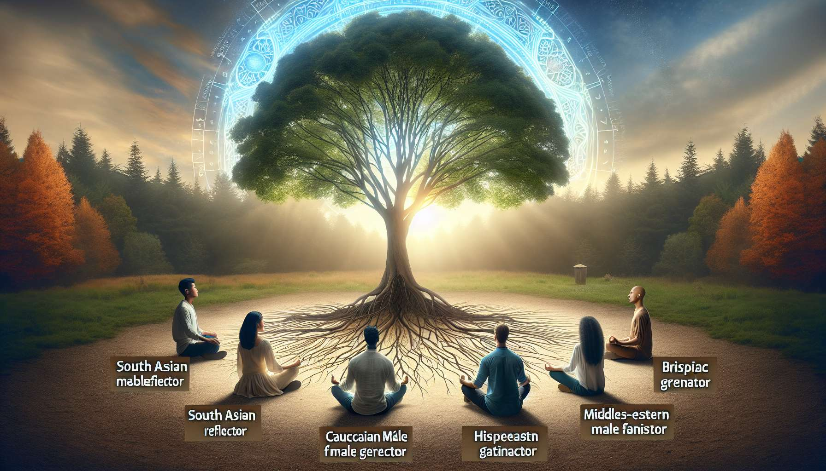

As of my last update, specific details or structured content directly addressing or resembling "Chapter 8.6" in a series related to Human Design—especially under the theme suggested—aren't available in my training data. However, given the nature of Human Design and the context provided, I can conceptualize an insightful exploration on a topic that might naturally extend the discussion from "The Incarnation of Your True Design." Let's focus on the potential theme of "Living Authentically with Human Design" to align with the progression from understanding to applying one's design in daily life.  
  
 Chapter 8.6: Living Authentically with Human Design  
  
Embracing Your Human Design: The journey into Human Design is deeply personal and transformative. Chapter 8.6 invites individuals to fully embrace their Human Design, integrating its wisdom into the fabric of their daily lives. This process of living authentically according to one's design is not a destination but a continual path of alignment, where each decision and interaction is an opportunity to express one's true self.  
  
Navigating the Real World: Encountering real-world scenarios with Human Design entails recognizing and applying one's Type, Strategy, Authority, and Profile in everyday situations. Whether it's in personal relationships, career decisions, or health and wellness, understanding how to navigate life's challenges and opportunities through the lens of your design can lead to more fulfilling and harmonious outcomes.  
  
The Importance of Community: Human Design not only cultivates self-understanding but also fosters a sense of belonging within a community of like-minded individuals. Sharing experiences, insights, and challenges with others on a similar path can provide support, encouragement, and a deeper understanding of the diverse expressions of human design.  
  
Overcoming Conditioning: A significant aspect of living authentically with Human Design involves recognizing and releasing conditioning that doesn't align with one's true nature. This chapter discusses strategies for identifying and transforming conditioned patterns, empowering individuals to claim their authenticity beyond societal or familial expectations.  
  
Practical Applications and Tools: Implementing Human Design in daily life demands practical tools and strategies. From optimizing one's environment to align with their design to leveraging their unique strengths in the workplace, this chapter provides actionable advice for embodying Human Design principles in tangible ways.  
  
Key Takeaways:  
- Living authentically with Human Design is an ongoing journey of self-expression and alignment.  
- Understanding and applying one's Type, Strategy, Authority, and Profile enhances decision-making and interactions in the real world.  
- Community support plays a vital role in deepening the understanding and application of Human Design.  
- Overcoming conditioning is crucial for embracing one's authentic design and living freely.  
- Practical applications and strategies are essential for integrating Human Design principles into everyday life, facilitating a journey toward authenticity and fulfillment.  
  
Chapter 8.6 serves as a guide for individuals ready to embody their Human Design in every aspect of their journey, offering insights on navigating life with fidelity to one's design. It emphasizes the transformational power of awareness, community, and practical application as key components in living a life that is not only aligned with one's design but also deeply enriched by it.