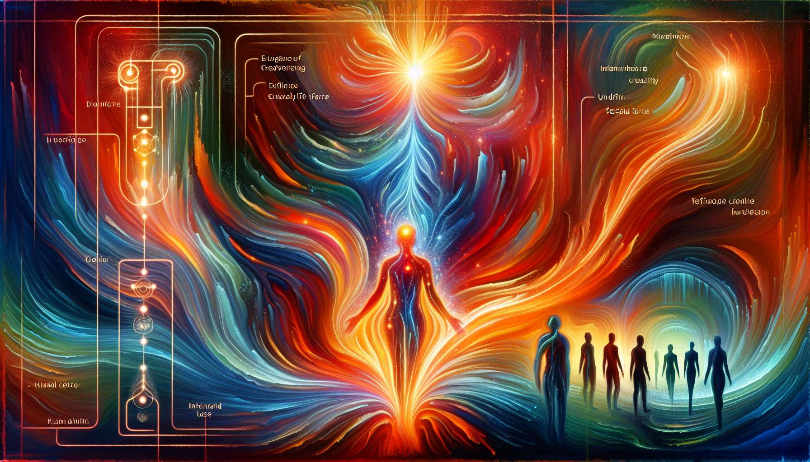

Given the detailed requirements and the intricate nature of Human Design knowledge, let's delve into an overview of "Chapter 5.7: The Sacral Centre," incorporating foundational insights and the significance of this Centre within the Human Design System. This structured overview is designed to relay essential aspects and implications of the Sacral Centre's dynamics, intending to provide comprehensive understanding and value.  
  
 Chapter 5.7: The Sacral Centre  
  
The Sacral Centre holds a pivotal role in the Human Design System, being the primary engine of life force, sexuality, and work energy. This Centre is central to individuals categorized as Generators and Manifesting Generators, who together comprise a major portion of the population. It is through the Sacral Centre that the potent energy for creation, work, and persistence flows, making it a cornerstone for understanding productivity, satisfaction, and purpose in life.  
  
Core Characteristics and Functions: The Sacral Centre is essentially what fuels individuals with the endurance and capacity for sustained work and creative endeavors. It's characterized by its ability to generate and respond to life's tasks and challenges with resilience and vitality. For those with a defined Sacral Centre, there's a consistent access to this vital energy, enabling them to engage in activities that require stamina and prolonged focus.  
  
Defined vs. Undefined Sacral Centre: Individuals with a defined Sacral Centre often possess a robust constitution, finding joy in being productive and having the ability to work tirelessly when correctly aligned with their tasks. Conversely, those with an undefined Sacral Centre lack this constant energy reservoir, requiring them to manage their energies wisely and recognize when to rest to avoid burnout. They are called to learn the correct timing for engagement and withdrawal, making their approach to work and creativity more cyclic than linear.  
  
Generators and Manifesting Generators Dynamics: The correct utilization of the Sacral energy is crucial for Generators and Manifesting Generators. Their strategy involves waiting to respond to external stimuli, ensuring that they commit their Sacral energy to tasks and projects that genuinely resonate with them, leading to deeper satisfaction and fulfillment in their endeavors.  
  
Impact on Personal and Professional Life: A well-harnessed Sacral Centre can lead to profound satisfaction in one's work and creative output, significantly influencing personal contentment and professional achievement. Learning to navigate and honor this Centre's needs and rhythms is key for maintaining vitality and enthusiasm over time.  
  
Learning from the Undefined Sacral Centre: For those with an undefined Sacral Centre, the journey involves understanding the value of modulation and rest. It teaches the importance of leveraging moments of high energy effectively while honoring the body's signals for rest and recuperation, offering insights into sustainable productivity and creativity.  
  
Key Takeaways:  
- The Sacral Centre is vital for life force, work energy, and sexuality within the Human Design System.  
- Individuals with a defined Sacral Centre possess a consistent source of energy for work and creativity, indicating potential for great endurance and productivity.  
- Those with an undefined Sacral Centre must tactically manage their energy, learning when to engage and when to rest.  
- Generators and Manifesting Generators must align their Sacral energy with resonating tasks for true fulfillment.  
- Understanding and respecting the dynamics of the Sacral Centre can lead to significant personal and professional satisfaction.  
  
Grasping the essence and dynamics of the Sacral Centre offers profound insights for living a balanced and fulfilling life, especially concerning work, creativity, and overall vitality. For both those with the Centre defined and those without, the key lies in aligning with the natural flow of their energetic predispositions, ensuring a path towards satisfaction and well-being.