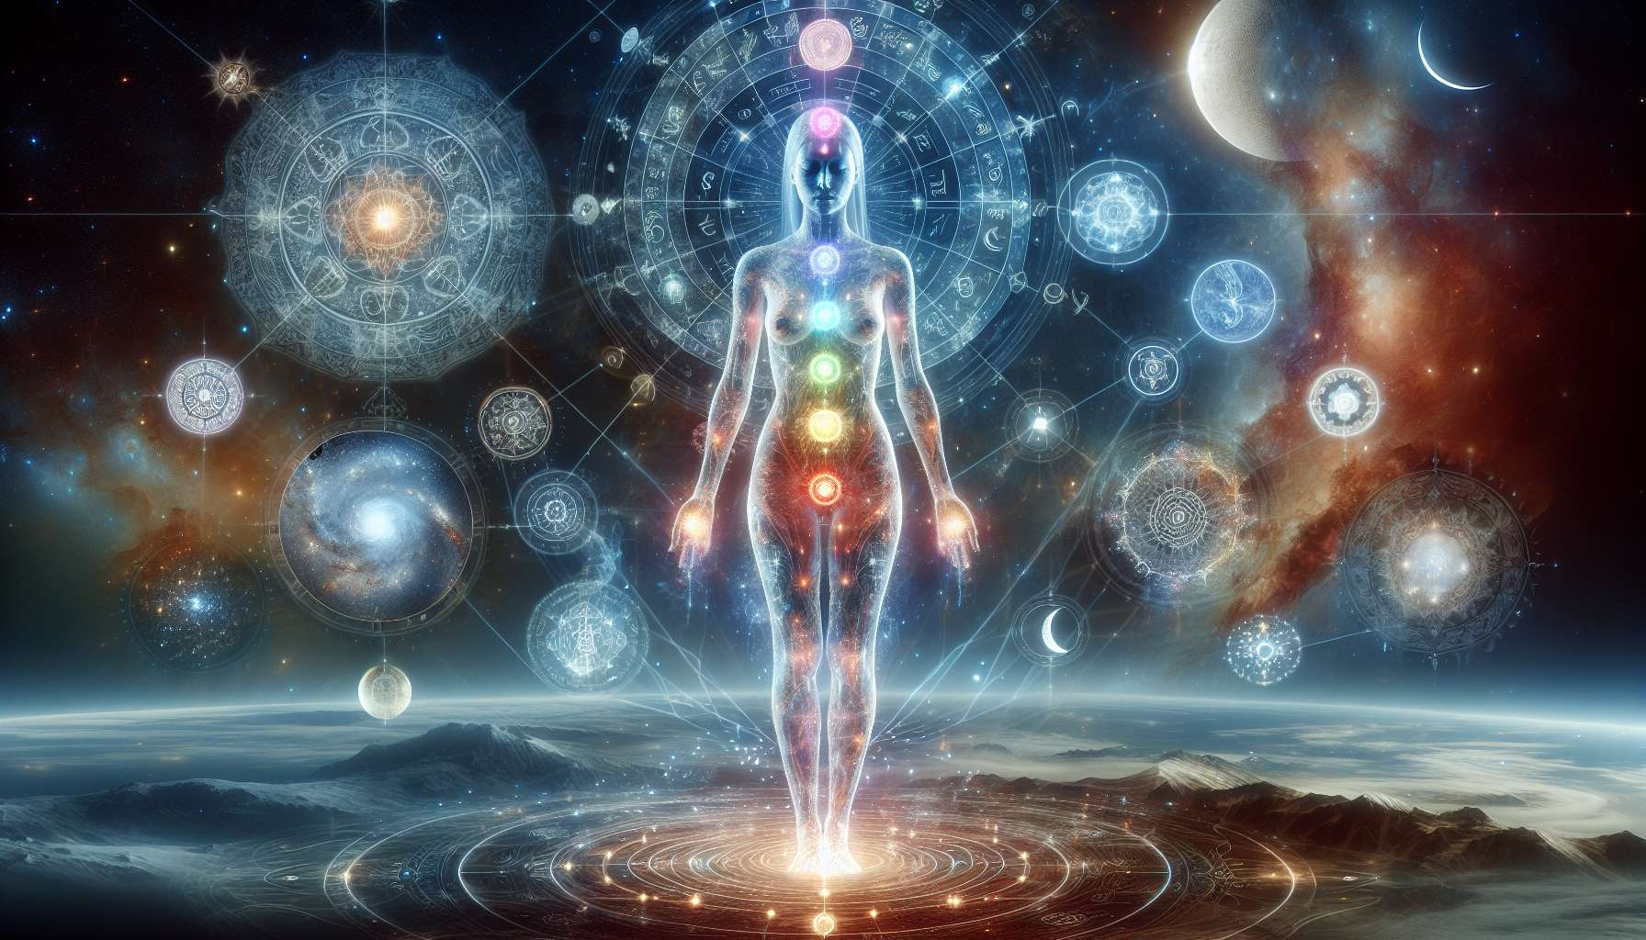

Chapter 1.1: History and Origins of Human Design  
  
Human Design is an intricate system that integrates wisdom from various ancient and contemporary traditions to offer insights into human behavior, potentials, and the dynamics of how we interact with the world and each other. The system was introduced in the late 20th century by Ra Uru Hu, born Robert Allan Krakower. His encounter with a mysterious voice, which he referred to as "The Voice," over the course of several days in 1987, led to the revelation of the Human Design System. This mystical experience in Ibiza, Spain, marked the birth of a new blueprint for understanding human life.   
  
The foundation of Human Design draws upon the I Ching, the ancient Chinese "Book of Changes," which details 64 hexagrams representing different energetic archetypes. The system also incorporates astrology, specifically how the positions of planets at the time of our birth influence our particular design. The Kabbalistic Tree of Life, representing the journey and relationship between the divine and the mundane, provides a spiritual structure to the system. Furthermore, the Chakra system, with its focus on energy centers within the body, is expanded in Human Design to include nine centers, up from the traditional seven, to represent different facets of the human experience.  
  
An interesting anecdote highlighting the system's impact involves an executive who, after years of struggling with decision-making, discovered her type as a Projector. This revelation allowed her to understand her natural inclination to wait for invitations before taking action, drastically reducing her stress and improving her career satisfaction. Such stories are not uncommon among those who delve into Human Design, demonstrating its potential power to transform understanding and interactions.  
  
Human Design is unique because it doesn't just categorize personalities but provides a dynamic map of how we are designed to navigate the world, make decisions, and interact with others. It suggests that by aligning with our unique design, we can improve our energy, decision-making, and overall satisfaction with life. For instance, a Generator, designed to respond rather than initiate, may find peace in waiting for things to come to them, enriching their life experience.  
  
In summary, Human Design is more than a system for understanding the self; it's a tool for navigating the complexities of human interaction and personal development. Its historical origins and theoretical underpinnings provide a deep well of knowledge for practitioners and enthusiasts to draw from.  
  
Key Takeaways:  
- Human Design combines elements from the I Ching, astrology, the Kabbalistic Tree of Life, and the Chakra system.  
- The system was introduced by Ra Uru Hu in 1987, following a mystical experience that provided the basis for Human Design.  
- Human Design offers unique insights into our nature and potential, suggesting alignment with our design can improve life satisfaction.  
- The system's depth allows for personalized strategies in decision-making and interaction, emphasizing the role of types, such as Projectors and Generators.  
- Through understanding and living according to one's Human Design, individuals can experience transformation in self-awareness and personal interactions.