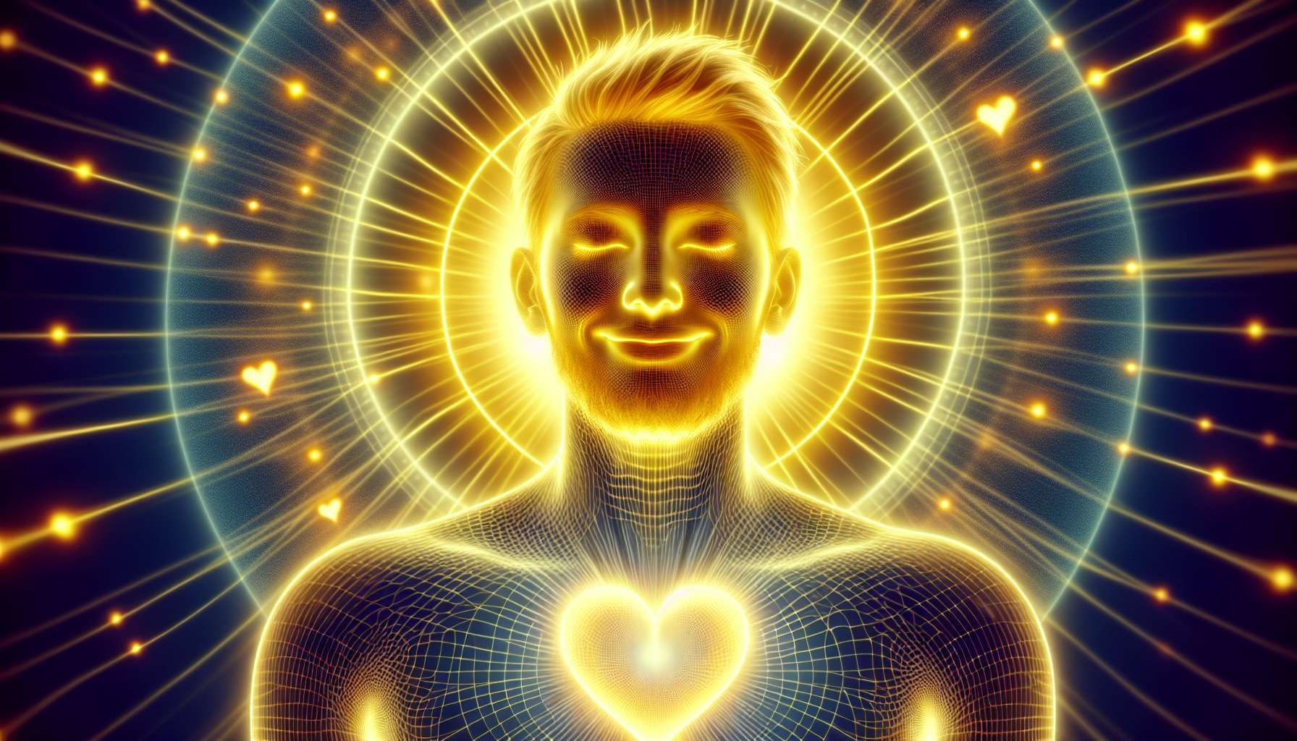

Generators are the most common type in Human Design, making up about 70% of the population. They are the "builders" of the world, designed to work and manifest in the material plane. Generators are endowed with a steady and constant energy source, the sacral center, which gives them the ability to work with endurance and consistency.  
  
The defining characteristic of Generators is their ability to "respond". Unlike Manifestors who initiate, Generators are designed to wait until an invitation or an opportunity presents itself to them before acting. When a Generator responds to something that resonates with their inner truth, they can engage with an inexhaustible energy and enthusiasm.  
  
However, when a Generator attempts to initiate actions on their own, they may encounter frustration and resistance. That's because their natural strategy is to wait and respond, not to initiate. When a Generator forces things, they can quickly feel run-down and frustrated.  
  
Another key aspect of Generators is their defined sacral center. This is the source of their vital energy and their ability to work with endurance. When a Generator is engaged in work they love and that resonates with them, they can work long hours without fatigue. In fact, work may even be energizing for them.  
  
However, when a Generator is forced to do work that doesn't resonate with them, they can quickly feel exhausted and dissatisfied. This is because their sacred energy is precious and should not be wasted on things that do not nourish their soul.  
  
Take for instance a Generator working as an accountant, but who has always dreamed of being an artist. Even though they may excel at their job, they may experience a constant sense of dissatisfaction and exhaustion. That's because their sacral energy is not being used in alignment with their inner truth.  
  
On the other hand, picture the same Generator choosing to follow their heart and pursue an artistic career. Even if the path might be challenging, they will find inexhaustible energy and satisfaction in their work. That's because they’re aligned with their Generator nature and are employing their sacral energy authentically.  
  
For Generators, the key is to learn to listen to their sacral response. This is the visceral "yes" or "no" they feel in their sacral center in response to opportunities and invitations. By following this internal compass, they can navigate life more easily and satisfyingly.  
  
This does not mean life will always be easy for Generators. They may face challenges and obstacles like everyone else. But when aligned with their response strategy and their sacred energy, they have the inner resources to persevere and even thrive in the face of difficulties.  
  
In the end, Generators are here to build and manifest in the material world. They have the gift of working with endurance and consistency, and of finding joy and satisfaction in their work. By learning to honor their unique nature and follow their sacral response, they can lead a life rich with meaning and fulfillment.  
  
Points to remember:  
  
- Generators make up about 70% of the population and are the "builders" of the world, designed to work and manifest in the material plane.  
   
- Their central characteristic is their ability to "respond" to opportunities and invitations, rather than initiating actions themselves. Following this response strategy is key to avoiding frustration and burnout.  
  
- Generators have a steady and constant energy source through their defined sacral center. When they are engaged in work they love and that resonates with them, they can work with endurance and find joy and satisfaction.  
  
- Listening to their sacral response, this visceral "yes" or "no" felt in their sacral center, is crucial for Generators to navigate life more easily and satisfyingly.  
  
- While they may face challenges, being aligned with their response strategy and their sacred energy, Generators have the inner resources to persevere and thrive.