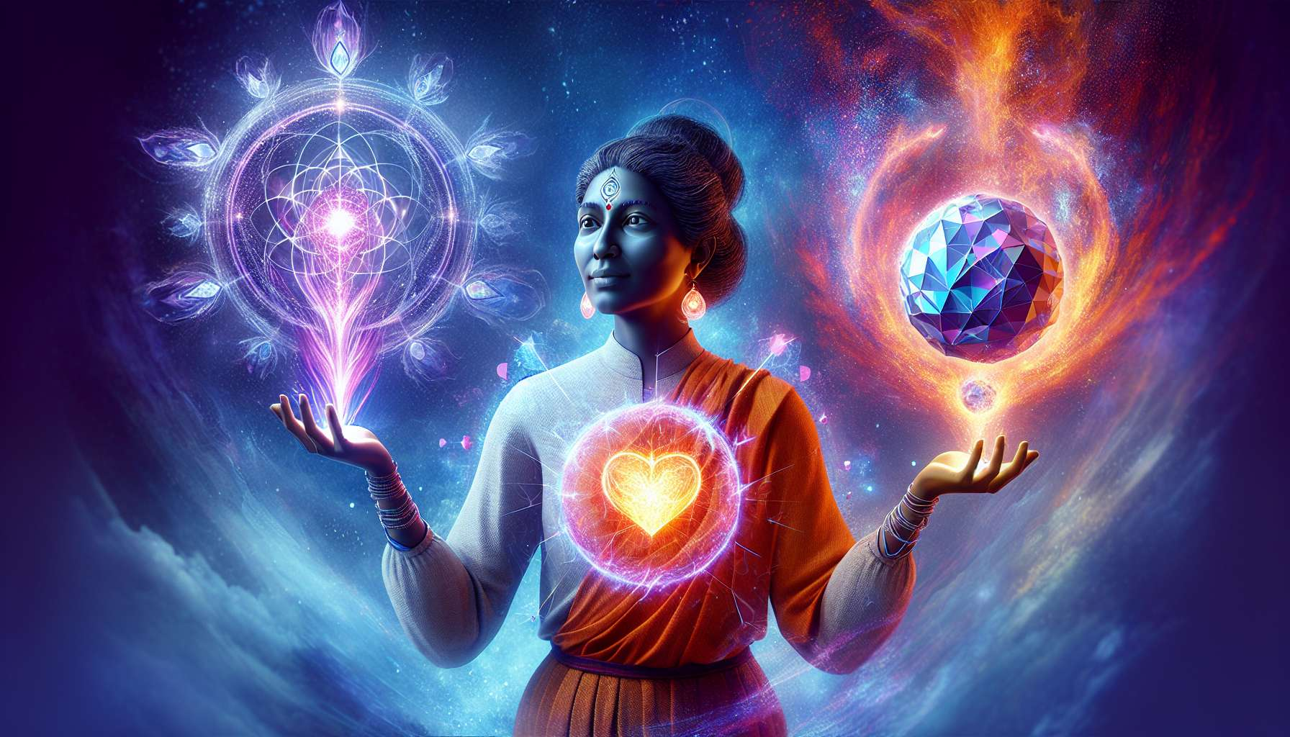

Manifesting Generators are a fascinating type in the Human Design, combinin the qualities of Manifestors and Generators. They represent about 33% of the population, making them the second most common type after Generators. Manifesting Generators are designed to initiate and manifest like Manifestors, but they also have the ability to sustain and carry through like Generators.  
  
The main characteristic of Manifesting Generators is their defined sacral center, which gives them access to durable, renewable life energy. Like Generators, they are here to work and manifest on the material plane. However, unlike pure Generators, Manifesting Generators also have a defined throat center, giving them the ability to initiate and set new things in motion.   
  
This unique combination of sacral energy and initiation ability makes Manifesting Generators incredibly powerful and effective beings. They can have ideas and visions like Manifestors, but they also have the sustainable energy to bring these to fruition and carry them through. They are often natural entrepreneurs, leaders, and pioneers, capable of turning ideas into tangible realities.   
  
However, this dual nature can also present challenges for Manifesting Generators. As they have both the impulse to initiate and to respond, they can sometimes feel torn or confused about the best way to act. They may start many projects with enthusiasm, but struggle to maintain this momentum in the long term.   
  
Take for example a Manifesting Generator who has an idea for a new product. With his Manifestor energy, he immediately plunges into creation and development. He works long hours, driven by his enthusiasm and vision. However, once the product is launched, he may start to lose interest and feel like moving on to something else. This is where his Generator energy comes in, giving him the ability to sustain and develop his product in the long term, if he chooses to do so.  
  
Another challenge for Manifesting Generators can be knowing when to initiate and when to respond. As they have both abilities, they can sometimes feel confused about the best way to use their energy. Should they wait for an invitation or an opportunity like Generators, or follow their impulse and initiate like Manifestors?   
  
The key for Manifesting Generators is learning how to balance and integrate these two aspects of their being. They must honor their impulse to initiate when it arises, but also learn to respond and sustain when appropriate. This requires practice and self-observation to discern which energy is being called upon at any given time.   
  
Another key for Manifesting Generators is learning to inform before initiating, like pure Manifestors do. Even if they have the sacral energy to support their initiatives, they can still encounter resistance if they don't communicate their intentions. By informing their surroundings before taking action, they can create a space for their energy to be received and supported.   
  
Imagine a Manifesting Generator who decides to change careers. With her Manifestor energy, she might be tempted to quit on a whim and dive into her new path without telling anyone. But if she takes the time to inform her partner, family, and friends of her intention, she can create a support system for her transition. She can also benefit from their advice and resources, making the process smoother and more enjoyable.  
  
Ultimately, Manifesting Generators are here to initiate and manifest sustainably and in alignment. They have incredible potential to create positive changes in the world, combining the vision of Manifestors with the work strength of Generators. By learning to master and balance these energies, they can live an incredibly rich and impactful life.   
  
Like all types, the path of the Manifesting Generator is unique and personal. Some may feel more comfortable initiating, others in maintaining. Some may excel in entrepreneurship, others in leadership within an organization. The key is to get to know and honor your own nature, and to find environments and activities that allow for its full expression.   
  
Manifesting Generators have much to learn from Manifestors about the art of informing and initiating, and from Generators about the art of responding and maintaining. By integrating these lessons, they can become incredibly powerful and effective beings, capable of turning visions into realities sustainably and in alignment.   
  
So if you are a Manifesting Generator, celebrate your uniqueness and potential. Get to know and master your initiation and maintenance energies. Find areas where you can fully express your gifts and creativity. And don't be afraid to inform and ask for support when you need it. The world needs your vision and strength, and you have everything it takes to offer them powerfully and in alignment.  
  
Key takeaways:  
  
- Manifesting Generators combine the qualities of Manifestors and Generators. They represent about 33% of the population.  
  
- Their defined sacral center gives them access to durable, renewable life energy to work and manifest on the material plane. Their defined throat center allows them to initiate new things.  
  
- They are often natural entrepreneurs, leaders, and pioneers, capable of turning ideas into tangible realities.   
  
- Their dual nature can present challenges, like feeling torn between the impulse to initiate and to respond, or struggling to maintain their momentum in the long term.  
  
- The key for Manifesting Generators is to learn how to balance and integrate their initiation and maintenance energies, by honoring their impulse to initiate when it arises, and learning to respond and maintain when appropriate.   
  
- They also need to learn to inform their surroundings before initiating, to create a space where their energy can be received and supported.  
  
- Every Manifesting Generator has a unique and personal path. By getting to know and honoring their own nature, they can find environments and activities that allow them to express fully and offer their gifts to the world powerfully and in alignment.