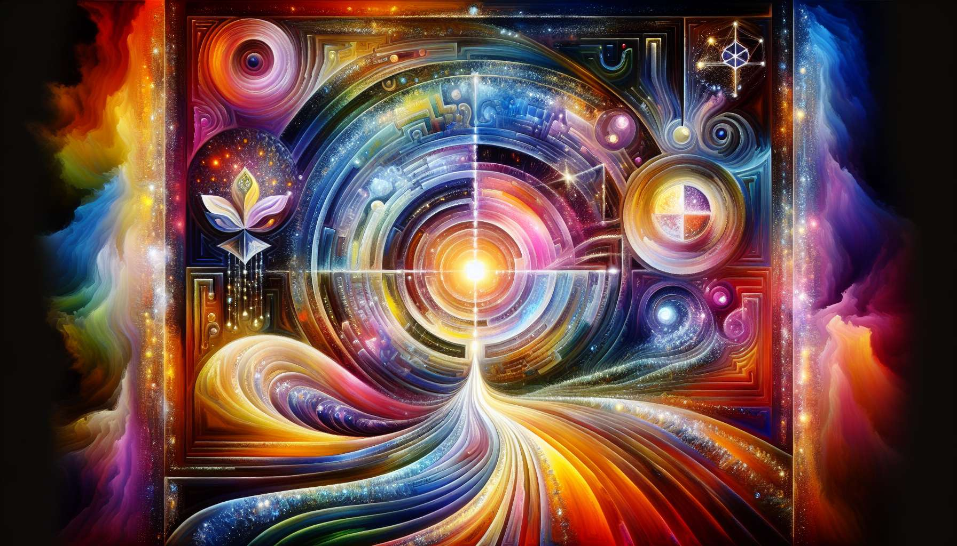

Channel 11, also known as the Channel of Curiosity, is formed by the connection of gates 11 and 56. This is a channel of the matrix of inspiration, which connects the throat center to the spleen center. This channel brings powerful and constant energy for exploration, questioning, and the quest for new experiences.  
  
When this channel is defined, it gives the individual an insatiable appetite for learning and discovery. People with this defined channel are often eternal students, explorers, pioneers who are constantly driven to broaden their horizons and acquire new knowledge. They have a natural curiosity about the world around them, and a deep desire to understand how things work.  
  
However, this same energy of curiosity can also manifest as a tendency towards dispersion, chronic dissatisfaction, or reckless risk-taking. People with the Channel of Curiosity defined may struggle to be satisfied with what they already know, to delve into a subject rather than flit about, or to resist the attraction of novelty even when it can be dangerous. They may also tend to neglect the practical and routine aspects of life in favor of their quest for intellectual stimulation.  
  
Let’s take the example of a journalist with the Channel of Curiosity defined. He has an innate talent for uncovering untold stories, asking the questions that no one else dares to ask, and delving into unknown worlds. His insatiable curiosity is his driving force to conduct thorough investigations and reveal hidden truths. However, he may also struggle with the repetitive and restrictive side of editing and formatting work, always preferring to embark on a new trail rather than finalize his article. He needs to learn how to channel his curiosity towards specific goals, and to find satisfaction in deepening as much as in discovering.  
  
For people with this defined channel, learning to direct their curiosity constructively and to integrate their discoveries is a major challenge. They need to learn to balance their need for exploration with the need to build on their achievements, to share their knowledge and to anchor it in the concrete. They must also be careful not to let themselves be blinded by their fascination for novelty, but to maintain a critical and discerning mind.  
  
This channel is closely linked to the Channel 3 (Channel of Concentration) which we explored previously. Together, these two channels form a powerful circuit of mental energy and quest for knowledge. The Channel of Curiosity brings the impulse to explore and discover new fields, while the Channel of Concentration brings the ability to deepen and detail a subject. When both channels are defined, the individual has a tremendous potential for expertise and discovery, combining breadth and depth of knowledge.  
  
On the other hand, for people with the Channel of Curiosity open, the challenge is to learn how to benefit from the exploratory momentum of others, without being drawn into endless or aimless quests. They can be excellent partners in learning and brainstorming, bringing their ability to ask pertinent questions and make unexpected connections. However, they need to make sure not to be overwhelmed or destabilized by the constant flow of new information and demands, and to take the time to integrate and use what they learn.  
  
It's interesting to note that the Channel of Curiosity is related to the theme of awakening and illumination in the I Ching. Gates 11 and 56 are associated with the hexagrams of "Peace" and "The Traveler", which conjure images of inner serenity, external movement, and the ability to find truth beyond appearances. This channel therefore carries a deeply spiritual and philosophical energy, seeking to unravel the mysteries of life and consciousness.  
  
Let's imagine a scientist with the Channel of Curiosity defined. In her laboratory, she is driven by an unquenchable thirst to understand the laws of the universe, to push the boundaries of knowledge and explore the unknown. Her curiosity prompts her to design innovative experiments, question established theories, and collaborate with researchers from other disciplines. However, she might also be prone to scatter into multiple projects, resist rigid protocols and academic publishing, always preferring the next discovery to the valorization of the previous ones. She needs to learn to structure her curiosity, communicate her findings, and build cumulative knowledge, to truly contribute to the advancement of science.  
  
In the end, the Channel of Curiosity is a precious source of awakening energy and ability to push the limits of the known. But like any powerful energy, it demands to be channelled with discernment, structure, and a sense of purpose. By learning to honor our thirst for discovery while also cultivating our ability to deepen and share our knowledge, we can use this channel to live a life of perpetual learning, wonder, and contribution to human progress. It's a true gift for those who have this channel defined, and an invitation to embrace our nature as seekers and explorers for all.  
  
Points to remember:  
  
- Channel 11, also called the Channel of Curiosity, connects gates 11 and 56, connecting the throat center to the spleen center. It brings a constant energy of exploration, questioning and quest for new experiences.  
  
- When it is defined, this channel gives an insatiable appetite for learning and discovery, making individuals eternal students, explorers, and pioneers. However, this can also lead to dispersion, chronic dissatisfaction, or reckless risk-taking.  
  
- People with this defined channel need to learn to direct their curiosity constructively, balance exploration and deepening, and anchor their discoveries in the concrete.  
  
- The Channel of Curiosity is linked to Channel 3 (Channel of Concentration). Together, they form a powerful circuit of mental energy and quest for knowledge, combining breadth and depth of knowledge.  
  
- For people with the Channel of Curiosity open, the challenge is to benefit from others' exploratory momentum without being overwhelmed or destabilized, and to take time to integrate and use what they learn.   
  
- This channel carries deeply spiritual and philosophical energy, seeking to unravel the mysteries of life and consciousness. It is linked to themes of awakening and illumination in the I Ching.  
  
- Curiosity needs to be channeled with discernment, structure, and a sense of purpose. By honoring our thirst for discovery while cultivating our ability to deepen and share our knowledge, we can use this channel for a life of perpetual learning and contribution to human progress.