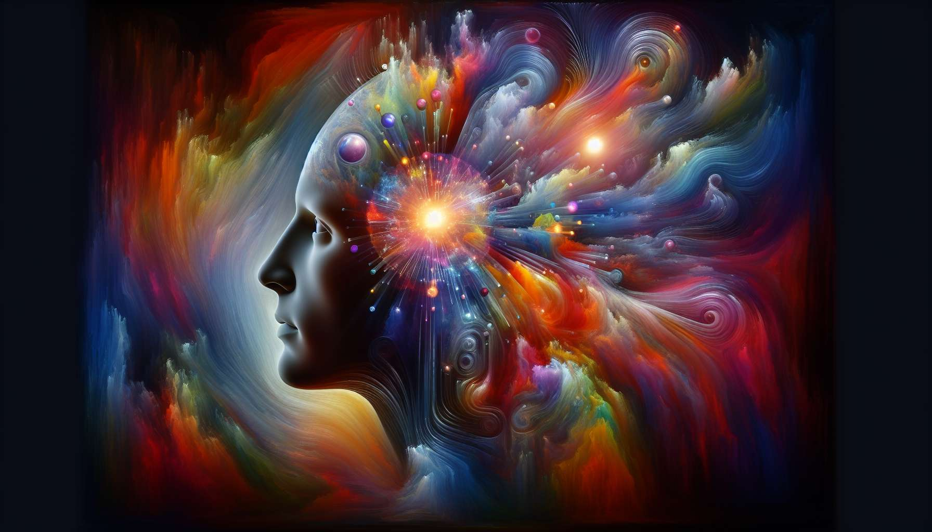

The center of the head, located at the top of the BodyGraph, is a pressure center that represents our inspiration, our ideas, and our direction in life. This is the center for mental conceptualization, where ideas take shape before descending to the ajna center for analysis and the throat center for expression.  
  
When the head center is defined, that is when an activated gate exists, the individual has constant access to the pressure for inspiration. They may be filled with ideas, questions, and concepts that seem to come out of nowhere. This pressure can be both stimulating and overwhelming, as there can be a constant flow of thoughts demanding expression.   
  
Individuals with a defined head center are often visionaries, original thinkers who are here to bring new ideas into the world. They have a deep need to follow their inspiration and share their concepts with others. However, they may also feel overwhelmed by mental pressure and struggle to find inner peace.  
  
When the head center is open, that is when there are no activated gates, the individual does not have constant access to pressure for inspiration. Instead, they may be open to the ideas and influences of others. They can absorb concepts and inspirations from their environment, but they don’t have the same internal pressure to generate and express their own ideas.  
  
People with an open head center can be excellent sounding boards for others, as they can listen to and reflect on ideas without needing to own or express them themselves. However, they may also easily feel overwhelmed by other's ideas and struggle to find their own direction.  
  
It is important to note that the head center is not the seat of intellect or logic - that function belongs to the ajna center. The head center is rather the realm of raw inspiration, ideas that seem to come from another plane. It is the start of the creative process, where something new enters the world.  
  
A concrete example could be that of a writer with a defined head center. They may wake up in the middle of the night with a novel idea that seems to emerge out of nowhere. They feel an intense pressure to write, to give form to this raw inspiration. If they do not honor this pressure, they may feel frustrated and blocked.   
  
In contrast, a writer with an open head center could find inspiration from reading other authors' works, talking with friends, or experiencing new things. They absorb the ideas from their environment and then transform them through their own creative process.  
  
Understanding your head center, whether defined or open, is essential for navigating the creative process and finding balance between inspiration and expression. This is the first step in the journey of manifestation, where ideas begin to take shape before materialising into the world.  
  
Key takeaways:  
  
1. The head center represents inspiration, ideas, and direction in life. It is the center of mental conceptualization.  
  
2. When the head center is defined (with an activated gate), the individual has constant access to pressure for inspiration and may be filled with ideas and concepts. These individuals are often visionary and original thinkers.  
  
3. When the head center is open (without an activated gate), the individual is open to ideas and influences from others. They can absorb concepts from their environment, but do not have internal pressure to generate and express their own ideas. These individuals can be excellent sounding boards.  
  
4. The head center is the realm of raw inspiration, ideas that seem to come from another plane. It is the start of the creative process.  
  
5. Understanding your head center, whether defined or open, is essential for navigating the creative process and finding balance between inspiration and expression.