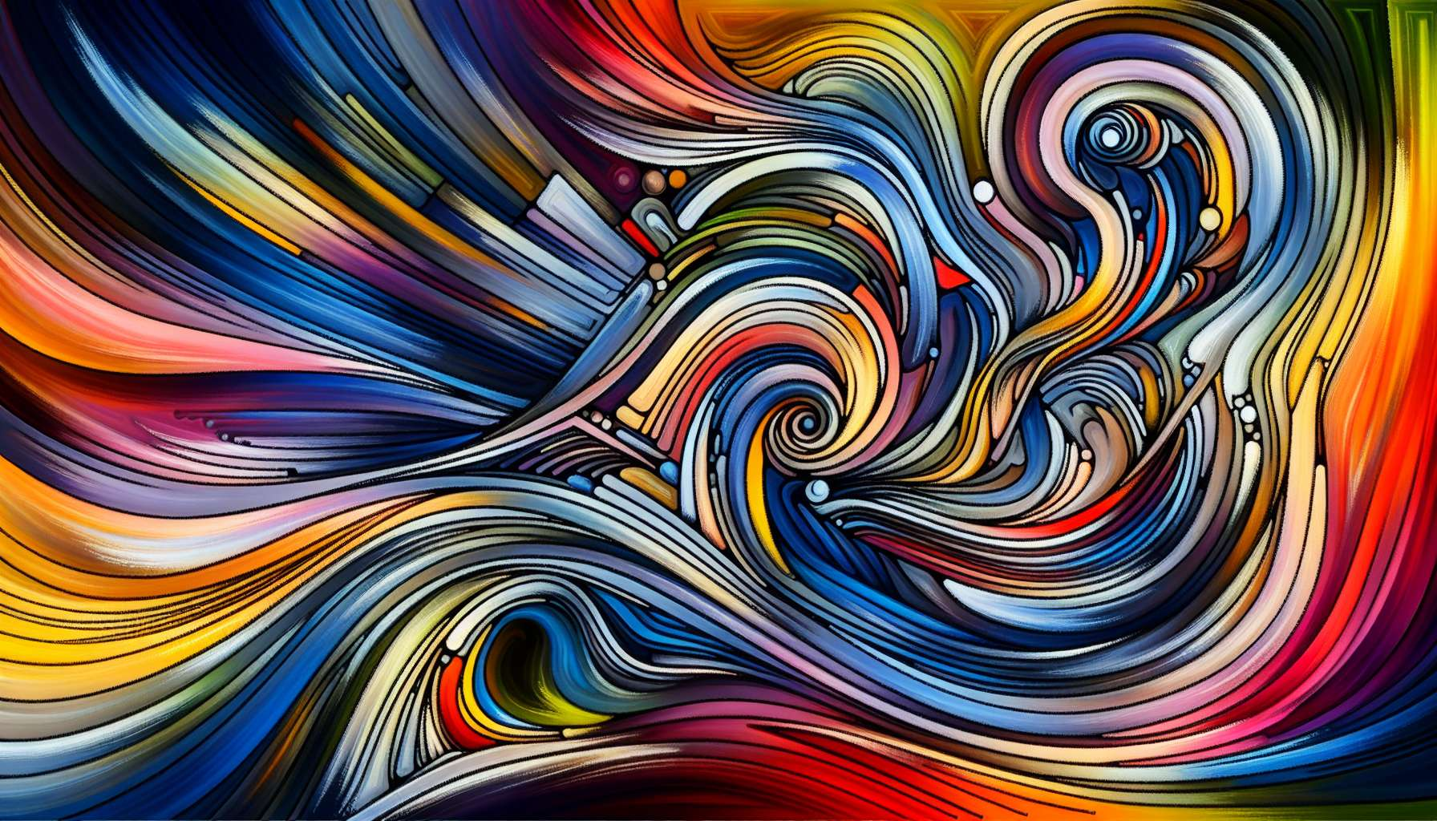

Channel 2, also known as the Channel of Inspiration, is formed by the connection of gates 1 and 8. It is a channel of the matrix of inspiration, connecting the head center to the throat center. This channel brings a powerful and constant energy of creativity, self-expression, and manifestation in the world.   
  
When this channel is defined, it gives the individual an inexhaustible source of creative ideas and a profound need to express them and share them with the world. People with this defined channel are often artists, writers, speakers, or visionary entrepreneurs. They have an innate ability to inspire and motivate others with their ideas and creations.  
  
However, this very energy of inspiration can also manifest as a constant pressure to create and express, which can be exhausting if not managed in a balanced way. People with the defined Inspiration Channel may tend to scatter themselves into multiple projects or ideas without always carrying them through. They may also have trouble finding the silence and rest necessary to recharge their creative energy.  
  
A concrete example could be that of a painter with the defined Inspiration Channel. She is constantly flooded with new ideas for paintings and artistic projects, which she has a vital need to express on canvas. Her art is a source of inspiration and wonder for those who see it. However, she may also struggle with periods of overactive creativity followed by periods of burn-out, and have trouble balancing her time between creation and other aspects of her life.  
  
For people with this defined channel, learning to channel and direct their creative energy in a sustainable way is a major challenge. They need to learn to prioritize their ideas and projects, and to give themselves permission to rest and refresh regularly. They also have to learn to trust the creative process, including the periods of pause and gestation that are an integral part of the cycle of inspiration.  
  
This channel is closely linked to Channel 1 (Channel of the Will) that we explored in the previous sub-module. Together, these two channels form a powerful circuit of creative energy and manifestation. The Inspiration Channel brings the ideas and vision, while the Will Channel brings the determination and perseverance necessary to materialize them. When both these channels are defined, the individual has immense potential for creativity and realization.  
  
On the other hand, for people with the Inspiration Channel open, the challenge is to learn to open up and be inspired by the ideas and visions of others, without losing touch with their own creativity and inner truth. They can be terrific muses and catalysts for the creativity of others, but they must be careful not to let themselves be overwhelmed or defined by outside ideas. Cultivating a deep sense of their own creativity and expression is essential for them.  
  
It is interesting to note that the Inspiration Channel is linked to the theme of creativity and self-expression in the I Ching. Gates 1 and 8 are associated with the hexagrams of "Creative Yang" and "Union", which evoke images of creative power, harmony and realization. This channel therefore carries a deeply creative and expressive energy that seeks to manifest itself and unite with the world.  
  
In the end, the Inspiration Channel is a wonderful source of creative energy and potential for self-expression. But as with any powerful energy, it demands to be channeled and balanced with wisdom. By learning to honor our inspiration while respecting our own rhythms and needs, we can use this channel to bring beauty, meaning and wonder into our life and the world around us. It's a true gift for those who have this channel defined, and an invitation to fully embrace our creativity and uniqueness for all.  
  
Takeaways:  
  
- Channel 2, also known as the Channel of Inspiration, connects gates 1 and 8, linking the head center to the throat center.  
- This channel brings a constant energy of creativity, self-expression, and manifestation in the world.  
- People with this defined channel have an inexhaustible source of creative ideas and a deep need to express and share them.  
- This inspirational energy can also manifest as a constant pressure to create and express, leading to burn-out if not managed in a balanced way.  
- People with the defined Inspiration Channel need to learn to channel and direct their creative energy sustainably, prioritizing their ideas and taking regular rests.   
- The Inspiration Channel is closely linked to Channel 1 (Channel of the Will), together forming a powerful circuit of creative energy and manifestation.  
- For people with the Inspiration Channel open, the challenge is to open up to others' ideas while cultivating their own creativity and inner truth.  
- The Inspiration Channel is linked to the theme of creativity and self-expression in the I Ching, carrying a deeply creative and expressive energy.   
- This channel is a gift for those who have it defined, but needs to be channeled and balanced with wisdom to bring beauty, meaning and wonder into life and the world.