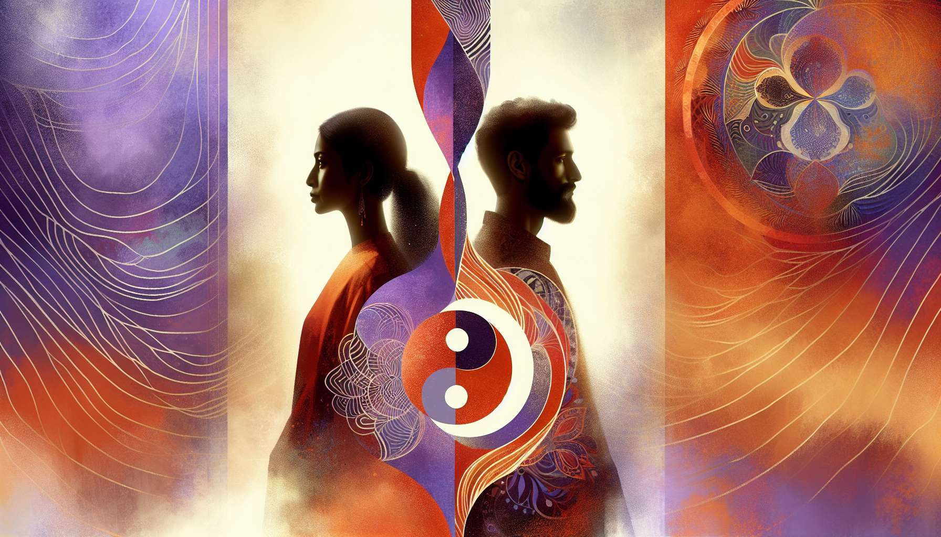

Channel 35, also known as the Marriage Channel, is formed by the connection of gates 39 and 55. It is a channel of the community matrix, linking the sacral center to the spleen center. This channel brings a powerful and constant energy of alliance, the ability to create enduring and mutually beneficial partnerships.  
  
When this channel is defined, it gives the individual an innate sense of complementarity and a natural attraction to committed relationships. People with this defined channel are often mediators, diplomats, couple therapists who excel in the art of bridging differences and building strong unions. They have a gift for sensing individual needs and resources, finding balance and reciprocity points, and inspiring long-term loyalty and cooperation.  
  
However, this same alliance energy can also manifest as a tendency toward dependence, loss of individuality, or fear of solitude. People with the Marriage Channel defined may have trouble being alone, maintaining their autonomy in relationships, or managing conflicts and separations. They may also tend to define themselves by their partnerships, at the risk of neglecting their own development and desires.  
  
Let's take the example of a marital counselor with the Marriage Channel defined. In her work with couples, she demonstrates remarkable finesse and accuracy in identifying relational dynamics, unexpressed needs and individual potentials. Her alliance energy allows her to create a space for dialogue and reconciliation, guide partners toward greater mutual understanding and respect, and help them renew their commitment on a healthier basis. Her advice is imbued with wisdom and kindness that call for responsibility and growth. However, in her personal life, she may tend to lose herself in her relationships, make too many compromises or remain in partnerships that no longer truly nourish her. She needs to learn to be a partner to herself, establish her limits with love, and dare to make the necessary transitions for her evolution.  
  
For those with this defined channel, learning to live their alliance energy in a balanced and fulfilling way is a major challenge. They need to create relationships that honor each individual's identity, keep the flame of the encounter alive, and embrace the natural cycles of closeness and distance. They must take care not to make maintaining the relationship an end in itself, but to always put it at the service of each individual's growth and fulfillment. Finally, they need to nurture their own inner strength, their ability to keep their own company, to be free and loving partners.  
  
This channel is closely related to Channel 29 (Communion Channel) that we previously explored. Together, these two channels form a powerful circuit of relational energy and commitment. The Marriage Channel brings the ability to create enduring and complementary alliances, while the Communion Channel brings the ability to deeply connect and share one's inner experience. When these two channels are defined, the individual has immense potential for relational wisdom and creating nourishing unions, combining commitment and intimacy.  
  
On the other hand, for people with the Marriage Channel open, the challenge is learning to appreciate and contribute to partnerships without losing themselves or becoming dependent. They can be excellent catalysts of individuality and autonomy within relationships, bringing their freedom and detachment to help others not to merge or stagnate in routine. However, they must be careful not to shun any commitment for fear of losing freedom, but find their own way of aligning with respect for their independent nature.  
  
It is interesting to note that the Marriage Channel is linked to the theme of meeting and just relation in the I Ching. Gates 39 and 55 are associated with the hexagrams of "Obstruction" and "Abundance," which evoke images of challenge, sharing, and ability to overcome difficulties together to achieve prosperity and harmony. This channel therefore carries a deeply evolving and creative energy, which knows how to use complementarities to overcome obstacles and build win-win relationships.  
  
Imagine an entrepreneur with the Marriage Channel defined. In his business creation journey, he displays a remarkable talent for surrounding himself with the right partners and creating mutually beneficial strategic alliances. His alliance energy allows him to see the potential for synergy with other actors, build trust and long-term commitment, and rally complementary and supportive teams around his vision. His business grows organically and sustainably, carried by the strength of his partnerships. However, he may also tend to rely too much on his associates, have difficulty making decisions or imposing his direction when necessary, or maintain alliances that no longer serve his project's growth. He needs to learn to be the leader of his own vision, reassess the relevance of his partnerships regularly, and dare to separate when it's right for evolution.  
  
Ultimately, the Marriage Channel is a valuable source of alliance energy and the ability to create committed and complementary relationships. But like any powerful energy, it demands to be channeled with discernment, balance and respect for the individuality of each person. By learning to honor our need for partnership while cultivating our inner strength, we can use this channel to build relationships and collaborations that elevate, support, and enable us to fully realize ourselves. It is a true art of alliance and commitment for those who have this defined channel, and an invitation to find our just place in relationships for all.  
  
Here is a summary of the key points to remember from this text about Channel 35 or the Marriage Channel in Human Design:  
  
Key points:  
  
- Channel 35 connects the sacral and spleen centers, providing an alliance energy and the ability to create durable and complementary partnerships.   
  
- When defined, this channel gives an innate sense of complementarity, the ability to create strong unions, be a mediator and inspire cooperation and commitment.  
  
- The alliance energy can also lead to a tendency towards dependence, the loss of individuality, or the fear of solitude if not balanced.  
  
- To live this channel fulfilled, it's important to honor each individual's individuality in relationships, cultivate inner solidity, and embrace proximity/distance cycles.  
  
- With Channel 29, Channel 35 forms a powerful relational energy circuit combining commitment and intimacy.  
  
- For those with this channel open, the challenge is to appreciate partnerships without losing themselves and to bring freedom and autonomy into relationships.  
  
- This channel is linked to meeting themes, just relationships, the ability to overcome challenges together to achieve harmony and prosperity.  
  
- The Marriage Channel's energy is valuable for building nourishing relationships and collaborations, but requires discernment and balance between partnership and individuality.