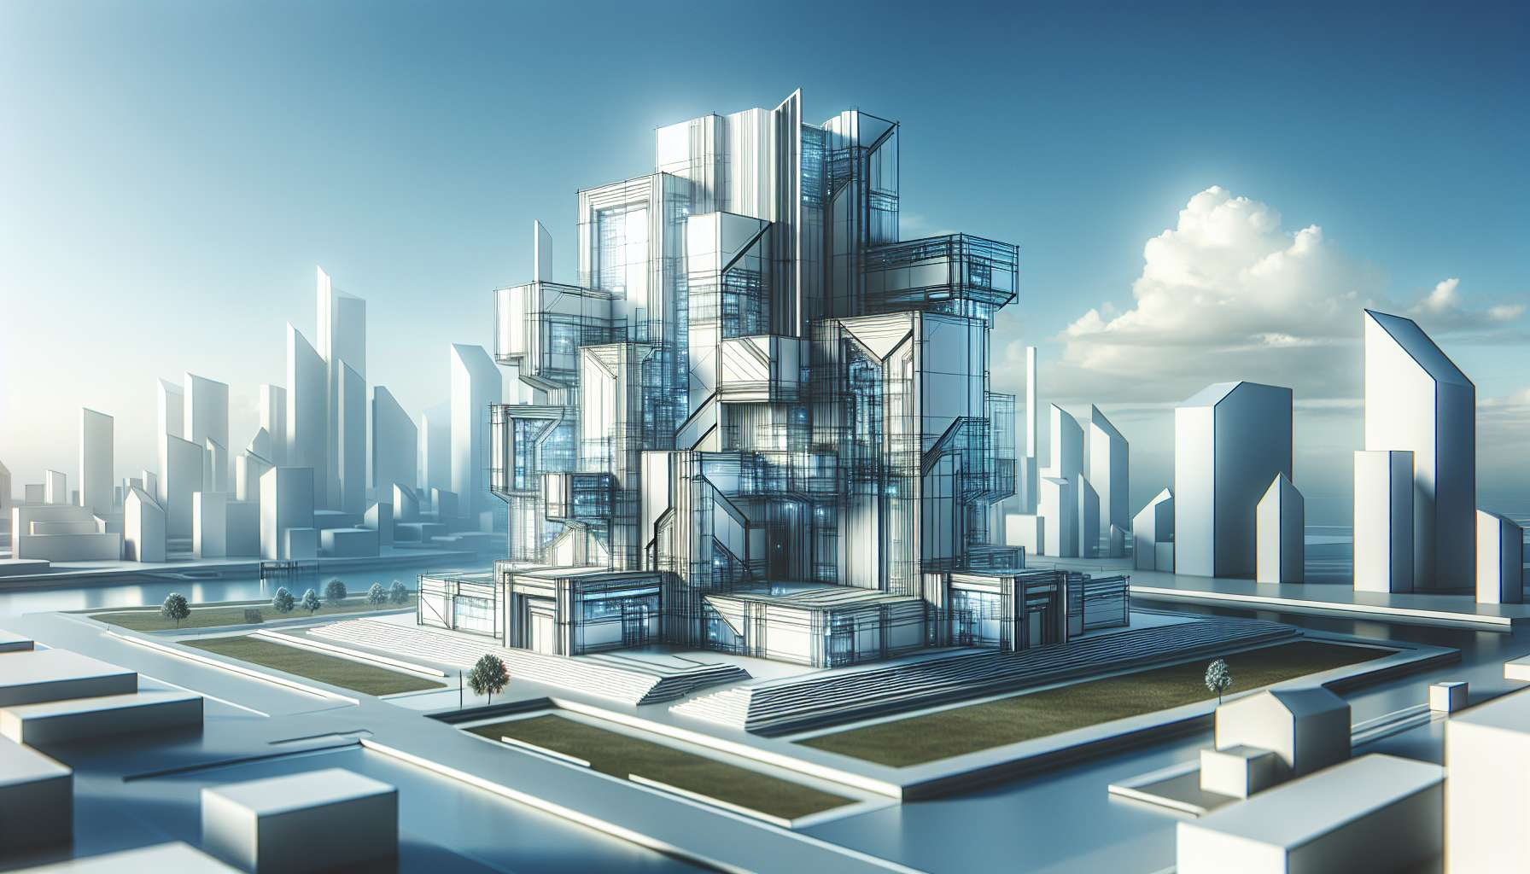

Channel 23, also known as the Channel of Structuring, is formed by the connection of gates 35 and 36. It is a channel of the form matrix that connects the sacral center to the spleen center. This channel brings a powerful and constant energy of organization, and ability to create solid and functional structures in the physical world.  
  
When this channel is defined, it gives the individual an innate talent to bring order to chaos and build efficient and enduring systems. People with this defined channel are often managers, architects, engineers who excel in the art of planning, coordinating, and executing complex projects. They have a knack for seeing patterns and processes, for optimizing resources and for creating infrastructures that support growth and development.  
  
However, this same structuring energy can also manifest as a tendency towards rigidity, excessive control, or resistance to change. People with the defined Structuring Channel may have difficulty adapting to the unexpected, making room for spontaneity and creativity, or accepting ways of doing things that are different from their own. They may also tend to identify with their achievements and their role, at the risk of neglecting other aspects of their life and their being.  
  
Take the example of a factory manager with the defined Structuring Channel. In his work, he excels at optimizing production chains, managing teams and schedules, and ensuring the quality and profitability of finished products. His structuring energy allows him to keep his calm and clarity even under pressure, to always find pragmatic solutions to problems, and to inspire trust and respect from his colleagues. However, he may also struggle to manage more subtle human relationships, to be flexible in the face of change requests, or to balance his professional and personal life. He must learn to delegate, to trust in the creative potential of disorder, and to nourish other facets of his identity beyond his role as a leader.  
  
For people with this defined channel, the significant challenge is to learn to use their structuring energy in a flexible and balanced way. They need to learn to create structures that are solid but not rigid, that can evolve and adapt to changing needs. They must also take care not to impose their structures on others, but to co-create solutions that honor diversity and complementarity of approaches. Finally, they must cultivate their ability to let go, to trust in the flow of life, and to find their value beyond their tangible achievements.  
  
This channel is closely related to Channel 10 (Channel of Planning) which we have explored previously. Together, these two channels form a powerful circuit of manifestation energy and mastery in the physical world. The Channel of Structuring brings the ability to create functional and efficient systems, while the Channel of Planning brings the ability to project into the future and anticipate steps. When these two channels are defined, the individual has immense potential for concrete achievement and organizational leadership, combining strategic vision and operational excellence.  
  
On the other hand, for people with the open Structuring Channel, the challenge is to learn to appreciate and rely on the structures created by others, without feeling trapped or limited by them. They can be excellent agents of change and innovation, bringing their creativity and adaptability to evolve existing systems. However, they must take care not to reject all structures on principle, but to discern those that are useful and necessary to support life and projects.  
  
It is interesting to note that the Channel of Structuring is related to the theme of sustainability and legacy in the I Ching. Gates 35 and 36 are associated with the hexagrams of "Progress" and the "Darkening of the Light", which evoke images of moving forward, going through trials, and the ability to create something that lasts and inspires beyond the vicissitudes of time. This channel therefore carries a deeply builder and responsible energy, which knows how to build for future generations.  
  
Let's imagine a teacher with the defined Structuring Channel. In her class, she excels at creating a clear and caring framework, where each student knows what is expected of them and how to progress in their learning. Her structuring energy allows her to design perfectly adapted programs and exercises, to manage calmly and methodically different levels and needs, and to lead everyone towards success at their own pace. Yet, she may also tend to be too attached to her plans and methods, to lack spontaneity and lightness in her interactions with students. She must learn to soften, to give more room for expression and initiative to learners, and to see the value of informal and playful moments in the educational relationship.  
  
In the end, the Channel of Structuring is a precious source of creative energy and the ability to build solid foundations for projects and communities. But like any powerful energy, it needs to be balanced with flexibility, openness, and a consciousness of what cannot be mastered. By learning to honor our talent for structuring while cultivating our ability to dance with the flow of life, we can utilize this channel to create works and systems that support everyone's long-term growth. It's a real asset for those who have this defined channel, and an invitation to find the right place for structures in our lives for all.  
  
Key points to remember:  
  
- Channel 23, also called the Channel of Structuring, connects the sacral center to the spleen center. It brings an energy of organization and creation of solid and functional structures.  
  
- People with this defined channel excel in planning, coordinating, and executing complex projects. They have a talent for optimizing resources and creating enduring infrastructures.  
  
- The structuring energy can also manifest by rigidity, excessive control, or resistance to change. It's important to learn to use this energy in a flexible and balanced way.  
  
- Channel 23 is related to Channel 10 (Channel of Planning). Together, they form a powerful circuit of manifestation and mastery in the physical world.  
  
- For people with Channel 23 open, the challenge is to appreciate and rely on the structures created by others, while bringing their creativity and adaptability to evolve existing systems.  
  
- The Channel of Structuring is associated with the theme of sustainability and legacy in the I Ching. It carries a builder and responsible energy, which knows how to build for future generations.  
  
- The structuring energy must be balanced with flexibility, openness, and a consciousness of what cannot be mastered, in order to create works and systems that support everyone's long-term growth.