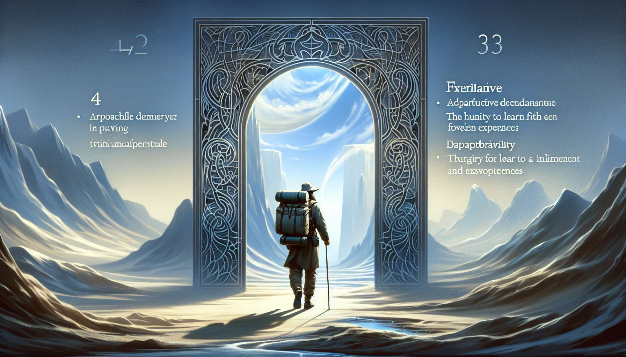

Channel 36, also known as the Experience Channel, is formed by the connection of gates 42 and 53. It's a channel of the form matrix, connecting the throat center to the root center. This channel brings powerful and constant energy for learning, for drawing life lessons and transmitting this experiential wisdom.  
  
When this channel is defined, it gives the individual a deep need to live varied experiences and to extract meaning and knowledge from them. People with this defined channel are often explorers, philosophers, teachers who excel in the art of diving into life, tasting all its flavors, and drawing universal lessons from it. They have a gift for embracing change, adapting to new situations, and seeing every challenge as an opportunity for learning and growth.  
  
However, this same energy of experience can also manifest as a tendency towards dispersion, reckless risk-taking, or difficulty in stabilizing achievements. People with the defined Experience Channel may struggle to settle down, to deepen a field, or to capitalize on their learnings. They may also tend to seek intensity or novelty for its own sake, at the risk of getting lost or endangering themselves.  
  
Let's take the example of a long-distance traveler with the defined Experience Channel. In his journeys around the world, he demonstrates remarkable openness and adaptability, able to immerse himself in radically different cultures and learn their codes and wisdom. His experiential energy allows him to create connections with all kinds of people, to overcome obstacles and unforeseen events with creativity, and to continuously expand his vision of the world and himself. His travels are for him a school of life, a quest for meaning and truth through the encounter of otherness. However, he may also tend to flee commitments and responsibilities, to never really invest in a relationship or project, or to take reckless risks in environments he does not master. He must learn to balance his need for exploration with pauses and integration, to discern the experiences that make him grow from those that endanger him, and to share the fruits of his learnings in a more structured and transmissible manner.  
  
For people with this defined channel, learning to live their experiential energy healthily and fruitfully is an important challenge. They must learn to balance their thirst for discovery with times of deepening and stabilization, to take calculated risks rather than senseless bets, and to transform their experiences into shareable wisdom. They must ensure that they do not scatter or lose themselves in frenzied activism, but find the red thread that gives meaning and direction to their quest. Finally, they must cultivate their ability to transmit their learnings, to inspire others by the example of their life, and to be conveyors between worlds.  
  
This channel is closely linked to Channel 35 (Marriage Channel) that we previously explored. Together, these two channels form a powerful circuit of experiential and relational wisdom energy. The Experience Channel brings the ability to learn from all meetings and situations of life, while the Marriage Channel brings the ability to build lasting and evolving alliances. When these two channels are defined, the individual has immense potential for life wisdom and transmission, combining richness of experiences and depth of relationships.  
  
On the other hand, for people with the Experience Channel open, the challenge is to learn how to benefit from others' experiential wisdom without being destabilized or scattered by it. They can be excellent points of anchor and stability for explorers, providing their constancy and structure to help integrate and fructify learnings. However, they should ensure they do not become rigid in their habits or certainties for fear of change but remain open to the challenges and opportunities for evolution that others' experiences can bring them.  
  
It is interesting to note that the Experience Channel is linked to the theme of gradual progression and evolution by stages in the I Ching. Gates 42 and 53 are associated with the hexagrams of "Increase" and "Development," which evoke images of organic growth, cautious expansion, and ability to build on past achievements to go further. This channel therefore carries deeply evolutionary and integrative energy, knowing how to learn from each experience to become increasingly wise and conscious.  
  
Let's imagine a psychotherapist with the defined Experience Channel. In her work with her patients, she has an extraordinary ability to welcome and understand the most diverse life experiences, to perceive their conductive threads and hidden lessons. Her experiential energy allows her to create a space of trust and exploration, to accompany her patients through the meanders of their history with benevolence and insight, and to help them draw liberating lessons and new strengths from it. Her practice is nourished by her own quest for wisdom, by all the experiences she has gone through and integrated. However, she may also tend to identify too closely with her therapist role, to accumulate trainings and approaches without truly digesting them, or to project her own need for novelty and intensity onto her patients. She must learn to step back and take care of herself, to deepen and exemplify her learnings more before transmitting them, and to let each patient be the author and expert of his or her own life.  
  
In the end, the Experience Channel is a precious source of learning energy and ability to draw life lessons to become increasingly wise and conscious. But as with any powerful energy, it calls for channeling with discernment, maturity and sense of transmission. By learning to honor our thirst for experiences while cultivating our ability to digest and share them, we can use this channel to make our life a path of awakening and a source of inspiration for others. This is a true art of living and transmitting for those who have this defined channel, and an invitation to open up to the wisdom of experience in all its forms for everyone.  
  
Key Takeaways :  
  
- Channel 36, also known as the Experience Channel, connects the throat and root centers. It brings an learning energy, a capacity to draw lessons from life and to transmit this wisdom.  
  
- When defined, this channel confers a deep need to live varied experiences, to extract meaning and knowledge from them. People with this defined channel are often explorers, philosophers, teachers who excel in the art of embracing change and seeing each challenge as an opportunity for growth.  
  
- However, this energy can also manifest as a tendency towards dispersion, reckless risk-taking, or a difficulty stabilizing achievements. It's important to learn to balance the need for exploration with times for pause, integration and structured sharing of learning.  
  
- Channel 36 is closely linked to Channel 35 (Marriage Channel). Together, they form a powerful circuit of experiential and relational wisdom energy.  
  
- For people with Channel 36 open, the challenge is to learn how to benefit from the experiential wisdom of others without getting destabilized, while remaining open to challenges and opportunities for evolution.  
  
- This channel is linked to the theme of gradual progression and evolution by stages in the I Ching. It carries a deeply evolutionary and integrative energy.  
  
- The Experience Channel is a precious source of learning energy and wisdom, but requires discernment, maturity and a sense of transmission to make it a true art of living and inspiration.