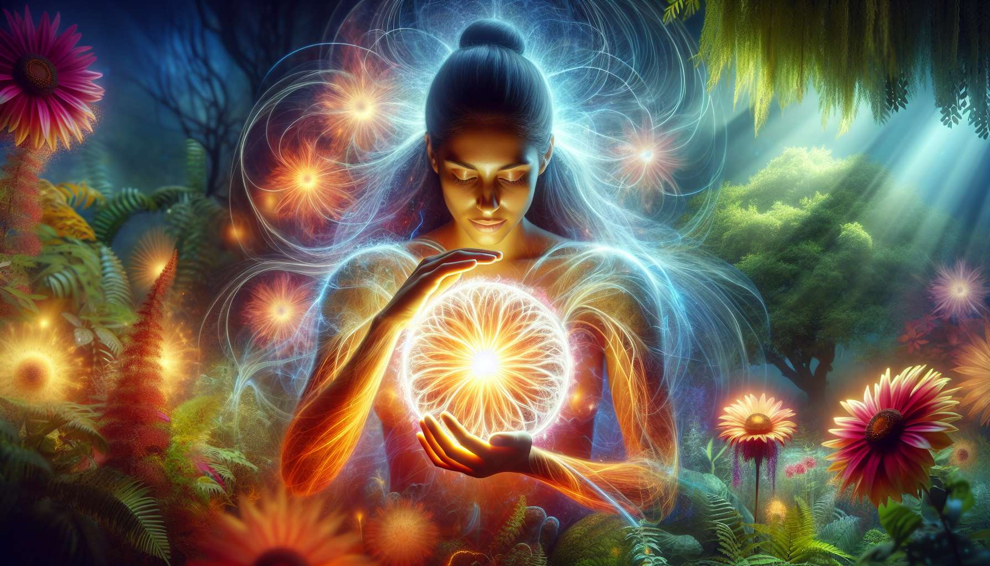

Channel 14, also known as the Vital Energy Channel, is formed by the connection of gates 27 and 50. It is a channel of the direction matrix, linking the sacral center to the spleen center. This channel provides a powerful and constant energy of vitality, the ability to nourish, and sustain life in all its forms.  
  
When this channel is defined, it imparts upon the individual an inexhaustible source of vital energy and a profound desire to share and put it to service for others. People with this defined channel are often healers, therapists, midwives who excel in the art of supporting, regenerating, and facilitating the natural processes of life. They have an innate gift for sensing the energy needs of beings and situations, and reacting to them in an appropriate and nourishing manner.  
  
However, this same vital energy can also manifest as a tendency to overwork, excessive selflessness, or neglect of their own needs. People with the Vital Energy Channel defined may have difficulty setting boundaries, saying no, or taking care of themselves before caring for others. They may also tend to absorb negative or toxic energies from their environment and wear themselves out trying to heal or save everything.  
  
Consider an example of a nurse with the Vital Energy Channel defined. She has an outstanding talent for soothing patients, relieving their pains, and promoting their healing with her mere presence and attentive care. Her vital energy seems inexhaustible when it comes to accompanying the sick and dying, comforting families and managing crisis situations. However, she can also struggle with chronic fatigue, sleep disorders, and recurrent illnesses, as she tends to give more than she receives. She needs to learn to listen to herself, respect her own rhythms, and regularly replenish her resources in order to continue providing her care with quality and longevity.  
  
For people with this defined channel, learning to manage their vital energy in a balanced and sustainable way is a significant challenge. They need to learn to discern when and how to share their vitality, set healthy boundaries, and take care of themselves as much as others. They also need to ensure that they are surrounded by positive and nourishing energies and protect themselves from toxic or energy-draining influences.  
  
This channel is closely tied to Channel 27 (Channel of Consciousness), which we will explore later. Together, these two channels form a powerful circuit of healing energy and bodily awareness. The Vital Energy Channel brings the ability to generate and transmit vitality, while the Consciousness Channel brings the ability to feel and understand the body's messages. When these two channels are defined, the individual has immense potential for healing and awakening through energy and somatic work.  
  
On the other hand, for people with the Vital Energy Channel open, the challenge is to learn to receive and benefit from others' vitality without being overwhelmed or destabilized by it. They can be excellent catalysts and energy amplifiers, using their sensitivity and receptivity to help others release and circulate their own vitality. However, they should be attentive not to let themselves be drained or energetically manipulated, and to distinguish between what belongs to them and what belongs to others.  
  
It is interesting to note that the Vital Energy Channel is associated with the theme of the cauldron and nutrition in the I Ching. Gates 27 and 50 are associated with the hexagrams of the "Cauldron" and the "Pot," which evoke images of containment, transformation, and the capacity to nourish and sustain life. This channel, therefore, carries a profoundly maternal and generous energy, which knows how to care for and promote growth in beings and things.  
  
Imagine a yoga teacher with the Vital Energy Channel defined. In her classes, she displays a warm and enveloping presence, able to put her students at ease and gently guide them in exploring their bodies and breath. Her vital energy seems to transmit through the mere sound of her voice and the caring precision of her adjustments, inviting everyone to connect with their own source of vitality and well-being. However, she may also tend to be drawn in by the needs and expectations of her students, accepting too many classes or workshops at the expense of her own balance. She needs to learn to honor her need for solitude and silence, to nourish herself from sources other than selflessness, and to inspire her students to become independent in their practice.  
  
In the end, the Vital Energy Channel is a precious source of vitality and capacity to nourish life in all its forms. But as with any powerful energy, it requires to be channeled with wisdom, discernment, and balance. By learning to honor our life force while respecting our limits and taking care of ourselves, we can use this channel to generate, share, and celebrate the life energy that passes through and connects us all. It is a real gift for those who have this channel defined, and an invitation to connect to the inexhaustible source of vitality within us and around us for all.  
  
Points to remember:  
  
- Channel 14, also known as the Vital Energy Channel, connects the sacral center to the spleen center and provides a powerful and consistent energy of vitality.  
  
- People with this defined channel have a gift for sensing the energy needs of others and responding in a nourishing way, but can also tend to give too much and neglect their own needs.  
  
- To manage this energy in a balanced way, it is crucial to learn to set limits, take care of oneself and regularly recharge.  
  
- The Vital Energy Channel is linked to Channel 27 (Channel of Consciousness), creating together a powerful circuit of healing energy and bodily awareness.  
  
- For people with this channel open, the challenge is to learn how to receive and benefit from others' vitality without being overwhelmed or destabilized.  
  
- This channel is associated with the themes of the cauldron and nutrition in the I Ching, carrying a maternal and generous energy that knows how to care and promote growth.  
  
- The vital energy of this channel must be channeled with wisdom, discernment, and balance, honoring our life force while respecting our limits and caring for ourselves.