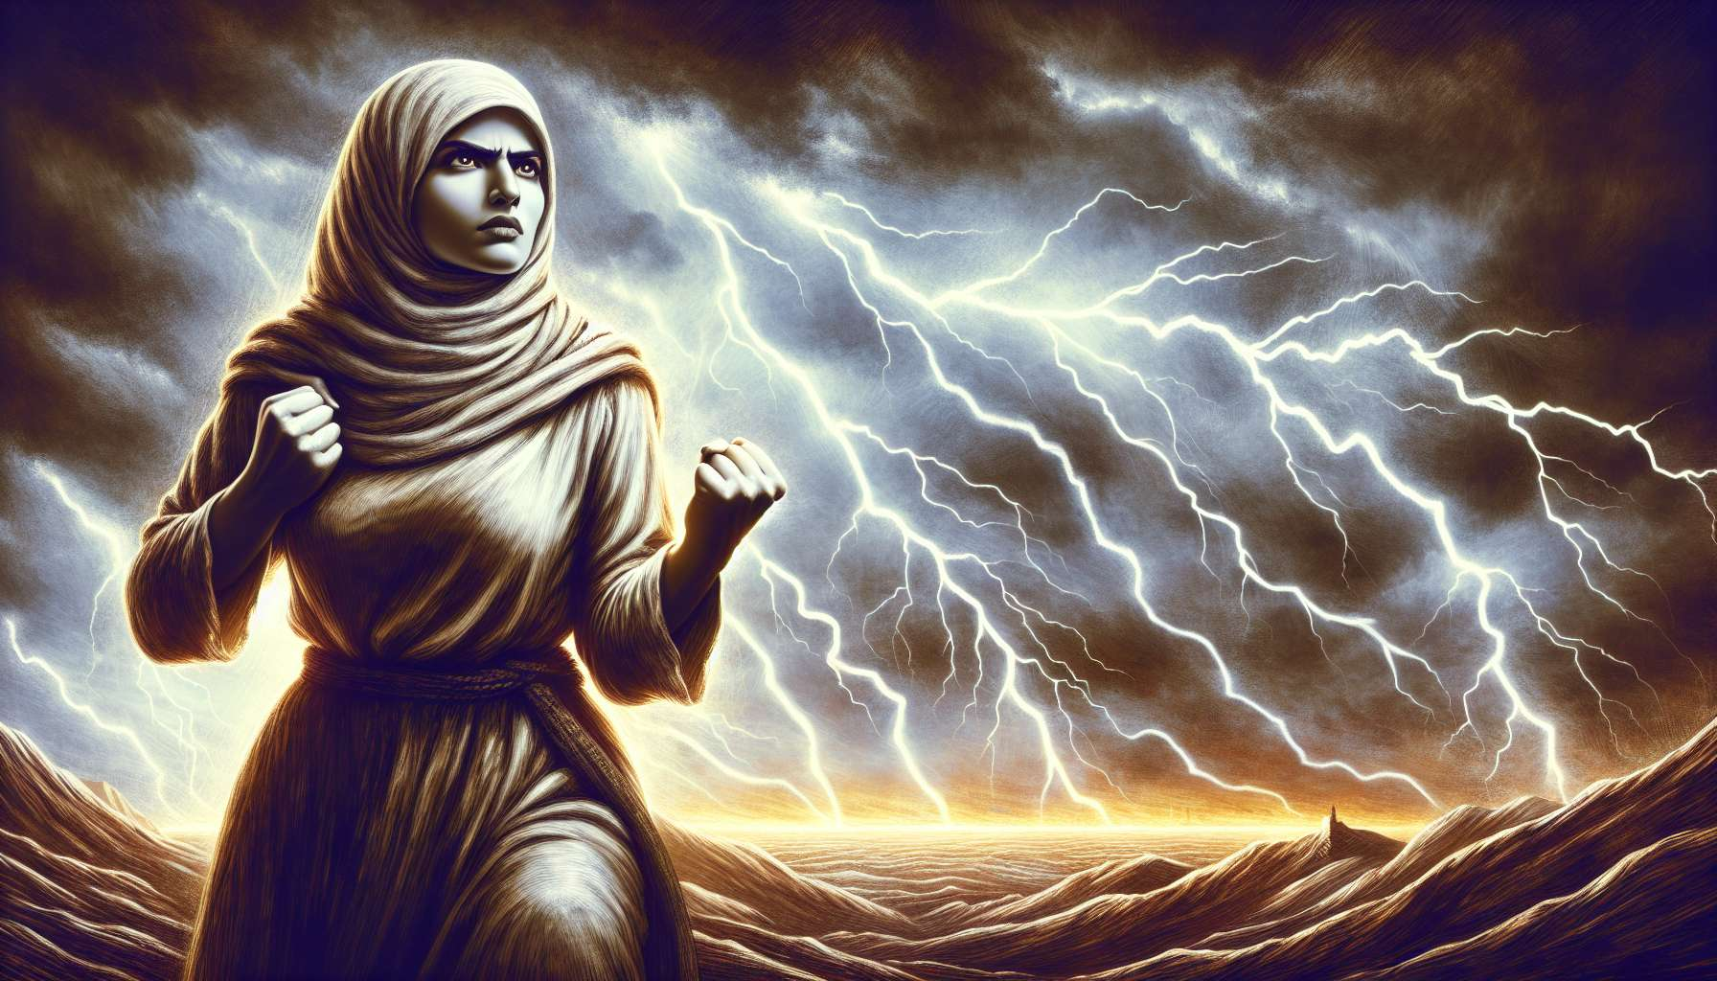

Channel 28, also known as the Struggle Channel, is formed by the connection of doors 28 and 38. It is a channel of the individuality matrix, which connects the spleen center to the throat center. This channel brings a powerful and constant energy of perseverance, ability to overcome obstacles, and fight for what is right.  
  
When this channel is defined, it gives the individual unwavering determination and invincible courage. People with this defined channel are often activists, entrepreneurs, high-level athletes who excel in the art of surpassing themselves and transforming challenges into opportunities. They have a gift for mobilizing their energy and will, to stay focused on their goal despite difficulties, and to inspire others by their example of tenacity.  
  
However, this same fighting energy can also manifest as a tendency to stubbornness, aggression, or exhaustion. People with the Struggle Channel defined may struggle to let go, to accept defeat, or to rest when necessary. They may also tend to see life as a constant struggle, to always be on the defensive, or to seek confrontation even when it's not useful.  
  
Let's take the example of a human rights lawyer with the defined Struggle Channel. In his fight against injustices, he shows remarkable commitment and resilience, ready to face threats, pressures, and failures to defend the causes that matter to him. His fighting energy allows him to speak up for the oppressed, to stand up to the powers that be, and to create legal precedents that advance law and society. However, he may also struggle to find a work-life balance, to step back and rest or to leave room for dialogue and compromise when necessary. He needs to learn to pick his battles, to conserve his energy to last, and to accept that he can't win everything on his own.  
  
For people with this defined channel, learning to live their fighting energy strategically and sustainably is a significant challenge. They need to learn to choose their battles wisely, to mobilize their resources intelligently, and to surround themselves with allies and supports over time. They must ensure not to identify with their fights to the point of losing themselves, but to stay connected to their humanity and their other basic needs. Finally, they must cultivate their inner resilience, their ability to bounce back and find meaning even in trials and failures.  
  
This channel is closely tied to Channel 1 (Channel of Will) that we previously explored. Together, these two channels form a powerful circuit of determination and self-realization energy. The Struggle Channel brings the ability to face adversity and to surpass oneself, while the Channel of Will brings the ability to remain faithful to one's direction and decisions. When these two channels are defined, the individual has immense potential for success and impact, combining strength of character and perseverance in effort.  
  
On the other hand, for people with the Struggle Channel open, the challenge is to learn to benefit from the combative energy of others without being drawn into struggles that are not their own. They can be excellent mediators and diplomats, bringing their ability to soothe tensions and find peaceful solutions. However, they must ensure not to systematically avoid conflicts for fear of confrontation, but to dare to defend their values and boundaries when it's important.  
  
It is interesting to note that the Struggle Channel is associated with the theme of perseverance and self-improvement in I Ching. Gates 28 and 38 are associated with the hexagrams of the "Preponderance of the Great" and "Opposition", which evoke images of strength, tenacity in the face of adversity, and the ability to rise after falling. This channel therefore carries deeply heroic and transformative energy, knowing how to transmute trials into opportunities for growth.  
  
Let's imagine a business owner with the defined Struggle Channel. In her entrepreneurial journey, she had to face many challenges and setbacks: lack of funding, partner betrayals, product failures, attacks from competitors... Her fighting energy allowed her to hold on despite everything, to always find creative solutions, and to rally her teams during tough times. Today, her company is a recognized leader in its market, and her story is a source of inspiration for many. However, she realizes she has trouble delegating, trusting, and letting the new generation take over. She needs to learn to see transmission as a new challenge, and to put her fighting energy into personal growth.  
  
In the end, the Struggle Channel is a valuable source of perseverance energy and the ability to turn obstacles into springboards. But as with any powerful energy, it needs to be channeled with discernment, stamina, and a sense of measure. By learning to honor our combativeness while cultivating our inner peace, we can use this channel to achieve great things and inspire the best in everyone. It's a real asset for those who have this channel defined, and an invitation to develop our resilience and sense of fair fights for everyone.  
  
Key points to remember :  
  
- Channel 28, also called the Struggle Channel, connects the spleen center to the throat center and brings an energy of perseverance and ability to overcome obstacles.  
  
- When it's defined, this channel gives unwavering determination and invincible courage but can also lead to stubbornness, aggression, or exhaustion.  
  
- People with this defined channel need to learn to live their fighting energy strategically and sustainably, by choosing their battles, surrounding themselves with allies, and cultivating their inner resilience.  
  
- The Struggle Channel is linked to Channel 1 (Channel of Will), forming together a powerful circuit of determination and self-realization energy.  
  
- For people with the Struggle Channel open, the challenge is to learn to benefit from the combative energy of others without being drawn into battles not their own, while daring to defend their values when it's important.  
  
- This channel is associated with the theme of perseverance and self-improvement in the I Ching, carrying heroic and transformative energy.  
  
- The energy of the Struggle Channel must be channeled with discernment, stamina, and a sense of measure, honoring our combativeness while cultivating our inner peace.