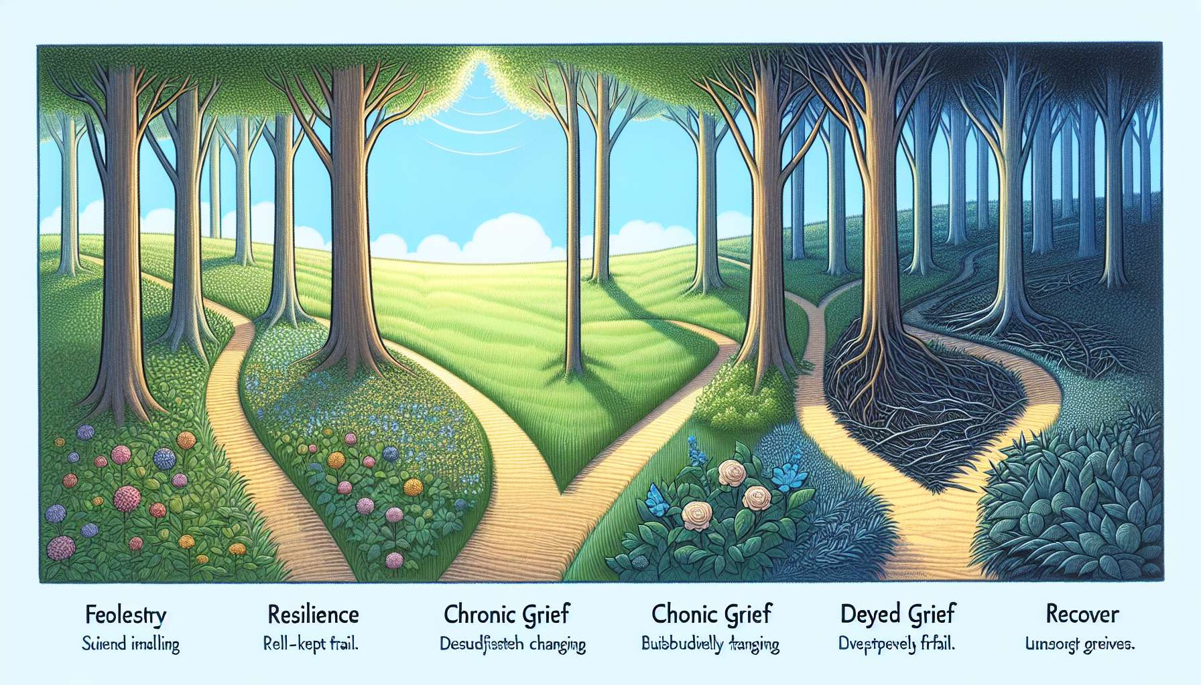

Sub-module 4.5 - The Four Grief Trajectories: Resilience, Chronic Grief, Delayed Grief, and Recovery  
  
George Bonanno's model of grief trajectories suggests four distinct paths that bereaved individuals can take following the loss of a loved one: resilience, chronic grief, delayed grief, and recovery. Each of these trajectories reflects a unique way of experiencing and adjusting to grief, with its own challenges and resources. Understanding these different paths allows a GRIEF COACH to tailor their support and propose interventions suited to the specific needs of each bereaved individual.  
  
The resilience trajectory is defined by an ability to deal with the loss with relative emotional stability and to maintain normal functioning across various aspects of life. Resilient people experience sadness and grief but manage to handle these emotions appropriately and gradually regain balance. They can rely on their internal resources, such as emotional regulation, cognitive flexibility or their sense of coherence, as well as on their external resources, such as their social support network or their involvement in meaningful activities. For example, a resilient person who has lost their spouse may continue to commit to their work, take care of their children, and maintain their friendships all while privately grieving in their own way. A GRIEF COACH can assist these individuals in identifying and mobilizing their strengths, cultivating their self-compassion, and finding ways to honor the memory of the deceased.  
  
The chronic grief trajectory, on the other hand, is characterized by intense and persistent distress, which hinders daily functioning and long-term well-being. People with chronic grief can experience overwhelming and uncontrollable emotions, such as devastating sadness, destructive anger, or paralyzing guilt. They may struggle to accept the reality of the loss, to find meaning in their life without the deceased, and to invest in new projects. They may also show symptoms of depression, anxiety, or post-traumatic stress disorder. For example, a person suffering from chronic grief after losing their child may sink into deep despair, neglect their health and relationships, and have trouble fulfilling their responsibilities. A GRIEF COACH can offer these people more intensive therapeutic support, emotional regulation techniques, exploration of distress maintaining factors, and help them slowly rebuild their lives.  
  
The delayed grief trajectory is characterized by a late and unexpected grief reaction. People with delayed grief may appear to function normally at first, even demonstrating an apparent absence of emotional distress. However, after a more or less lengthy latency period, they may suddenly experience intense distress and acute grief symptoms. This delay may be due to initial avoidance of painful emotions, lack of social support, or accumulation of stressors. For example, a person with delayed grief who has lost a sibling may immerse themselves in frenzied activities for a year, then emotionally collapse on the anniversary of the death. A GRIEF COACH can provide these individuals with a safe space to welcome late emotions, explore the reasons for the delayed grief, and help them gradually integrate the loss into their life story.  
  
The recovery trajectory, on the other hand, is characterized by initially high distress, which gradually diminishes over time to make way for a return to normal functioning. People in recovery can experience intense and painful emotions in the early stages of grief, but gradually manage to handle them appropriately and regain balance. They may go through ups and downs, but overall follow an upward curve towards well-being. They may also alternate between loss-focused and restoration-focused moments, as described by Stroebe and Schut's dual process model. For example, a person in recovery who has lost their mother may cry frequently, have difficulty concentrating at work initially, then gradually regain their appetite for life, reconnect with their passions, and form new emotional connections. A GRIEF COACH can support these individuals in their journey, by normalizing their emotions, helping them find a balance between grief and everyday life, and valuing their progress.  
  
It is crucial to note that these trajectories are not fixed and a person can move from one to the other during their grief. Some people may also show characteristics of several trajectories at once. Moreover, there is no hierarchy among these trajectories: each represents a unique and legitimate way of grieving. The role of the GRIEF COACH is to meet the bereaved individual where they are, validate their experience, and accompany them along a healing path, at their own pace and according to their needs.  
  
Drawing on Bonanno's model of grief trajectories, the GRIEF COACH has a valuable framework to understand the diversity of reactions to loss and adjust their support accordingly. They can help bereaved individuals to identify their own trajectory, mobilize their resources, and find coping strategies suited to their situation. By providing tailored and compassionate support, the GRIEF COACH can facilitate a more harmonious and meaningful grieving process, regardless of the path taken.  
  
Key points to remember:  
  
- George Bonanno's grief trajectory model outlines four distinct paths following the loss of a loved one: resilience, chronic grief, delayed grief, and recovery.  
  
- The resilience trajectory is characterized by relative emotional stability and maintaining functioning despite grief, thanks to the person's internal and external resources.  
  
- The chronic grief trajectory is marked by intense and persistent distress that hinders daily functioning and long-term well-being.  
  
- The delayed grief trajectory is manifested by a late and unexpected grief reaction, following a latency period and seemingly normal functioning.  
  
- The recovery trajectory is characterized by initially high distress that gradually lessens to allow a return to normal functioning.  
  
- These trajectories are not set in stone: a person can transition from one to another during their grief. There is no hierarchy among them, each one being a legitimate way of experiencing grief.  
  
- The GRIEF COACH must adapt their support to each bereaved individual's trajectory, helping them identify their journey, mobilize their resources, and find appropriate coping strategies to facilitate a harmonious grieving process.