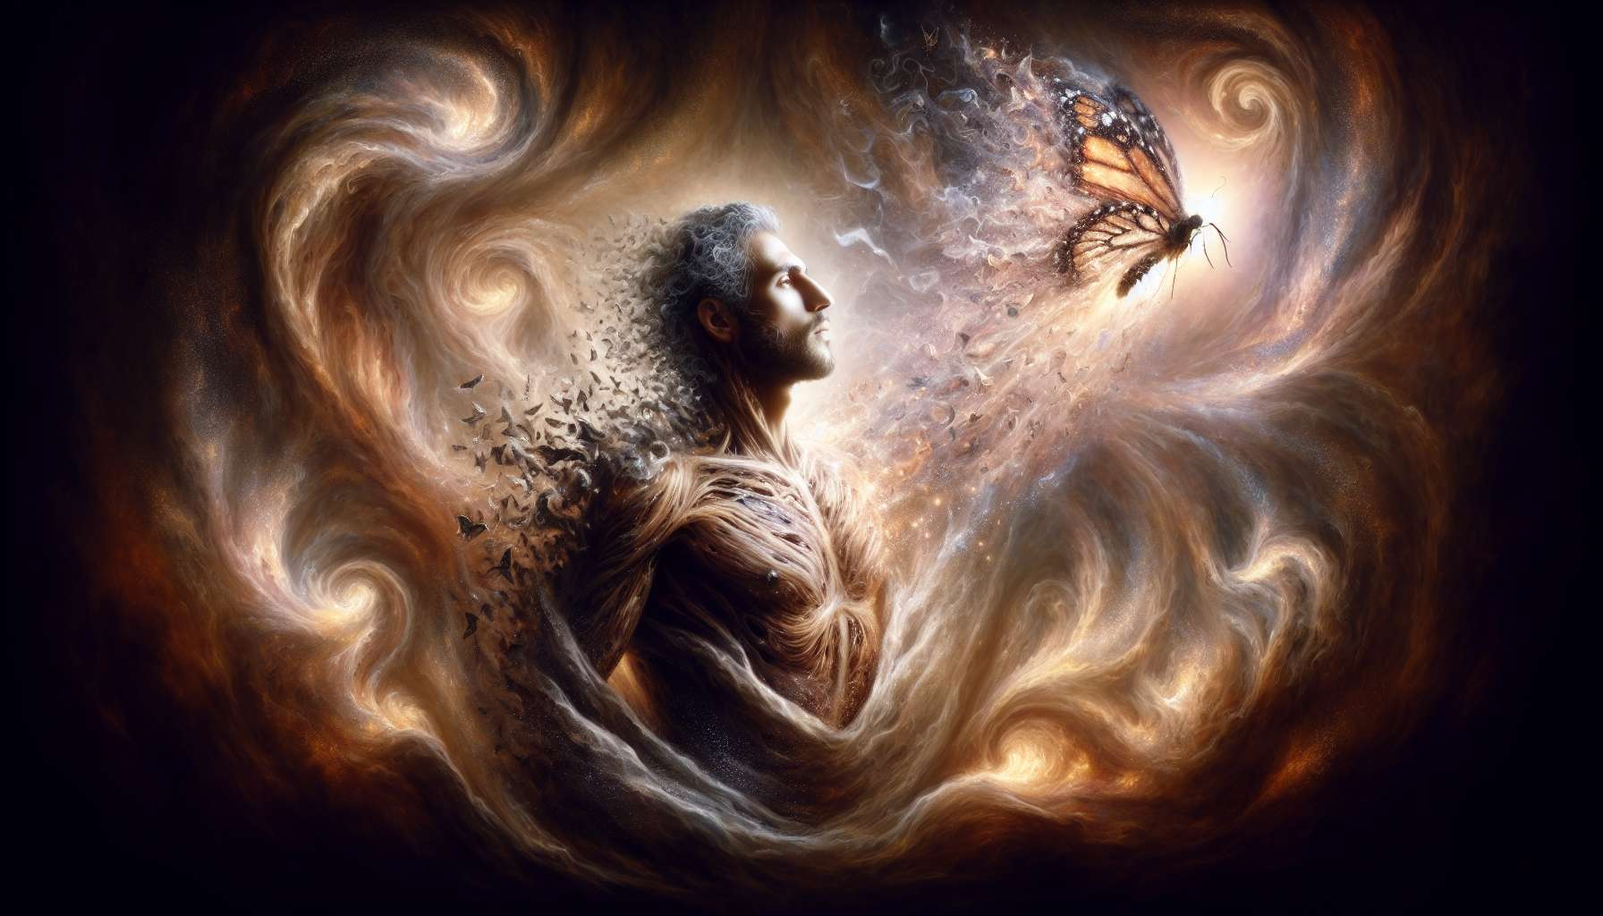

Channel 32, also known as the Transformation Channel, is formed by the connection of gates 32 and 54. It is a channel of the matrix of form, connecting the throat center to the sacral center. This channel brings a powerful and constant energy of metamorphosis, the ability to catalyze profound changes in oneself and in the world.  
  
When this channel is defined, it gives the individual an innate potential to be an agent of transformation and evolution. People with this defined channel are often therapists, artists, innovators who excel in the art of transmuting blockages into opportunities for growth. They have a gift for seeing the potential for change in every situation, for accompanying mutation processes with patience and wisdom, and for inspiring others to embrace their own transformation.  
  
However, this same transformation energy can also manifest as a tendency to instability, provocation, or hastening of crises. Individuals with the defined Transformation Channel may struggle to accept phases of stability or plateau, to allow time for processes to unfold, or to respect the pace of change of others. They may also tend to get lost in permanent changes, risking the loss of their center and sense of continuity.  
  
Let's take the example of a dancer with the defined Transformation Channel. In her art, she is recognized for her ability to embody and express the most subtle and profound metamorphoses of the human soul. Her transformation energy allows her to transcend the limits of her body, to reinvent herself at every moment, and to transport the audience into spaces of catharsis and renewal. Her dance is a powerful mirror that reveals and transmutes the parts of shadow and light in everyone. However, in her personal life, she may struggle to find stability and security, to commit in the long term, or to feel at peace with herself. She must learn to anchor herself in her center despite movement, to find constancy in impermanence.  
  
For individuals with this defined channel, learning to live their transformation energy in a balanced and integrated way is a significant challenge. They must learn to honor their need for change while respecting their need for coherence and grounding. They must be careful not to be fascinated by transformation for its own sake, but to always put it in the service of a positive and meaningful evolution. Finally, they must cultivate their ability to accompany others with compassion and non-judgment, respecting their freedom and unique path.  
  
This channel is closely linked to Channel 3 (Mutation Channel) that we have previously explored. Together, these two channels form a powerful circuit of change and renewal energy. The Transformation Channel brings the ability to catalyze and accompany metamorphoses, while the Mutation Channel brings the ability to adapt and regenerate through crises. When these two channels are defined, the individual has an immense potential for personal evolution and transformative impact on their environment, combining depth and resilience.  
  
On the other hand, for individuals with the Transformation Channel open, the challenge is to learn to rely on the wisdom and stability of others, without renouncing their own need for evolution. They can be excellent witnesses and supporters of change processes, providing reassuring presence and unwavering faith in everyone's potential for growth. However, they must be careful not to become rigid in comfort or fear of movement, and to dare to question and transform themselves as well.  
  
It is interesting to note that the Transformation Channel is related to the theme of duration and eternity in the I Ching. Gates 32 and 54 are associated with the hexagrams of "Duration" and "Young Bride," which evoke images of fidelity, maturation, and the ability to navigate life's cycles and trials to continually rebirth oneself. This channel therefore carries a profoundly initiatory and alchemical energy, which knows how to transmute lead into gold, suffering into wisdom.  
  
Imagine a writer with the defined Transformation Channel. In his novels, he explores with startling acuity and accuracy the meanderings of the human psyche, the darkest and brightest passages that each being is called to go through in their evolution journey. His transformation energy allows him to step into the shoes of characters in full metamorphosis, to reveal the invisible threads that connect destinies, and to bring the reader face to face with their own areas of shadow and light. His stories are initiatory mirrors that elevate and transform those who read them. However, in his writing process, he may tend to constantly question everything, never find his words accurate enough, or want to upheave everything with each new version. He must learn to trust his creative intuition, to accept imperfection in order to complete his works, and to release each book in order to write the next one.  
  
In the end, the Transformation Channel is a valuable source of evolution energy and ability to transmute trials into growth opportunities. But like with any powerful energy, it demands to be channeled with wisdom, patience, and inner grounding. By learning to honor our need for metamorphosis while cultivating our stability and faith in life, we can use this channel to become alchemists of our own existence and that of others. It is a real art of living and accompanying transformation processes for those who have this channel defined, and an invitation to embrace change with confidence and openness for everyone.  
  
Here is a summary of the key points to remember about Channel 32 or the Transformation Channel:  
  
Key Points to remember:  
  
- Channel 32 connects the throat center to the sacral center and brings an energy of metamorphosis and catalyst of change.  
  
- When defined, it offers a potential to be an agent of transformation of oneself and others, but can also bring instability.  
  
- Individuals with this defined channel excel at accompanying mutation processes but can struggle with phases of stability and the pace of change of others.  
  
- They must learn to balance their need for change with constancy and inner grounding, and to put transformation in service of positive evolution.  
  
- This channel is linked with the Mutation Channel 3, together forming a powerful circuit of renewal energy combining depth and resilience.  
  
- For those with this channel open, the challenge is to support the change processes of others while daring to transform themselves as well.  
  
- Channel 32 carries an initiatory and alchemical energy of trials transmutation into wisdom, related to the themes of duration and maturation of the I Ching.  
  
- This powerful transformation energy demands to be channeled with wisdom, patience and grounding to make it an art of living and accompanying metamorphoses.