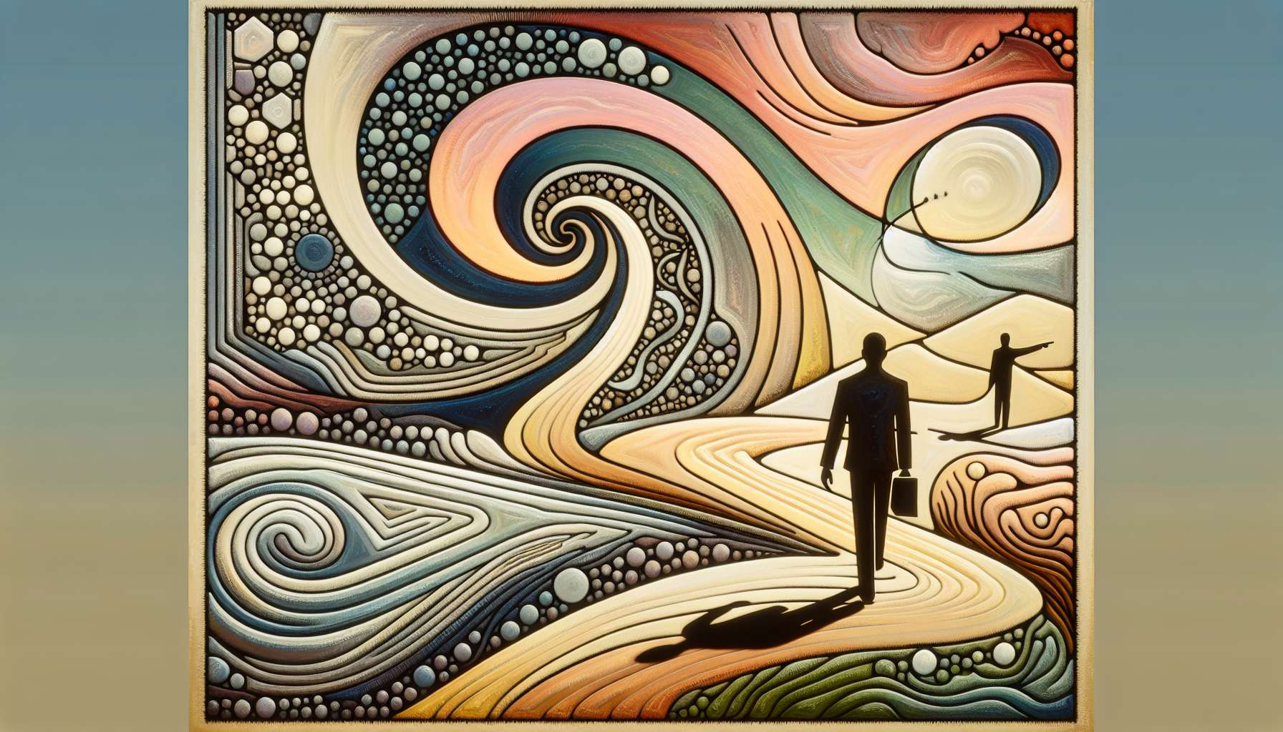

The "Profiles and Life Themes" sub-module is a fascinating exploration of how our Human Design profiles shape and reflect the overarching themes and recurring lessons of our existence. Each profile, with its unique combination of conscious and unconscious lines, qualities and challenges, predisposes us to certain types of experiences, relationships and life paths. Understanding these themes can help us make sense of our journey, navigate our challenges with more grace, and embrace our unique potential with greater clarity and confidence.  
  
One of the most powerful life themes associated with profiles is that of learning and growing through contrasts and polarities. Each profile contains within itself a dynamic tension between two different energies or qualities, represented by the two lines. For a 4/1 profile (Opportunist Investigator), for example, there is a tension between the desire to seize opportunities (line 4) and the need to seek truth and knowledge (line 1). For a 6/2 profile (Role Model Hermit), there is a tension between the desire to be an example and guide for others (line 6) and the need to withdraw to connect with inner wisdom (line 2). It is often through navigating and integrating these polarities that we grow and evolve the most.  
  
Another key life theme tied to profiles is that of vocation and unique contributions. Each profile has a specific role and gift to offer the world, which is intimately related to the combination of its lines and qualities. For a 5/1 profile (Heretic Investigator), this contribution might be to challenge the status quo and bring new perspectives and truths. For a 3/6 profile (Martyr Role Model), this contribution may be to inspire and guide others through the example of their own sacrifice and dedication. Discovering and embracing this unique vocation is often a central theme of individuals' life journeys, which can manifest through their career choices, relationships, passions, and challenges.  
  
Relationships and interactions are another area where profile themes play out powerfully. Each profile has its own way of approaching and experiencing relationships, with its specific strengths and challenges. For a 2/4 profile (Opportunist Hermit), a key relational theme could be learning to balance their need for independence and withdrawal (line 2) with their desire for connection and opportunities (line 4). For a 6/3 profile (Role Model Martyr), a relational theme could be learning to be an example and guide for others (line 6) while attending to their own needs and boundaries (line 3). Relationships often become the arena where we play out and integrate the lessons of our profile in the most intense and transformative way.  
  
It is important to note that these life themes are not fixed destinies or limitations, but rather invitations to growth and self-expression. They offer us a map to understand the territories we are most likely to explore in this life, but how we explore them remains our choice and responsibility. Two individuals with the same profile can live these themes very differently depending on their other aspects of design, their environment, and their choices.  
  
Take the example of a person with a 3/5 profile (Martyr Heretic). A key life theme for this profile could be learning to fight and sacrifice for a larger cause or truth (lines 3 and 5). However, how this theme manifests can vary greatly. One person might express it by becoming a political activist, openly fighting for social justice at the cost of their own safety and comfort. Another might express it by becoming a revolutionary artist, creating works that question social norms and inspire change, while grappling with rejection and misunderstanding. Another yet might express it by becoming an innovator in the business world, creating disruptive products or services that challenge the status quo, at the cost of long working hours and personal risks. Even though the underlying theme is similar, its expression is deeply personal.  
  
Ultimately, studying profiles and life themes is an invitation to embrace the unique journey of our soul and to find meaning and direction in the recurring patterns of our existence. It’s an opportunity to turn our greatest challenges into our biggest growth opportunities, and to recognize our unique gifts and contributions. By approaching our profile with curiosity, compassion, and openness, we can learn to navigate our life themes with more grace, resilience, and authenticity, and to live our unique design in the most fulfilling and impactful way possible.  
  
So, whether you’re exploring your own profile themes or working with those of others, remember that each profile is an invitation to a unique journey of learning, contribution, and becoming. Honor the themes and lessons that show up in your life or others', but do not let them define or limit you. Use them as guides and allies in your personal evolution journey, always remembering that you are both the traveler and the ultimate creator of your story. This is where the true magic and potential of Human Design resides.  
  
Key points to remember :  
  
- Human Design profiles reflect each one's overarching themes and life lessons, predisposing us to certain types of experiences, relationships, and paths.  
  
- A key theme is learning and growing through contrasts and polarities represented by the two lines of each profile. Navigating and integrating these polarities is a source of evolution.  
  
- Each profile has a unique vocation and contribution to offer the world, tied to the combination of its lines and qualities. Discovering this vocation is a main theme of life journey.  
  
- Relationships are an arena where profile themes intensely play out, with each profile having its own way to approach relationships with its specific strengths and challenges.  
  
- These themes are invitations to growth, not fixed destinies. Two people with the same profile can experience them very differently depending on their choices.  
  
- Studying profiles allows embracing one's unique soul journey, giving meaning to recurring patterns of life, and turning challenges into growth opportunities.  
  
- Profile themes are guides in our personal evolution but should not limit us. We are both the traveler and the creator of our story.