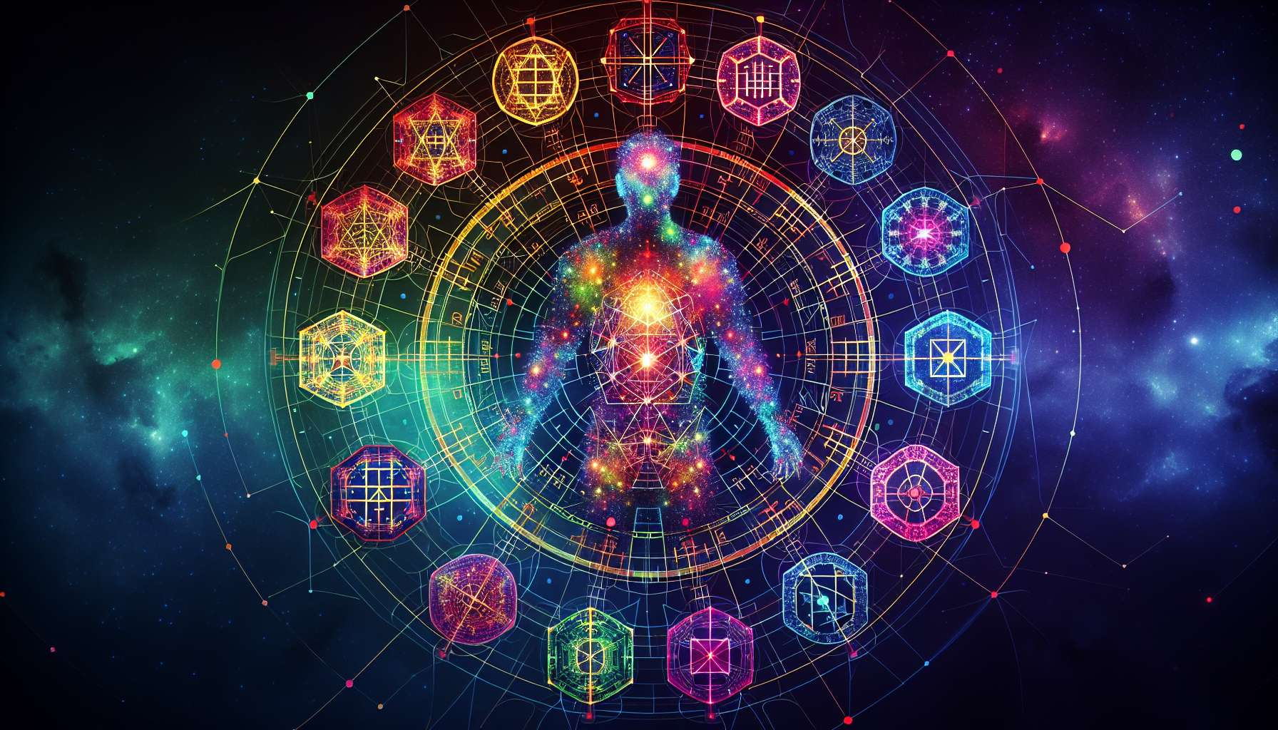

The I Ching, or "Book of Changes," is an ancient Chinese text that plays a central role in Human Design. This work, composed of 64 hexagrams, has been used for millennia for divination and philosophical wisdom. Each hexagram represents a specific state or situation, with its challenges and opportunities.  
  
In Human Design, each of the 64 hexagrams of the I Ching corresponds to a "gate" in the BodyGraph. These gates represent different energies and life themes that we may experience. When a gate is activated in our BodyGraph by a planet, it means we have access to the energy of that gate.  
  
For example, gate 1, which corresponds to the first hexagram of the I Ching, is called "Creativity." When activated, it brings an energy of creativity and inspiration. Gate 2, on the other hand, is called "The Receptivity" and brings an energy of cooperation and sensitivity.  
  
Each gate has its own meaning and theme. Some gates are related to self-expression, others to communication, knowledge, relationships, intuition, etc. Understanding the meaning of each gate is essential for interpreting a BodyGraph and for understanding the energies that drive us.  
  
It is interesting to note that opposite gates in the BodyGraph (such as gate 1 and gate 2, or gate 3 and gate 60) often represent complementary energies. When two opposite gates are connected by a defined channel, this creates a constant energy in our life.  
  
The I Ching hexagrams bring an incredible depth and nuance to Human Design. They allow us to understand the different facets of our being and how we interact with the world. Each activated gate in our BodyGraph tells a unique story about who we are and what we are here to experience.  
  
Consider the example of a person with gate 5 (Waiting) and gate 35 (Progress) activated and connected by a defined channel. This person will have a constant energy around the themes of patience and progress. They will naturally be skilled at waiting for the right time to act and progressing steadily and consistently towards their goals.  
  
In studying the I Ching and its relationship with Human Design, we open a door to a deeper understanding of ourselves and our place in the universe. It is an ancient system and yet incredibly relevant to our time, offering us a map to navigate the sometimes tumultuous waters of life.  
  
  
Key takeaways:  
  
- The I Ching, an ancient Chinese text composed of 64 hexagrams, is at the heart of Human Design. Each hexagram corresponds to a "gate" in the BodyGraph, representing different energies and life themes.  
  
- When a gate is activated in a BodyGraph by a planet, it means that the individual has access to the energy of that gate. Understanding the meaning of each gate is essential for interpreting a BodyGraph and the energies that drive an individual.  
  
- Opposite gates in the BodyGraph often represent complementary energies. When two opposite gates are connected by a defined channel, this creates a constant energy in the individual's life.  
  
- The I Ching hexagrams bring depth and nuance to Human Design, allowing for understanding of the different facets of our being and our interaction with the world. Each activated gate tells a unique story about an individual's identity and purpose.  
  
- Studying the I Ching and its relationship with Human Design offers a deeper understanding of oneself and one's place in the universe, providing a map for navigating life.