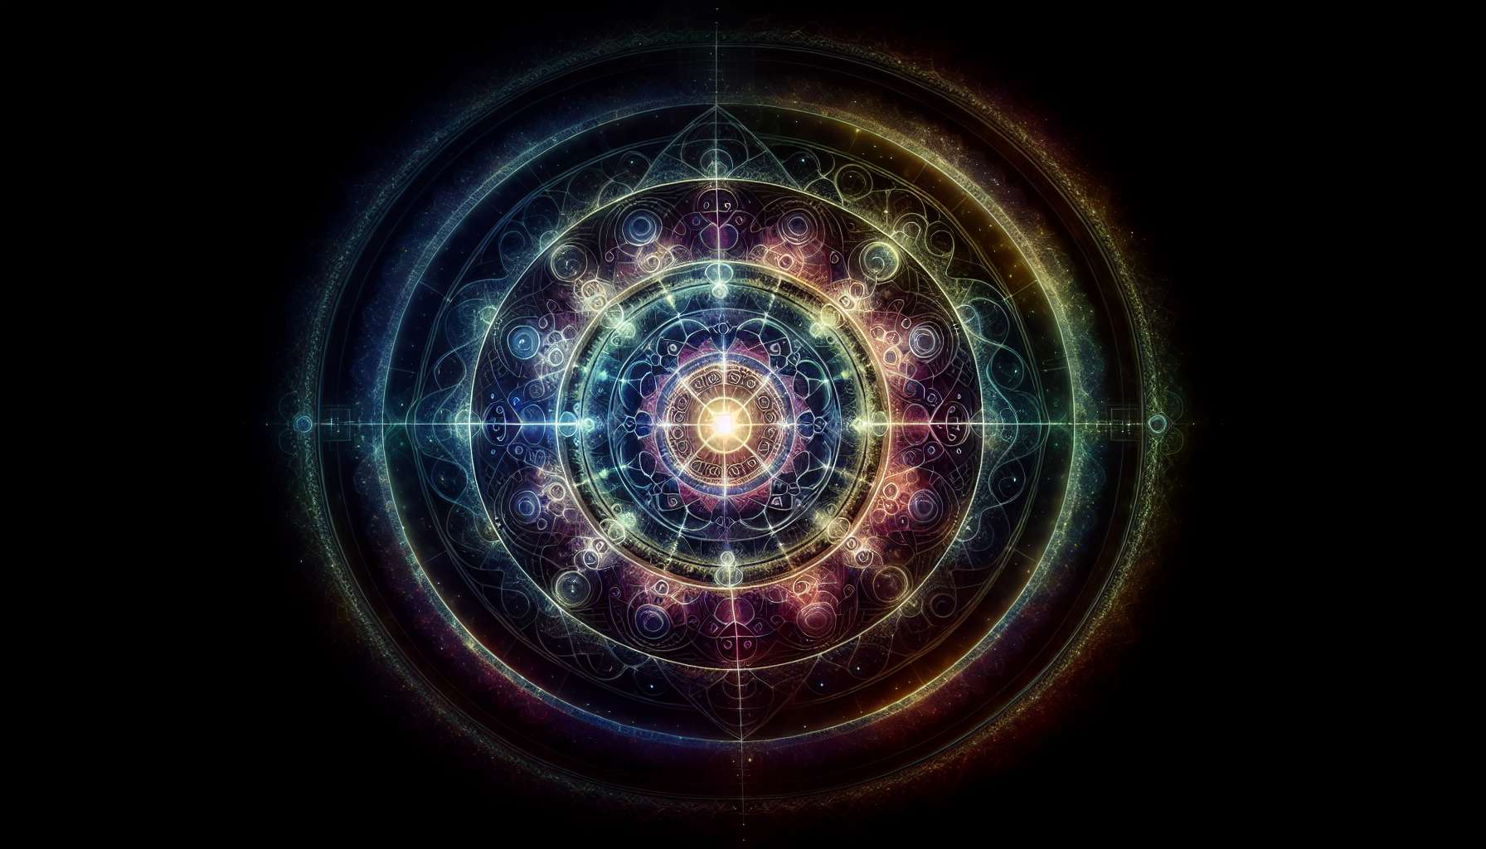

The G Center, located directly above the sacral center in the BodyGraph, is a mysterious and profound center that represents our identity, direction, and love. It is the seat of our essential identity, the place where we discover who we truly are beyond societal conditioning and expectations. The G Center is our internal compass, guiding us towards our true north.  
  
When the G center is defined, that is, when there is an activated gate, the person has a clear sense of their direction and identity. They know who they are and what they came to do in this life. People with a defined G center often have a magnetic and charismatic presence. They attract others with their sense of identity and clear direction.  
  
However, this definition can also create rigidity and resistance to change. Those with a defined G center may struggle to adapt to changing circumstances and may cling to an identity that no longer serves them. They may also tend to impose their direction onto others.  
  
When the G center is open, the person does not have this innate sense of identity and direction. Instead, they are open to the influence and direction of others. They can absorb the identity energies of their environment and may struggle to know who they truly are. People with an open G center are often highly adaptable and flexible, as they don't have a rigid identity to maintain.  
  
However, they can also feel lost and directionless, constantly searching for an identity to adopt. They can be easily influenced by the expectations of others and may struggle to make decisions on their own.  
  
A key aspect of the G Center is its relationship with love and direction. When we are in alignment with our true identity, we can experience unconditional love for ourselves and others. We can also find our true direction in life, a direction that is in harmony with who we truly are.  
  
For example, consider a person with a defined G Center who has always known they wanted to be a doctor. From a young age, they were drawn to healing and serving others. Despite obstacles and challenges, they never strayed from this path because they knew deep down that it was their true direction. Their clear sense of identity and direction allowed them to overcome difficulties and realize their dream.  
  
On the other hand, someone with an open G center might struggle to choose a career. They might try different jobs and fields, absorbing influences and expectations from their surroundings. They might feel lost and aimless until they learn to connect with their own inner truth and make choices aligned with it.  
  
Understanding your G center is a profound journey of self-knowledge. Whether the G center is defined or open, it's important to learn to listen to your own inner voice and honor your true self. By aligning with our essential identity and direction, we can live a life of love, purpose, and fulfillment.  
  
The G Center is closely related to the themes discussed in the "Introduction to Human Design" module, especially the concepts of uniqueness and life strategy. By understanding our G Center, we can begin to live our unique design and follow our life strategy with more clarity and confidence.  
  
Key points to remember:  
  
1. The G Center, located above the sacral center in the BodyGraph, represents our identity, direction, and love.  
  
2. When the G Center is defined (with an activated gate), the person has a clear sense of their identity and direction. They may have a magnetic and charismatic presence, but can also be rigid and resistant to change.  
  
3. When the G Center is open, the person is open to the influence and direction of others. They are adaptable and flexible, but can feel lost and directionless, constantly searching for an identity to adopt.  
  
4. Aligning with our true identity allows us to experience unconditional love for ourselves and others, as well as find our true direction in life.  
  
5. Understanding your G center is a profound journey toward self-knowledge, whether it is defined or open. It is important to listen to your inner voice and honor your true self.  
  
6. The G Center is related to the concepts of uniqueness and life strategy outlined in the introduction to Human Design. Understanding your G Center aids in living out your unique design and following your life strategy with more clarity and confidence.