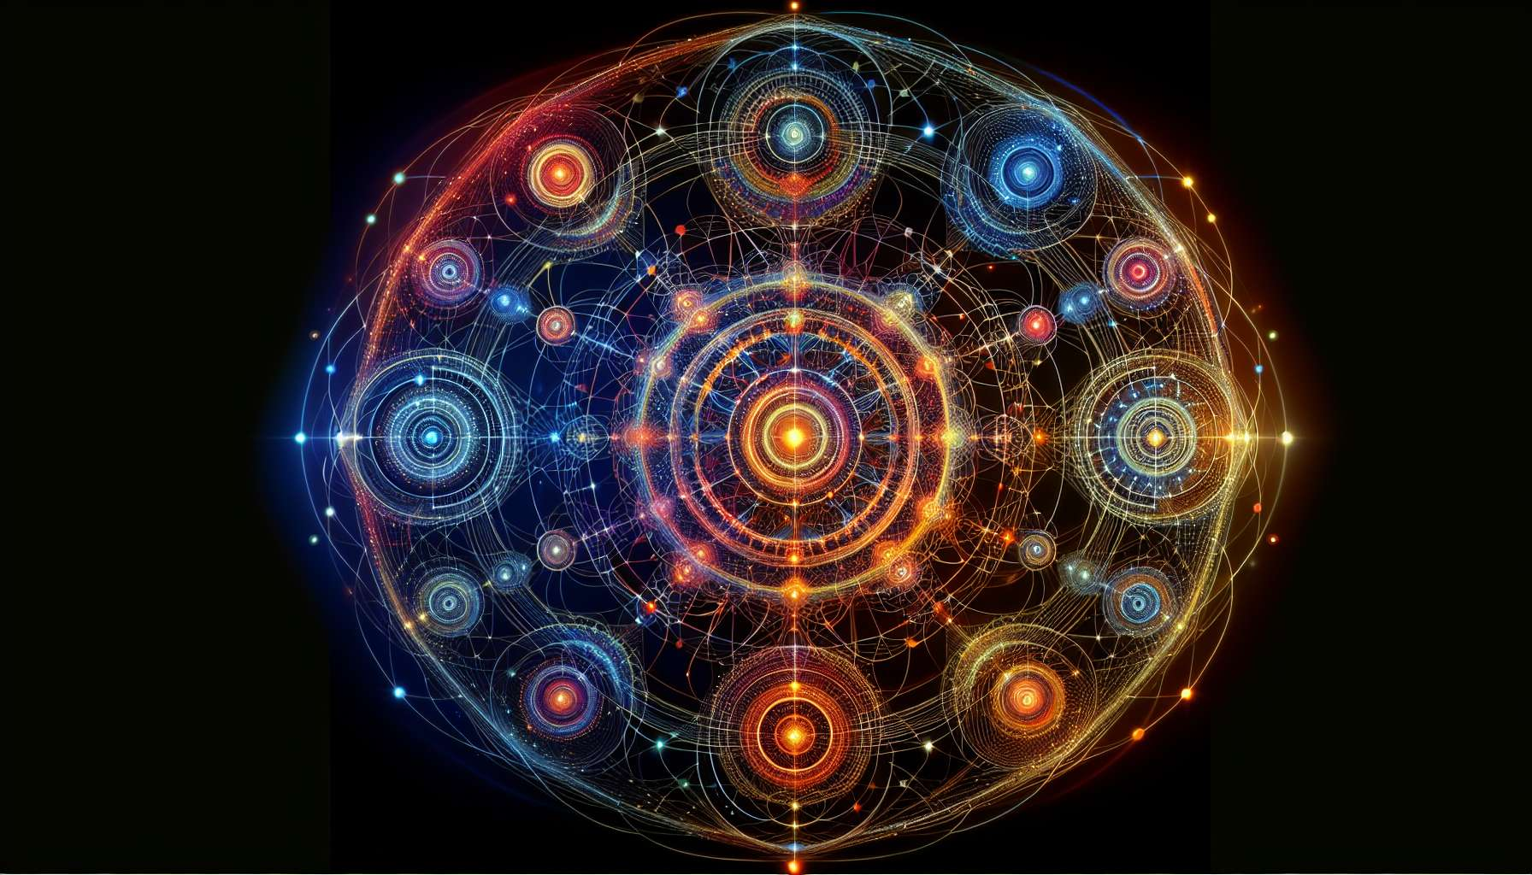

The submodule "Defined Gates and Their Themes" is a fascinating exploration of the meaning and impact of activated gates in a BodyGraph. Each of the 64 gates in the Human Design carries a specific energy and life theme, which are uniquely expressed when defined in an individual. Understanding these themes is essential for deeply interpreting a BodyGraph and for accompanying a person in their life journey.  
  
When a gate is defined, it means that it is consistently and sustainably activated in the BodyGraph. The energy and themes of this gate are therefore an integral part of the person's identity and life experience. They will tend to manifest the qualities and challenges associated with this gate recurrently, in different areas of their life.  
  
For example, a person with gate 1 defined, the gate of Creativity, will have constant access to creative and inspired energy. They will naturally be driven to innovate, initiate new projects, and express their creativity in the world. However, they may also be faced with the challenge of over-stimulation, dispersion, or difficulty in materializing their ideas.  
  
Each defined gate thus tells a unique story, a life fabric that unfolds and plays out at different levels. Gate 2, the gate of Direction, will speak of the ability to guide and influence others. Gate 10, the gate of Self-Love, will evoke the theme of self-esteem and the valorization of one's identity. Gate 15, the gate of Modesty, will touch on humility and the right place within the group. And so on for each of the 64 gates.  
  
It is important to note that the gate themes are not fixed destinies, but potentials for experience and learning. Each individual will live and integrate these themes uniquely, depending on their history, their other definitions, and their level of consciousness. Two people with the same defined gate can thus express it in very different ways.  
  
Defined gates are also in constant interaction with open gates and channels in the BodyGraph. A defined gate connected to another defined gate will form a channel, bringing constant energy into a particular area of life. A defined gate connected to open gates will be a source of energy and learning for others. Each configuration thus brings nuanced and subtle dynamics in the expression of gate themes.  
  
Take the example of a person with a defined 34-20 channel, the Channel of Determination. They will have a life theme related to perseverance, the ability to overcome obstacles to achieve their goals. This determination energy will be constant and defined, allowing them to carry out large projects over time. However, if their gate 10 is open, not connected, they may face challenges around self-esteem, sometimes doubting their worth despite their achievements. Their learning path will then be to integrate the perseverance of their defined channel with more unconditional appreciation of themselves.   
  
Beyond the specific themes of each gate, the defined gates also talk about our overall relationship to life and ourselves. They show where we have constant energy, on which we can rely. They reveal our innate gifts, our natural strengths, but also our blind spots and recurring challenges. In this sense, they are like a mirror that allows us to see ourselves more clearly, with our light and our shadows.  
  
Studying the defined gates in a BodyGraph is therefore delving into an intimate and subtle cartography of the human soul. It's discovering the red threads that weave a life, the lessons that repeat in different forms until they are integrated. It is also recognizing the beauty and perfection of each design, each unique combination of gates and themes.  
  
For beyond the details of each gate, the essential message of the defined gates may be this: we are all here to live and manifest certain qualities of being. Our defined gates are like potential seeds waiting to flourish, as long as we offer them the light of our consciousness and the water of our acceptance. They are our unique contribution to the grand symphony of life, the notes we came to play in this incarnation.  
  
Thus, by exploring the themes of the defined gates, we are actually exploring the multiple facets of the human experience. We touch on what connects us all beyond our differences: these great universal themes of love, truth, creativity, worth, wisdom... Each gate serves as a way to a richer and more conscious life, an invitation to fully embrace who we are and what we came to offer the world.  
  
Whether we have 10, 20 or 30 defined gates, each of them is a gift, an opportunity for learning and unfolding of our unique being. By honoring and embodying them each day more, we are gradually fulfilling our soul destiny, weaving our part in the grand cosmic mandala. Perhaps this is the greatest promise of the defined gates: that of an intensely and authentically lived life, in alignment with our inner truth and our reason for being.  
  
So, whether you are exploring your own defined gates or those of others, do it with a blend of curiosity, respect, and awe. See each gate as a window to the soul, each theme as a life path to tread with consciousness and presence. And let yourself be inspired and guided by these energies that inhabit you, these inner stars that only ask to shine even brighter.  
  
Key points to remember:  
  
- Each of the 64 gates in the Human Design carries a specific energy and life theme that are uniquely expressed when defined in an individual.   
  
- A defined gate is consistently and sustainably activated in the BodyGraph. Its energy and its themes are integral to the person's identity and life experience.  
  
- Each defined gate tells a unique story that unfolds at different levels. For example, gate 1 is related to creativity, gate 2 to direction, gate 10 to self-love, etc.  
  
- The themes of the gates are potentials for experience and learning, not fixed destinies. Everyone will live them in a unique way according to their life history and consciousness level.  
  
- Defined gates interact with the open gates and the channels, bringing nuances in their theme expression.  
  
- Defined gates reveal our overall relationship to life, our innate gifts but also our repeating challenges. They are a mirror of our being.   
  
- Our defined gates are our unique contribution to the symphony of life. By honoring them, we are realizing our soul destiny.  
  
- Exploring the defined gates, we touch the great universal themes that connect us all: love, truth, creativity, wisdom...  
  
- Each gate is an invitation to embrace who we are and what we can offer to the world. They promise an authentic life aligned with our inner truth.