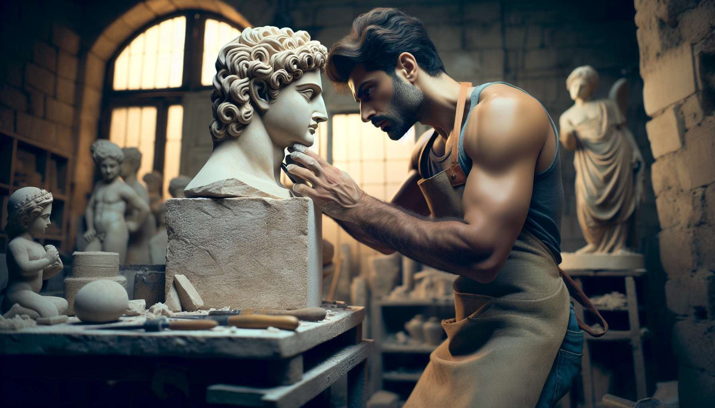

Channel 26, also known as the Channel of Manifestation, is formed by the connection of gates 2 and 14. It is a channel of the direction matrix, linking the sacral center to the spleen center. This channel brings a powerful and constant energy of grounding, capacity to fully embody in material and to manifest one's life direction.  
  
When this channel is defined, it gives the individual a deep anchorage in their body and in the physical world. People with this defined channel are often builders, craftsmen, body therapists who excel in the art of giving form and substance to their energy and intentions. They have a gift for centering, for acting with determination and perseverance, and for creating tangible and lasting achievements.  
  
However, this same energy of manifestation can also manifest as a tendency towards heaviness, inertia, or resistance to change. People with the Channel of Manifestation defined may struggle to adapt to new situations, to let go of their habits and assets, or to follow the flow of life when it leads them towards the unknown. They may also tend to overly identify with their body, their possessions, or their work, to the detriment of their spiritual evolution.  
  
Let's take the example of a sculptor with the Channel of Manifestation defined. In his studio, he excels at bringing life to raw material, shaping powerful and evocative works that seem to have a presence of their own. His energy of manifestation allows him to work with focus and endurance, to intimately feel the qualities of each material, and to transmit his creative intention down to the smallest details of his achievements. However, he may also struggle to detach from his creations, to explore new styles or techniques, or to cope with the vagaries of the art market. He needs to learn to stay true to his vision while cultivating detachment and adaptability, to find his deep identity beyond his work.  
  
For people with this defined channel, learning to live their energy of manifestation in an aligned and fluid way is a significant challenge. They need to learn to anchor in their body and in the present moment, to act with commitment and integrity, but also to remain open to change and renewal when necessary. They need to be careful not to become rigid in their routines or beliefs, but to keep a spirit of learning and exploration throughout their life. Finally, they need to nurture their inner life, their connection to their essence beyond their tangible achievements.  
  
This channel is closely linked to Channel 14 (Vital Energy Channel) which we explored previously. Together, these two channels form a powerful circuit of vitality and manifestation energy in the physical world. The Channel of Manifestation brings the capacity to anchor and persevere, while the Vital Energy Channel brings the capacity to generate and support vital momentum. When these two channels are defined, the individual has immense potential for achievement and lasting impact, combining strength of character and creative power.  
  
On the other hand, for people with the Channel of Manifestation open, the challenge is to learn to benefit from the stability and determination of others, without being limited or hindered by them. They can be excellent agents of change and innovation, bringing their flexibility and capacity to rebound to help others break out of their comfort zone and explore new possibilities. However, they need to be careful not to scatter or completely root themselves, but to find their own way to embody and manifest their direction.  
  
It is interesting to note that the Channel of Manifestation is linked to the theme of receptivity and gestation in the I Ching. Gates 2 and 14 are associated with the hexagrams of "The Receptive" and "Possession in Great", which evoke images of welcome, materialization, and the ability to make what one receives grow and prosper. This channel thus carries a deeply creative and nurturing energy, which knows how to bring spirit down into matter.  
  
Let's imagine a midwife with the Channel of Manifestation defined. In her job, she excels at accompanying pregnant women in this intense and transformative experience that is pregnancy and childbirth. Her energy of manifestation allows her to be fully present and attuned to the needs of the body, to reassure and encourage with gentleness and firmness, and to guide the birth process with confidence and skill. However, she may also tend to overly invest herself, to want to control everything, or to project her own fears and beliefs onto the expectant mothers. She must learn to respect the mystery and uniqueness of each birth, to trust the innate wisdom of women, and to take care of her own emotional and energetic balance.  
  
In the end, the Channel of Manifestation is a valuable source of grounding energy and the ability to sustainably manifest one's life direction. But as with any powerful energy, it calls for balance with flexibility, openness, and spiritual awareness. By learning to honor our need for manifestation while cultivating our inner evolution, we can use this channel to build a life rich in meaning, achievements, and presence to self and the world. It is a true gift for those who have this channel defined, and an invitation to find our rightful place in the dance of matter and spirit for all.  
  
Key points to remember :  
  
- Channel 26, also known as the Channel of Manifestation, links the sacral center to the spleen center and brings a powerful energy of grounding and capacity to manifest one's life direction.  
  
- When defined, this channel gives a deep anchoring in the body and physical world, as well as a gift for creating tangible and lasting achievements. However, it can also lead to a tendency towards heaviness, inertia or resistance to change.  
  
- To live this energy in an aligned way, people with this defined channel need to learn to anchor in the present, to act with integrity, while remaining open to change and cultivating their inner life.  
  
- The Channel of Manifestation is linked to Channel 14 (Vital Energy Channel), forming together a powerful circuit of vitality and manifestation energy in the physical world.  
  
- For people with this open channel, the challenge is to learn to benefit from the stability of others without being limited, and to find their own way to embody and manifest their direction.  
  
- This channel is associated with the themes of receptivity and gestation in the I Ching, carrying a creative and nurturing energy that knows how to bring spirit down into matter.  
  
- The energy of the Channel of Manifestation needs to be balanced with flexibility, openness, and spiritual awareness in order to build a life rich in meaning, achievements, and presence to oneself and the world.