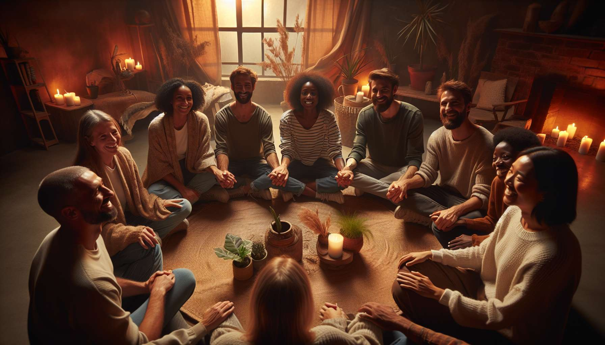

Channel 24, also known as the Channel of Communion, is formed by the connection of gates 37 and 40. It is a channel of the community matrix, linking the throat center to the emotional center. This channel brings a powerful and constant energy of connection, the ability to create deep and authentic connections with others.  
  
When this channel is defined, it gives the individual a vital need to share, communicate and feel in resonance with their surroundings. People with this defined channel are often mediators, diplomats, therapists who excel in the art of building bridges between people and groups. They have a gift for feeling the emotions and needs of others, for finding the right words that soothe and unite, and for creating spaces for dialogue and mutual understanding.  
  
However, this same communion energy can also manifest as a tendency towards emotional dependence, fear of rejection or difficulty in feeling whole when alone. People with the Channel of Communion defined may have trouble setting boundaries, saying no or managing conflicts for fear of losing the connection. They may also have a tendency to lose themselves in emotions and relational dramas, to the detriment of their own balance and individual creativity.  
  
Let's take the example of a family mediator with the Channel of Communion defined. In her work, she excels in creating a climate of trust and listening, helping family members express their feelings and deep needs, and finding solutions that honor the connection despite differences. Her communion energy allows her to be fully present and empathetic for each one, to defuse tensions with her gentleness and non-judgment, and to guide towards reconciliation and the healing of wounds. However, she may also have difficulty not absorbing the suffering of others, maintaining the right emotional distance, or preserving time and energy for her own family life. She must learn to set loving boundaries, to recharge in solitude, and not to make her value and well-being depend on her ability to solve the problems of others.  
  
For people with this defined channel, learning to live their communion energy in a healthy and balanced way is a significant challenge. They must learn to create connections that nourish and liberate rather than attachments that stifle or maintain dependency. They must also ensure that they do not carry all the responsibility for group harmony and cohesion, but encourage each individual to find their own resources and solutions. Finally, they must cultivate their inner garden, their passions, and personal expressions so as not to lose themselves in the "we" at the expense of the "I".  
  
This channel is closely linked to Channel 27 (Channel of Consciousness) which we will explore in the next sub-module. Together these two channels form a powerful circuit of relational energy and self and other awareness. The Channel of Communion brings the ability to create empathic and caring connections, while the Channel of Consciousness brings the ability to be lucid about one's own emotional and relational patterns. When these two channels are defined, the individual has immense potential for relational wisdom and guidance for others, combining intuition and discernment.  
  
On the other hand, for people with the Channel of Communion open, the challenge is to learn to appreciate and benefit from the connections created by others, without losing themselves or becoming dependent on them. They can be excellent catalysts for individuality and autonomy, bringing their clarity and detachment to help others free themselves from toxic attachments and find their own inner grounding. However, they must be careful not to reject all connections or commitments out of fear of merging, but to discern the relationships that nourish and elevate them.  
  
It is interesting to note that the Channel of Communion is linked to the theme of family and community in the I Ching. Gates 37 and 40 are associated with the hexagrams of "Family" and "Liberation", which evoke images of belonging, mutual support, but also the ability to differentiate oneself and find one's rightful place in the group. This channel therefore carries a deeply relational and evolving energy, which knows how to create nourishing and meaningful connections.  
  
Imagine a teacher with the Channel of Communion defined. In his class, he thrives at creating a warm and kind atmosphere where each student feels seen, heard and valued in their uniqueness. His communion energy allows him to build authentic connections with each one, to sense the unsaid and tensions, and to bring the group towards more trust, cooperation and mutual aid. Yet, he may also tend to want to be loved and approved by everyone, to avoid necessary questioning for fear of displeasing, or to feel personally responsible for the harmony and success of each student. He needs to learn to exercise kind but clear authority, to encourage independence and responsibility in each student, and to accept that relationships sometimes go through conflicts and challenges to evolve.  
  
In the end, the Channel of Communion is a precious source of relational energy and the ability to create authentic and nourishing connections. But as with any powerful energy, it needs to be channeled with wisdom, discernment and respect for the individuality of each. By learning to honor our need for connection while cultivating our inner grounding, we can use this channel to build relationships and communities that uplift and grow everyone. It is a true gift for those who have this channel defined, and an invitation to find the right balance between the "I" and the "we" for all.  
  
Takeaways:  
  
- Channel 24, also known as the Channel of Communion, links the throat center with the emotional center. It brings energy of connection and the ability to build deep bonds with others.  
  
- People with this defined channel have a vital need to share, exchange, and feel in tune with their surroundings. They are often talented in building bridges between people, soothing tensions, and bringing people together.  
  
- However, this energy can also manifest as a tendency towards emotional dependency, fear of rejection, and difficulty in setting boundaries. It is important to learn to build healthy and balanced bonds.  
  
- For people with this channel defined, the challenges are to learn to maintain their personal balance, to set caring boundaries, and not to base their self-worth on their ability to resolve other people's problems.  
  
- Channel 24 is linked to Channel 27 (Consciousness). Together, they form a powerful circuit of relational energy and self and other awareness.  
  
- For people with Channel 24 open, the challenge is to learn to appreciate the connections made by others without losing themselves in them, and to catalyze independence and individuality.  
  
- This channel is connected to the theme of family and community in the I Ching. It carries a relational and evolutionary energy to build nourishing and meaningful bonds.  
  
- The Channel of Communion is a valuable source of relational energy, but needs to be channeled with wisdom, discernment, and respect for the individuality of others to build fulfilling relationships and communities.