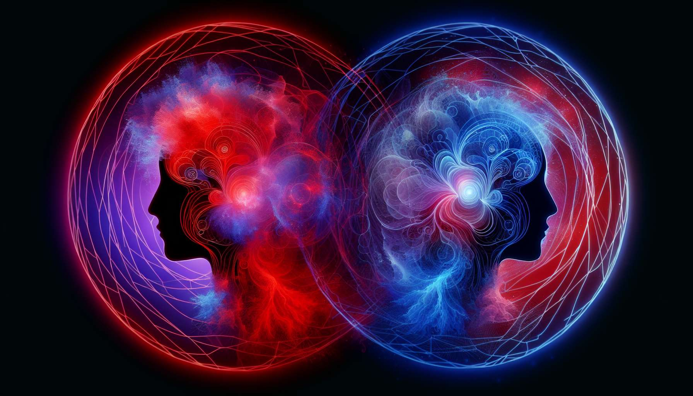

The submodule "Interactions between profiles" is a fascinating and essential aspect of Human Design that allows us to understand how different profiles interact and influence each other. Each profile brings its own qualities, challenges, and unique modes of operation, and when two or more profiles meet, it creates a particular dynamic that can be both rewarding and complex.  
  
Understanding interactions between profiles is particularly important in the context of relationships, whether at a personal, family, or professional level. When we understand the profile of those with whom we interact, we can better appreciate their strengths, needs, and potential points of friction. This allows us to adapt our approach, communicate more effectively, and create more harmonious and productive relationships.  
  
Let's take the example of an interaction between a 5/1 profile (the Heretic Investigator) and a 2/4 profile (the Opportunistic Hermit). The Heretic Investigator, with his tendency to question the status quo and to seek the truth, could find the Opportunistic Hermit too accommodating and superficial in his way of grasping opportunities. On the other side, the Opportunistic Hermit could find the Heretic Investigator too rigid and provocative in his quest for truth. However, if each is able to recognize and appreciate the strengths of the other - the ability of the Heretic Investigator to bring new perspectives and the Opportunistic Hermit's adaptability and ability to take advantage of situations - they can form a very complementary and effective team.  
  
Another important aspect of interactions between profiles is how they can influence and "condition" each other over time. In a long-term relationship, partners tend to unconsciously integrate some qualities of the other's profile. For example, a Generator with a 1/3 profile (Investigator Martyr) in relation with a Projector with a 2/5 profile (Hermit Heretic) might, over time, develop a greater ability to question things and to express his truth, under the influence of the line 5 of his partner. Similarly, the Projector might learn to be more attentive to his inner wisdom and to serve others, inspired by the lines 1 and 3 of his Generator partner.  
  
Understanding these mutual influences can help us navigate our relationships more consciously and use these dynamics for our personal growth and evolution. Rather than seeing differences between profiles as sources of conflict, we can see them as opportunities for learning and mutual balancing.  
  
It is also important to consider interactions between profiles in the context of the "gates" and "channels" of the BodyGraph. Each gate and each channel bring their own themes and energies, which can reinforce or temper the qualities of the profiles. For example, a Manifestor with a 3/5 profile (Martyr Heretic) and the defined gate 51 (Shock) could express his Martyr and Heretic tendencies in a particularly intense and provocative way, due to the shock and awakening energy of the gate 51. Understanding these nuances can help us better interpret and manage the interactions between profiles in all their complexity.  
  
Ultimately, studying interactions between profiles is an invitation to embrace the diversity and complementarity of human beings. Each profile has something unique and precious to offer, and it is in their interaction that this richness fully reveals itself. By learning to recognize, appreciate, and work with different profiles, we can create more harmonious, creative, and effective relationships and teams, while mutually supporting our personal growth and evolution.  
  
So whether you are exploring your own profile interactions or working with those of others, approach this study with curiosity, openness, and respect. Seek to understand rather than judge, to appreciate rather than criticize, and to use these insights to create more harmony and synergy in all your relationships. This is how Human Design can become a true tool for understanding, connection, and growth, serving more fulfilling relationships and a more integrated humanity.  
  
Key Takeaways:  
  
- Interactions between profiles are essential for understanding the dynamics of relationships in Human Design.  
- Each profile has its own qualities, challenges, and modes of operation that influence interactions.  
- Understanding others' profiles allows for adapted communication and the creation of more harmonious relationships.  
- Differences between profiles can provide complementarity and efficiency if well-understood and appreciated.  
- Over time, partners can influence each other and integrate certain qualities of the other's profile.  
- Interactions between profiles need to be considered in the context of the gates and channels of the BodyGraph, which bring additional nuances.  
- Studying interactions between profiles invites the embrace of human beings' diversity and complementarity.  
- Approaching this study with curiosity, openness, and respect helps create more fulfilling relationships and a more integrated humanity.