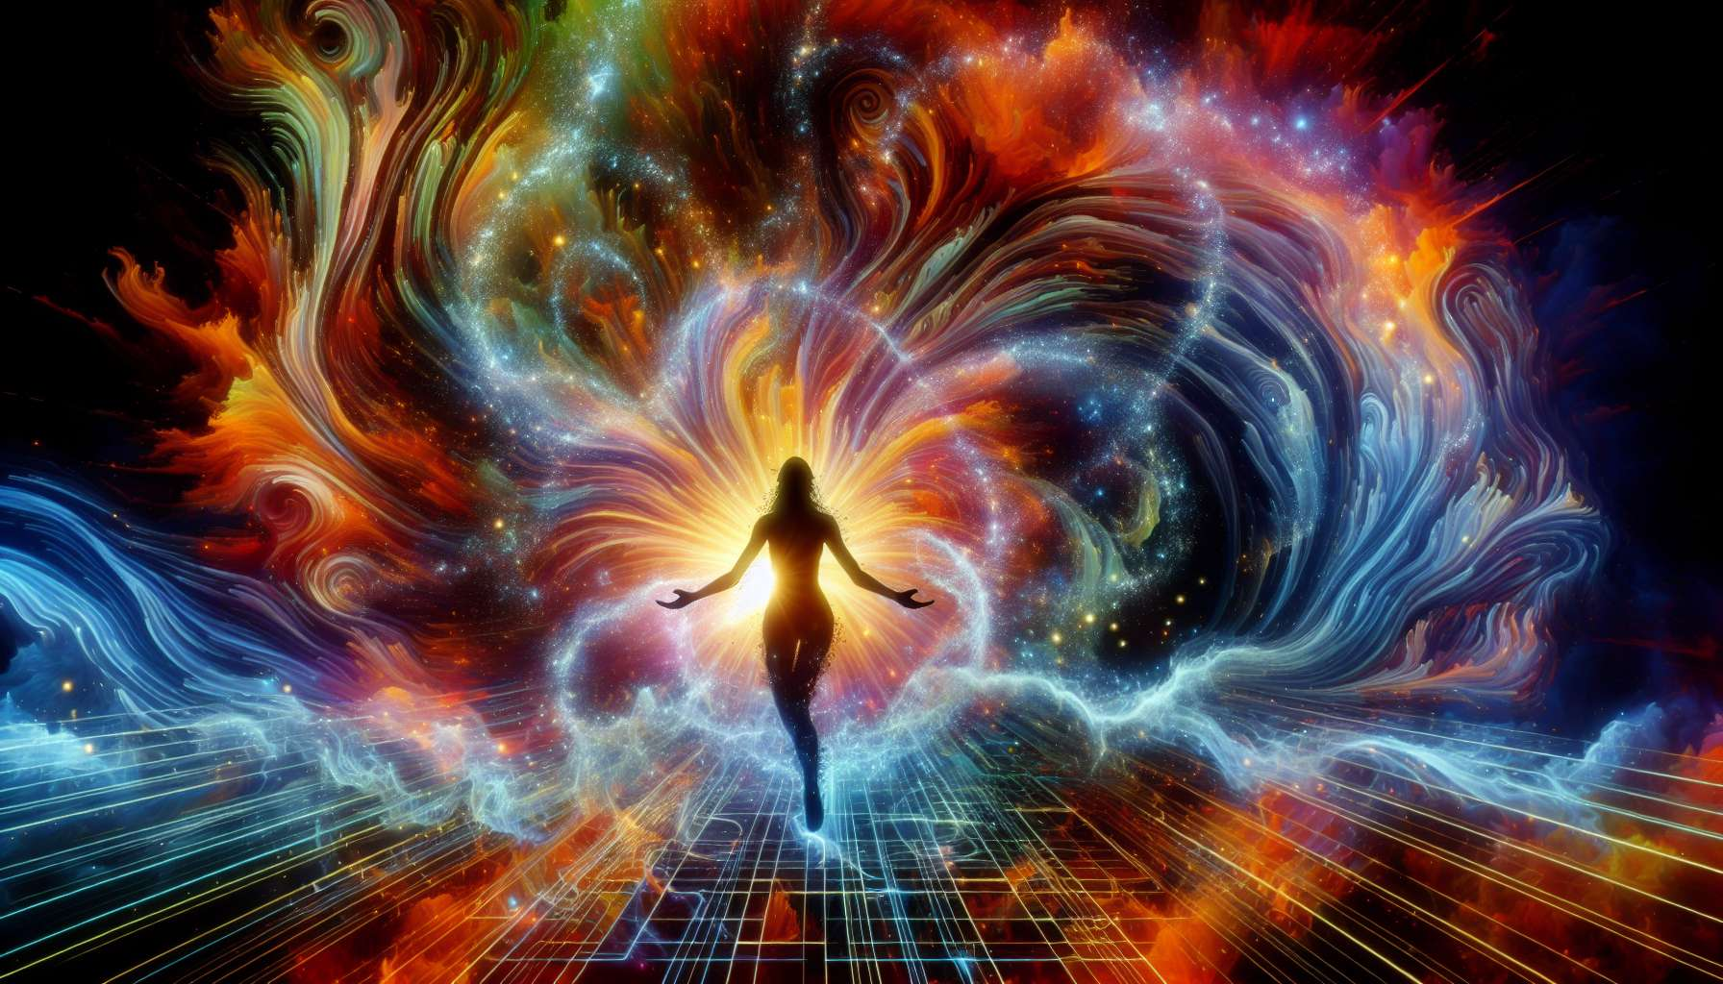

Channel 25, also known as the Channel of Initiation, is formed by the connection of gates 13 and 33. It is a channel of the identity matrix, which connects the throat center to the solar plexus center. This channel brings a powerful and steady energy of transformation, offering abilities to initiate profound changes in oneself and in others.   
  
When this channel is defined, it imparts a vital need for exploration, experimentation, and constant reinvention in the individual. People with this defined channel are often pioneers, innovators, change agents who excel in the art of shaking up the status quo and opening new paths. They have a gift for sensing blockers and limitations, for seeing the potential of transformation behind crises, and for inspiring others to step out of their comfort zone and embrace change.   
  
However, this very initiation energy can also manifest as a tendency towards instability, compulsive rebellion or difficulty in committing to the long term. People with the defined Initiation Channel may struggle to bear with routine, respect rules and authorities, or carry their projects through to completion. They might also tend to provoke crises and upheavals without always considering the consequences for themselves and for others.   
  
Let's take the example of an entrepreneur with the defined Initiation Channel. In his journey, he excels at identifying disruption opportunities, challenging established models, and launching innovative startups that revolutionize their sector. His initiation energy allows him to see beyond obstacles, take calculated risks, and lead teams into exciting entrepreneurial adventures. However, he may also struggle with managing the growth and structuring of his companies, delegating, and passing the baton once the launching phase is over. He must learn to surround himself with complementary people, accept necessary stabilization phases, and initiate change in a more sustainable and responsible way.   
   
For people with this defined channel, learning to live their initiation energy in a constructive and balanced manner is a significant challenge. They must learn to discern meaningful and necessary changes from sterile or destructive rebellions. They also need to make sure not to lose their way in a perpetual quest for newness but find meaning and direction in their need for exploration. Finally, they must cultivate their ability to accompany others through change processes, with patience, empathy, and respecting their pace.  
  
This channel is closely linked to Channel 3 (Channel of Mutation) that we have previously explored. Together, these two channels form a powerful circuit of transformation and renewal energy. The Initiation Channel brings the ability to trigger and catalyze change, while the Mutation Channel provides the ability to adapt and regenerate through crises. When these two channels are defined, the individual has immense potential for personal evolution and transformative impact on their environment, combining daring and resilience.  
   
On the other hand, for people with the Initiation Channel open, the challenge is to learn to open up and allow themselves to be transformed by initiations proposed by others, without losing their center and integrity. They can be excellent catalysts for stability and continuity, bringing their wisdom and grounding to help others navigate changes in a more serene and integrated way. However, they must take care not to resist or block transformational impulses out of fear of the unknown, but trust the process of life and their own adaptive capacity.  
  
It is interesting to note that the Initiation Channel is connected to the theme of rebirth and metamorphosis in the I Ching. Gates 13 and 33 are associated with the hexagrams of "The Fellowship of Men" and "Retreat", which evoke images of gathering, initiatory passage, and the ability to withdraw for better rebirth transformed. This channel, therefore, carries a deeply alchemical and evolutionary energy, knowing how to die to the old in order to make the new emerge.  
   
Imagine a life coach with the defined Initiation Channel. In her work with clients, she excels at spotting their limiting patterns, confronting them compassionately with their shadow zones, and guiding them toward liberating realizations and changes. Her initiation energy allows her to create powerful transformation spaces, dare to shake and provoke when necessary, and lead people to connect with their potential and untapped resources. However, she might also tend to project her own need for change onto her clients, want to make them evolve too quickly, or not know when to stop and allow them to integrate. She must learn to respect the pace and unique path of each individual, measure her interventions wisely, and accept that some people may not be ready or desiring to change.  
  
In the end, the Initiation Channel is a valuable source of transformation energy and ability to initiate profound and meaningful changes. But like with any potent energy, it requires being channeled with awareness, discernment and respect for the free will of others. By learning to honor our need for evolution while cultivating our inner wisdom and maturity, we can use this channel to be inspiring guides and benevolent alchemists in service of everyone's growth. This is a real challenge and a wonderful opportunity for those who have this defined channel, and an invitation to embrace change with confidence and openness for everyone.  
   
Key takeaways :  
  
- Channel 25, also known as the Initiation Channel, connects the throat center to the solar plexus center and brings an energy of transformation and the ability to initiate profound changes.  
   
- People with this defined channel are often pioneers, innovators, and change agents who excel at shaking up the status quo and opening new paths. However, they might also have a tendency towards instability, compulsive rebellion, and difficulty in committing to the long term.  
   
- To live this energy constructively, it’s crucial to discern necessary changes from sterile rebellions, find meaning in one's need for exploration, and accompany others through change processes with patience and respect.  
   
- The Initiation Channel is connected to Channel 3 (Channel of Mutation). Together they form a powerful circuit of transformation and renewal energy.  
   
- For people with this channel open, the challenge is learning to open themselves up to initiations proposed by others without losing their integrity, and being catalysts for stability to help others navigate changes serenely.  
   
- This channel is connected to the theme of rebirth and metamorphosis in the I Ching, carrying an alchemical and evolutionary energy.  
  
- The energy of the Initiation Channel should be channeled with awareness, discernment, and respect for the free will of others to be used beneficially and inspiringly in service of everyone's growth.