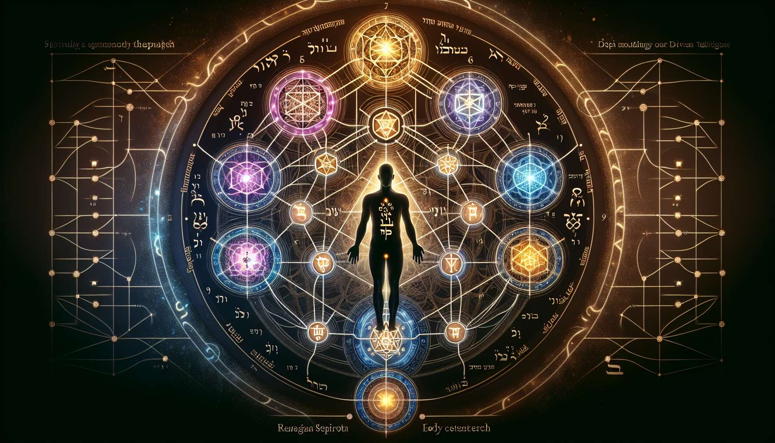

The Kabbalah, a Jewish esoteric tradition, brings a profound spiritual dimension to Human Design through the concept of the Tree of Life. This symbolic Tree represents the process of divine creation and the structure of the universe. It consists of ten sephiroth, or divine emanations, connected by 22 paths.  
  
In Human Design, the Tree of Life is reflected in the very structure of the BodyGraph. The nine centers of the BodyGraph correspond to the nine lower sephiroth of the Tree of Life. Each center represents a specific quality of the life energy that animates us.  
  
For example, the Throat center, which is linked to the sephira Daath (knowledge), is the center of manifestation and self-expression. The Sacral center, connected to Yesod (foundation), is the center of vital energy and life force. The Splenic center, attached to Hod (splendor), is the center of intuition and well-being.  
  
Understanding the correspondence between the centers of the BodyGraph and the sephiroth of the Tree of Life brings additional depth to our understanding of ourselves. It allows us to see how different qualities of divine energy express themselves through us.  
  
Consider the example of a person with a defined Sacral center. In Human Design, this means that they have access to constant vital energy and that they are here to work and manifest in the material world. From the Kabbalistic perspective, this means that they have a strong connection with the sephira Yesod, the realm of vitality and creativity.  
  
Another fascinating aspect is the link between the 22 paths of the Tree of Life and the 36 channels of the BodyGraph. Although there is no direct correspondence, some interesting parallels can be seen. For instance, the 20-34 channel, called the "Channel of Realization", connects the Throat center to the Sacral center, just as the Daath-Yesod path connects the sephira of knowledge to that of the foundation.  
  
Exploring these correspondences can help us understand the subtle energies underlying our unique design. It can provide insight into our life path and potential for spiritual growth.  
  
It is important to note that integrating Kabbalah into Human Design is not a direct transplant, but rather, a reinterpretation through the lens of Human Design. Ra Uru Hu, the founder of Human Design, used his understanding of Kabbalah to illuminate certain aspects of the system, but Human Design remains a unique system in itself.  
  
For students interested in the spiritual dimension of Human Design, exploring the connection with Kabbalah can be a rewarding path. It may add a new layer of meaning to our understanding of ourselves and our place in the universe. However, it is not necessary to master Kabbalah to use and benefit from Human Design in our daily lives.  
  
  
Key Takeaways:  
  
1. The Kabbalah's Tree of Life brings a spiritual dimension to Human Design, representing the process of divine creation and the structure of the universe.  
  
2. The nine centers of the BodyGraph correspond to the nine lower sephiroth of the Tree of Life, with each center representing a specific quality of life energy.  
  
3. Understanding the correspondence between the BodyGraph centers and the sephiroth allows to deepen self-understanding and see how different qualities of divine energy express themselves through us.  
  
4. There are interesting parallels between the 22 paths of the Tree of Life and the 36 channels of the BodyGraph, although there is no direct correspondence.  
  
5. The integration of Kabbalah into Human Design is a reinterpretation through the lens of Human Design, not a direct transplant.  
  
6. Exploring the link between Kabbalah and Human Design can enrich the understanding of oneself and one's place in the universe, but it is not essential for using and benefiting from Human Design on a daily basis.