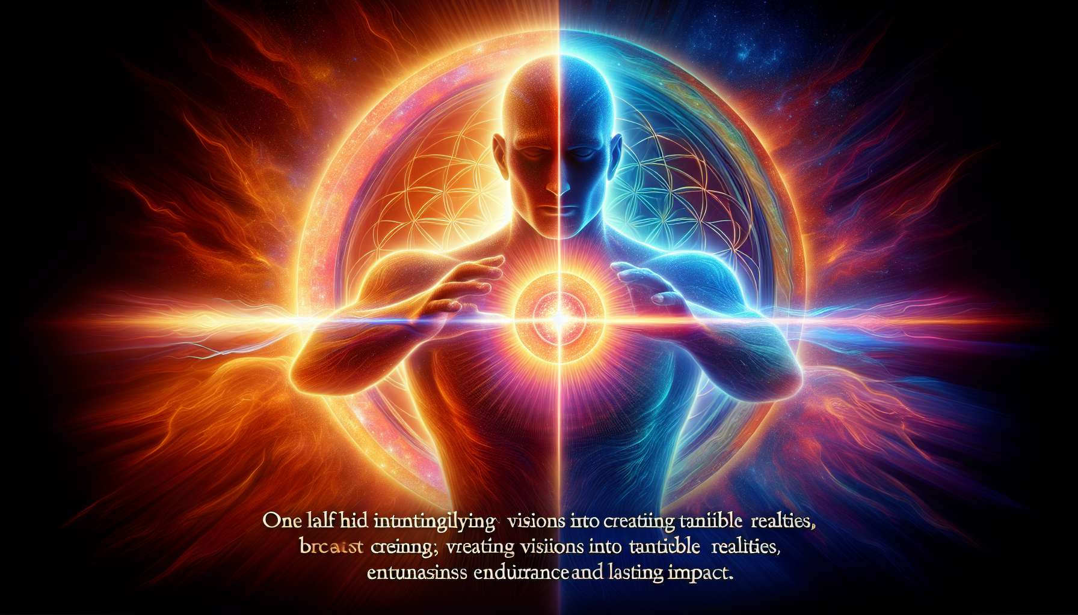

Manifesting Generators' strategy is a fascinating blend of the strategies of Manifestors and Generators. Like Manifestors, they are here to initiate and set new things in motion. But like Generators, they also have the ability to respond and sustain. It is this dual nature that makes Manifesting Generators such uniquely powerful beings.  
  
Informing is the first part of the Manifesting Generators' strategy. Like pure Manifestors, they must communicate their intentions and decisions before acting. This is a way to honor their initiation energy while minimizing potential resistance from their environment. By informing, Manifesting Generators create a space for their energy to be received and supported.  
  
Take the example of a Manifesting Generator deciding to launch a new project at work. Before setting off, they take the time to inform their team and superiors of their intention. They explain their vision, their objectives, and how they plan to proceed. By doing so, they allow their environment the opportunity to align with their energy, ask questions, and offer their support. This can greatly facilitate the process and increase the chances of success.  
  
Responding is the second part of the Manifesting Generators' strategy. Like Generators, they have the ability to commit and maintain once they have initiated something. It is their defined sacral center that provides them this sustainable and renewable energy. When a Manifesting Generator responds to their own initiation, they can work with endurance and consistency to realize their vision.  
  
Imagine a Manifesting Generator that has launched their own business. After the initial excitement of creation, they enter a response phase where they must maintain and develop their business daily. This is where their Generator energy comes into play, giving them the necessary work force to manage operations, serve their clients, and sustainably grow their business. By responding to their own initiation, they can transform their vision into a tangible and impactful reality.  
  
The art for Manifesting Generators is to balance and integrate these two aspects of their strategy. They must learn to discern when to initiate and when to respond, when to inform and when to act. This requires practice and self-observation to recognize the different energies and impulses that animate them at a given moment.  
  
A common challenge for Manifesting Generators is wanting to do everything all at once. With their dual capacity for initiation and response, they may tend to launch into multiple projects simultaneously, risking spreading themselves thin or wearing themselves out. Learning to prioritize and sequence their actions is a key skill for them. They also need to learn to delegate and surround themselves, so as not to bear all the weight of their initiatives alone.  
  
Another important aspect of the Manifesting Generators' strategy is to honor their unique rhythm. As they combine two different types of energy, they may have activity and rest cycles different from other types. They may need periods of intense initiation followed by calmer periods of response and maintenance. Learning to respect these natural cycles rather than forcing themselves to maintain a constant rhythm is essential for their well-being and long-term effectiveness.  
  
Ultimately, the strategy of informing and responding is an invitation for Manifesting Generators to fully embrace their unique nature. By honoring both their impulse to initiate and their capacity to sustain, they can express their gifts in the most powerful and aligned way possible. When they master this balance, they become amazing forces of change and creation, bringing their visions into reality with endurance and impact.  
  
For Manifesting Generators, the path to self-mastery involves constant experimentation and adjustment. Each initiation, each response teaches them something about themselves and the best way to use their energies. By staying open and attentive, they can refine their strategy over time, becoming increasingly effective and aligned in their expression.  
  
So, if you are a Manifesting Generator, celebrate your uniqueness and potential. Learn to understand and master your impulses of initiation and response. Inform your environment about your intentions and be open to their support. Honor your natural rhythms and don't be afraid to adjust your approach along the way. You have within you the ability to create wonders and change the world, one step at a time. Trust in your unique strategy and let it guide you to your highest expression.  
  
Points to remember:  
  
- Manifesting Generators combine the strategies of Manifestors (to initiate) and Generators (to respond and maintain), making them uniquely powerful beings.  
  
- Their strategy has two key aspects: to inform before acting to minimize resistance, and to respond to their own initiation to sustain and realize their vision.  
  
- They need to learn to balance and integrate these two aspects, discerning when to initiate and when to respond, when to inform and when to act.  
  
- A common challenge is the tendency to want to do everything at once. They need to learn to prioritize, sequence actions, delegate, and surround themselves.  
  
- Honoring their unique rhythm, alternating periods of intense initiation and calmer response periods, is crucial for their well-being and effectiveness.  
  
- Their path to self-mastery involves constant experimentation and adjustment, staying open and attentive to refine their strategy over time.  
  
- By embracing their unique nature and mastering their impulses of initiation and response, they can become amazing forces of change and creation, bringing their visions into reality with endurance and impact.