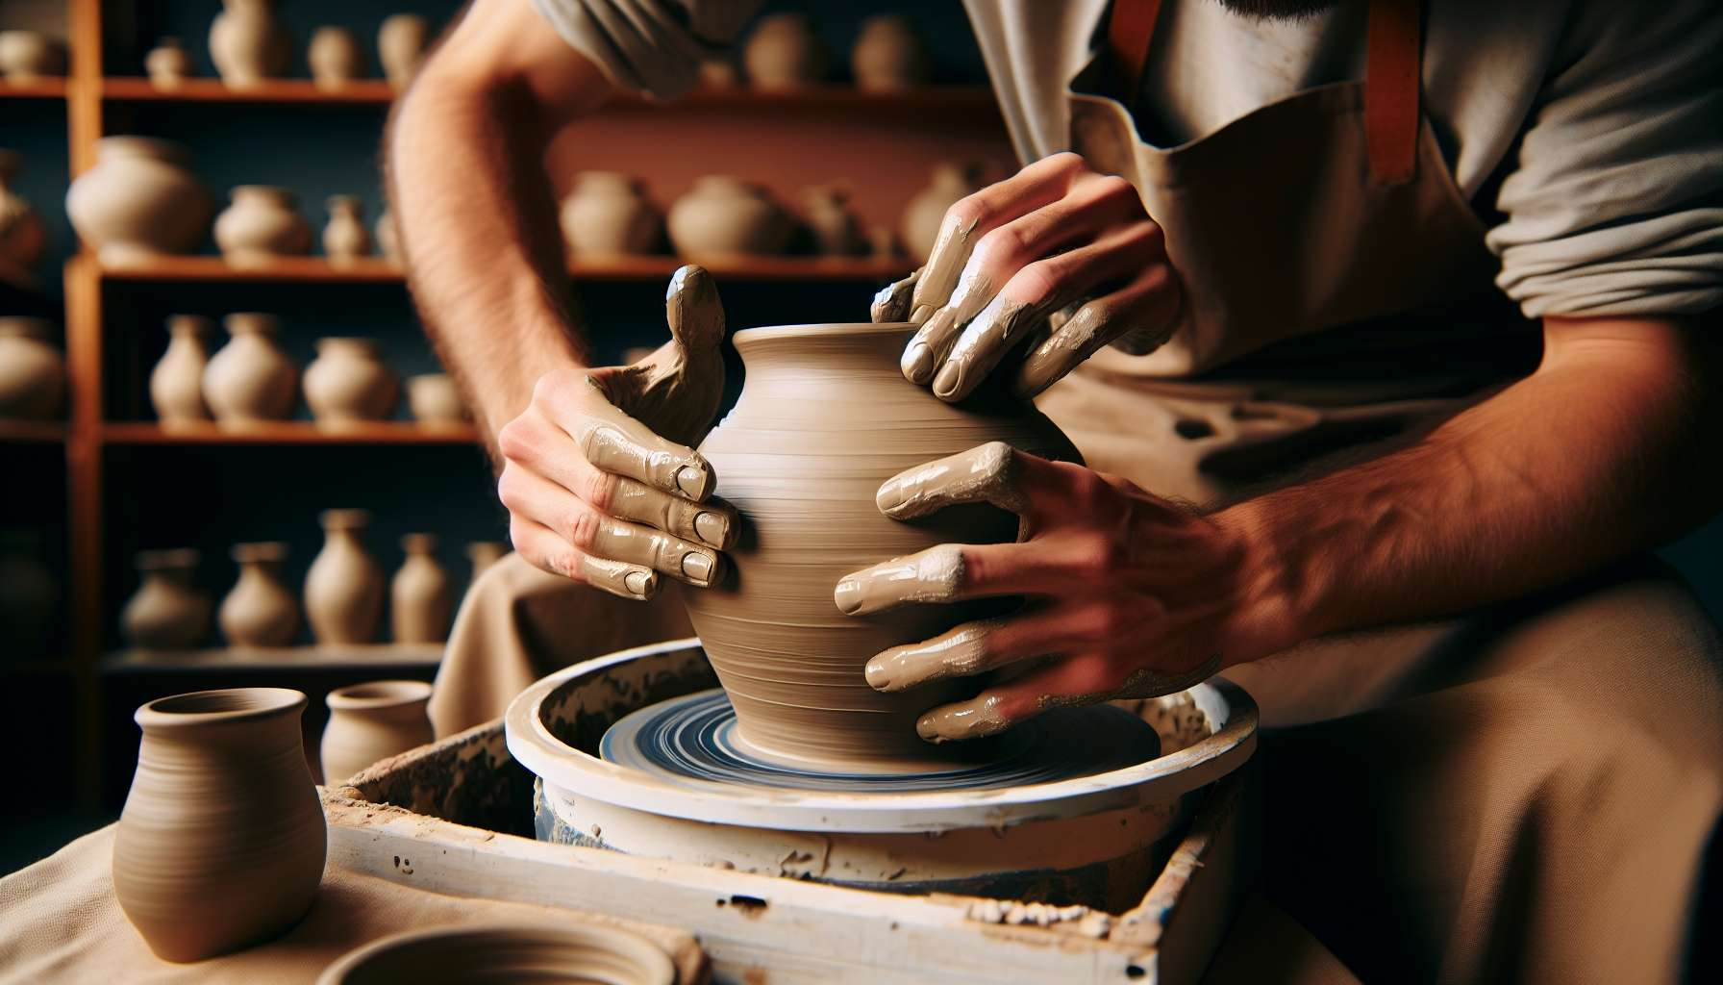

Channel 4, also known as the Form Channel, is formed by the connection of gates 48 and 16. This is a channel of the matrix of form, connecting the root center to the sacral center. This channel brings a powerful and constant energy of materialization, shape-giving, and tangible achievement.  
  
When this channel is defined, it gives the individual a remarkable ability to give form to their visions and ideas in the physical world. People with this defined channel are often builders, craftsmen, designers, or entrepreneurs. They have a gift for transforming abstract concepts into tangible realities, for creating structures and shapes that work in the real world.  
  
However, this same shaping energy can also manifest as a tendency towards rigidity or excessive attachment to existing forms. People with the Form Channel defined may struggle to adapt to changes or to let go of structures that no longer serve. They may also tend to define themselves or others by fixed roles or identities, rather than remaining open to evolution and transformation.  
  
A concrete example might be that of an architect with the Form Channel defined. He has an innate ability to design buildings that are beautiful, functional, and well integrated into their environment. His mastery of form allows him to create spaces that elevate and inspire those who inhabit them. However, he may also struggle with a certain inflexibility when his plans are questioned or need to be modified along the way. He may have difficulty letting go of his initial vision, even when circumstances call for adaptation.  
  
For people with this defined channel, learning to balance their sense of form with flexibility and openness is a significant challenge. They must learn to see their creations as stages in an evolutionary process, rather than as unchangeable endpoints. They must also cultivate their ability to listen to and incorporate feedback and ideas from others so that their forms can enrich and adapt to changing needs.  
  
This channel is closely linked to Channel 5 (Rhythm Channel) which we will explore in the next sub-module. Together, these two channels form a powerful circuit of manifestation energy and achievement in the physical world. The Form Channel brings the ability to structure and give concrete shape, while the Rhythm Channel brings the ability to adapt and find the right timing. When these two channels are defined, the individual has immense potential for creation and tangible success.  
  
On the other hand, for people with the Form Channel open, the challenge is to learn to appreciate and make use of the forms and structures created by others, without feeling limited or defined by them. They can be excellent agents of change and innovation, bringing flexibility and novelty into existing forms. However, they must be careful not to reject all structure on principle but to discern which ones are useful and necessary.  
  
It is interesting to note that the Form Channel is linked to the theme of materialization and realization in the I Ching. Gates 48 and 16 are associated with the hexagrams of the "Well" and "Enthusiasm," which evoke images of depth, resources, and the ability to mobilize energy to achieve a goal. This channel thus carries a deeply creative and achieving energy, seeking to anchor visions in concrete reality.  
  
Ultimately, the Form Channel is a precious source of manifestation energy and the ability to structure the physical world. But as with any powerful energy, it needs to be balanced with flexibility and openness. By learning to honor our sense of form while remaining receptive to change and input from others, we can use this channel to build realities that are both sturdy and adaptive, serving our fulfillment and that of the world around us. This is a true gift for those who have this channel defined, and an invitation to appreciate the value of form and structure to all.  
  
Key Points:  
  
1. Channel 4, also called the Form Channel, connects gates 48 and 16, linking the root center to the sacral center. It brings an energy of materialization and tangible realization.  
  
2. People with this defined channel have a remarkable ability to give form to their ideas and visions in the physical world. They are often builders, craftsmen, designers, or entrepreneurs.  
  
3. However, this energy can also manifest as rigidity or excessive attachment to existing forms, making adaptation to change difficult.  
  
4. To balance this energy, people with this defined channel must learn to see their creations as stages of an evolutionary process and incorporate feedback from others.  
  
5. The Form Channel is linked to Channel 5 (Rhythm Channel). Together, they form a powerful circuit of manifestation and realization in the physical world.  
  
6. For people with the Form Channel open, the challenge is to appreciate and utilize the structures created by others without feeling limited by them. They can be excellent agents of change and innovation.  
  
7. This channel is linked to the theme of materialization and realization in the I Ching, carrying a deeply creative and achieving energy.  
  
8. The energy of the Form Channel must be balanced with flexibility and openness to build sturdy and adaptive realities, serving personal and collective fulfillment.