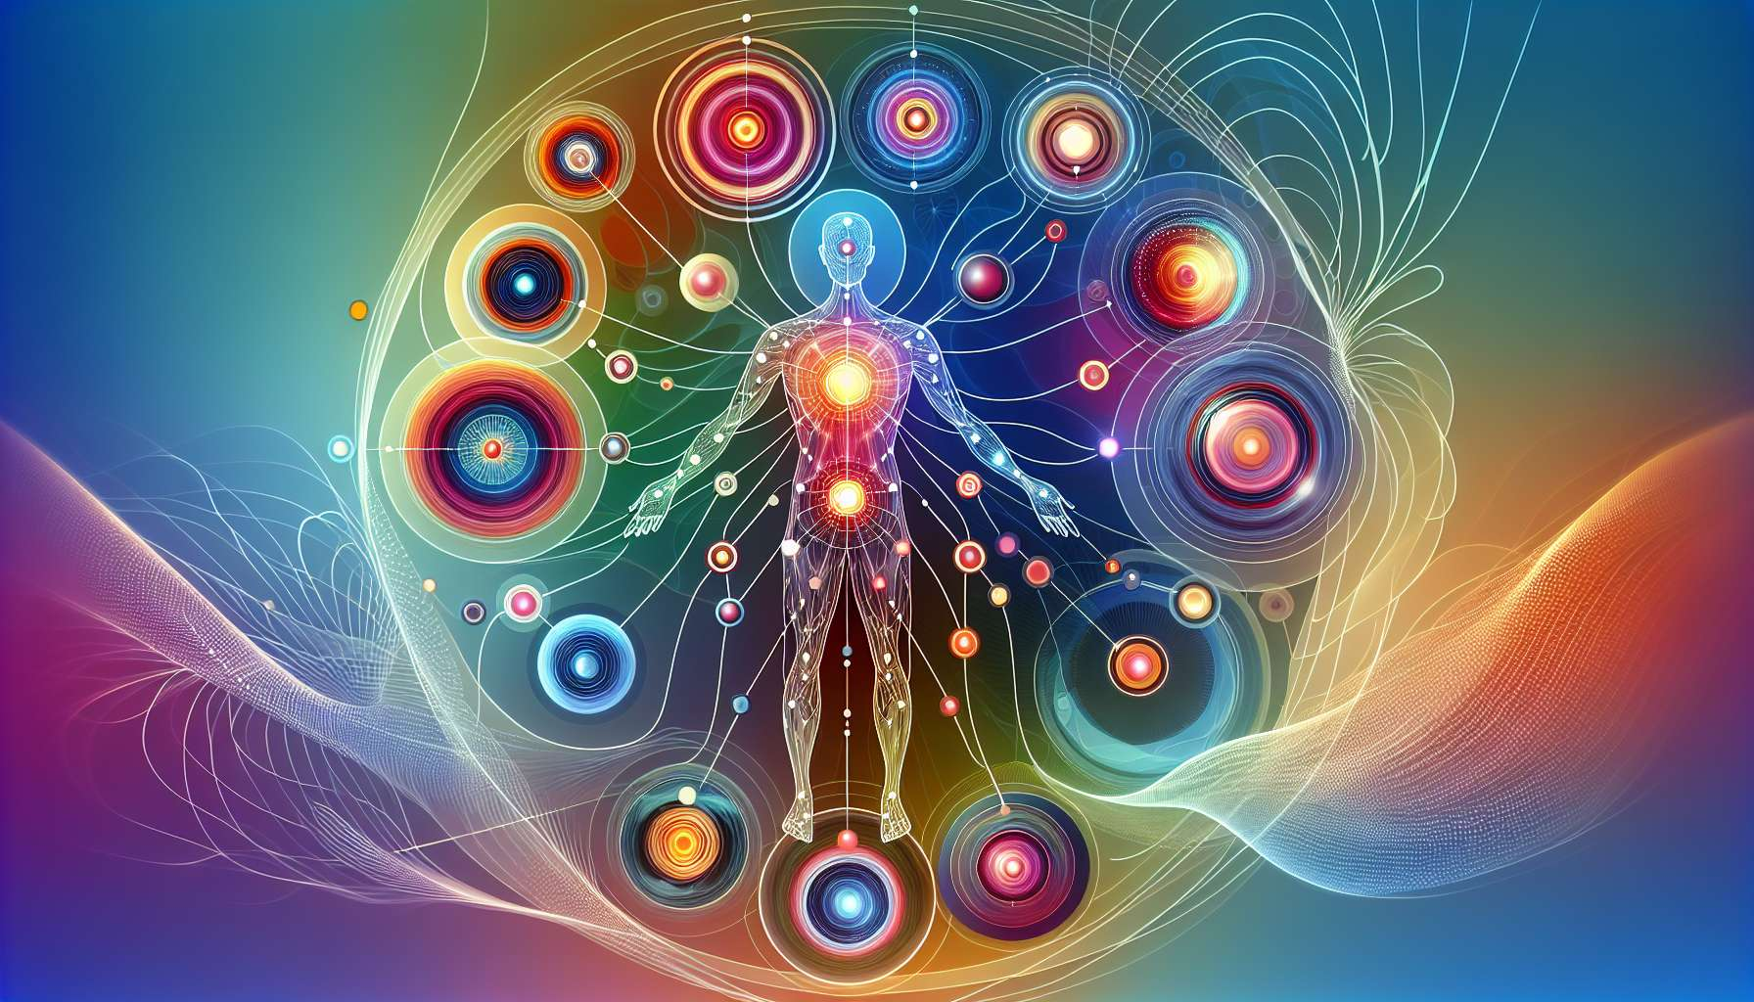

The concept of defined and undefined (or open) centers is fundamental in Human Design. It allows us to understand how we interact with the energies of life and how we make our decisions. Each of the nine centers of the BodyGraph can either be defined or open, which profoundly affects our life experience.  
  
A center is considered defined when there is at least one activated gate linked to it. This means that the energy of this center is consistent and reliable. When a center is defined, we have access to its energy quality in a stable and predictable manner. For example, if your throat center is defined, you will have a constant pressure to communicate and express your ideas. If your sacral center is defined, you will have access to sustainable vital energy for work and manifestation in the material world.  
  
Defined centers are the stable foundations of our being. They represent our strengths, our gifts, and our most reliable ways of functioning. When we act from our defined centers, we are aligned with our inner truth, and we can make a powerful and authentic impact on the world around us.  
  
On the other hand, a center is considered open (or undefined) when there are no activated gates linked to it. This means that the energy of this center is more variable and influenced. When a center is open, we don't have constant access to its energy quality, but we can be amplified or impacted by the energies of others in this area. For example, if your emotional (splenic) center is open, you may be very sensitive to the emotions and moods of people and environments around you. If your head center is open, you can be highly open to ideas and inspirations from others.  
  
Open centers are areas of our greatest sensitivity and learning potential. They represent the areas where we are here to listen, learn, and let ourselves transform by life. When we try to control or fix the energy of our open centers, we can feel stressed, frustrated, or exhausted. But when we learn to welcome and let this energy flow without making it our own, we can access great wisdom and flexibility.  
  
It is important to note that open centers are not weaknesses or lacks. They are simply areas where our energy is more fluid and receptive. In fact, our open centers can be sources of great insight and great compassion, precisely because they allow us to feel and understand a wide range of human experiences.  
  
Take the example of a person with an open throat center. This person can be an excellent listener and communicator, able to adapt to different communication styles and make people comfortable. However, they may also tend to talk too much or say things they don't really mean under the influence of others. Learning to discern when to communicate and when to be silent is a key lesson for this person.  
  
Or take the example of a person with an open sacral center. This person may be very sensitive to the energy and needs of others, and may excel in support or facilitation roles. However, they might also tend to overdo things or get exhausted by the demands of others. Learning to manage their energy and set healthy boundaries is crucial for this person.  
  
Ultimately, understanding our defined and open centers is a key to living our design in an aligned and fulfilled way. This allows us to lean on our strengths, embrace our sensitivity, and interact with the world in a way that respects and nurtures us. This is an art of living that requires practice and self-compassion, but that can lead us to a life of great richness, authenticity, and impact.  
  
Whether you have many defined centers or many open centers, remember that your design is perfect and complete as it is. Each center, whether defined or open, has something to teach you and to offer to the world. By learning to honor and work with your energies as they are, you can unlock your unique potential and live your life with more grace, ease, and joy.  
  
Takeaways:  
  
- Defined and undefined (or open) centers are fundamental for understanding our energy functioning and decision-making according to Human Design.  
  
- A center is defined when it has at least one activated gate, its energy is then constant and reliable. A center is open when it has no activated gates; its energy is more variable and affected.  
  
- Defined centers are our most authentic strengths and ways of functioning. Acting from them aligns us with our inner truth.  
  
- Open centers are our areas of greatest sensitivity and receptivity. They allow us to learn, evolve, and feel a broad spectrum of human experiences.  
  
- Open centers are not weaknesses, but require learning to welcome and let their energy flow without claiming it.  
  
- Understanding and honoring our configuration of defined and open centers is key to flourishing and impacting the world in an aligned way. This is an art of living that requires practice and self-kindness.  
  
- Each center, defined or open, has something to teach us and to give to others. Our design is perfect and complete as it is.