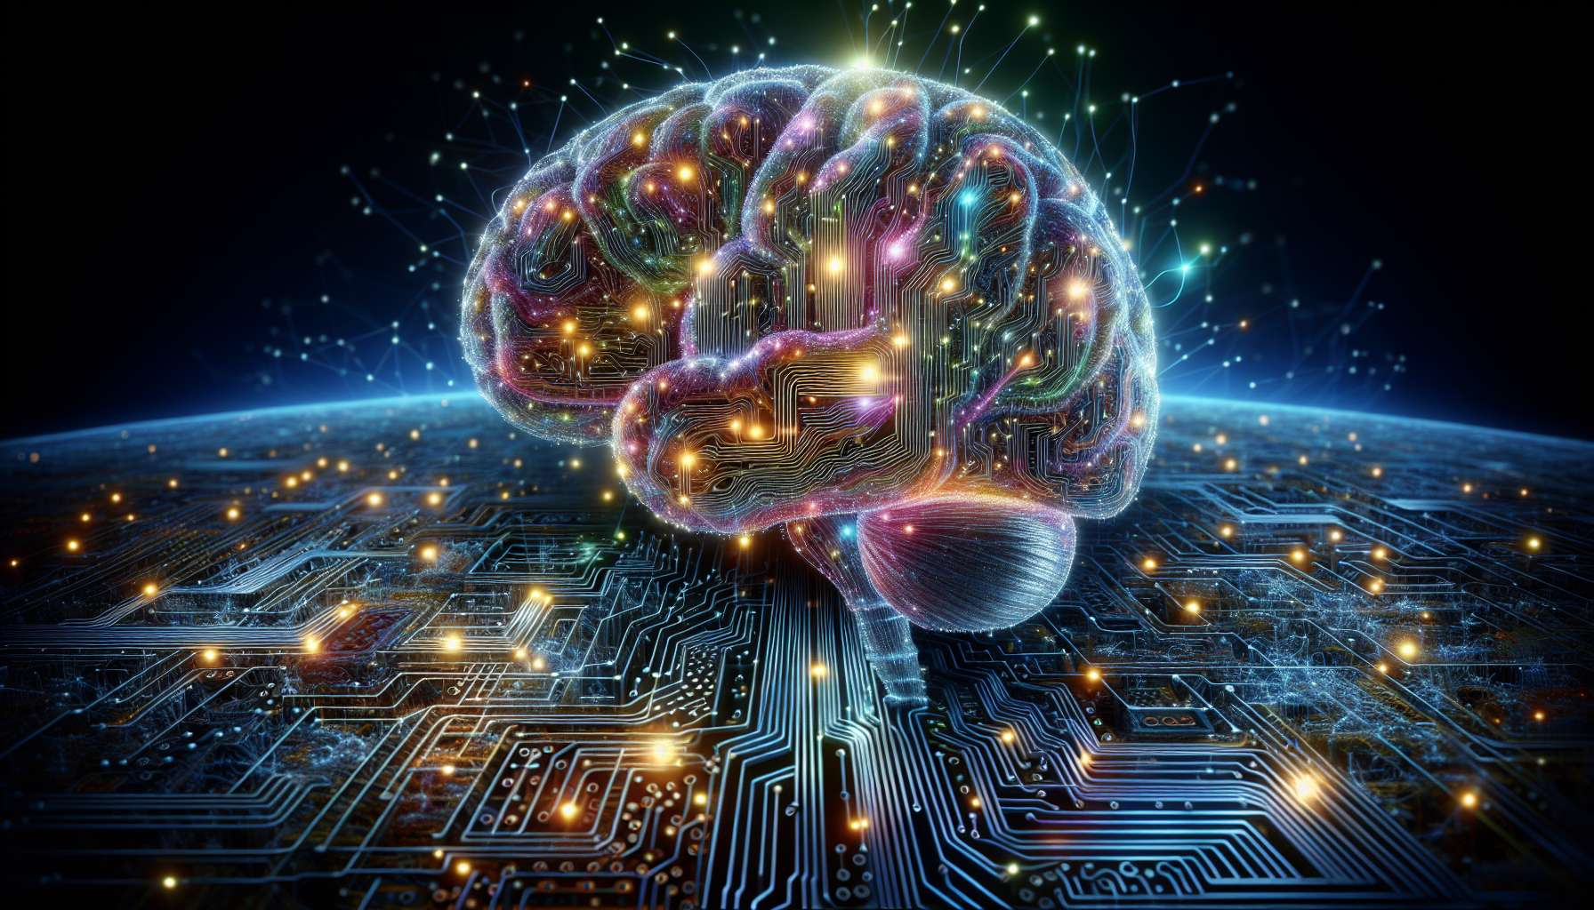

Channel 9, also known as the Logic Channel, is formed by the connection of gates 63 and 4. This is a channel of the identity matrix, connecting the center of the head to the center of the ajna. This channel brings a powerful and constant energy of logical reasoning, the ability to analyze and understand systems and patterns.  
  
When this channel is defined, it gives the individual a rational and analytical mind, capable of dissecting complex problems and finding logical solutions. People with this defined channel are often scientists, engineers, strategists who excel in problem solving and fact and data-based decision making. They have mental clarity and the ability to see cause-and-effect links, which allow them to navigate through the most tangled situations.  
  
However, this same logic energy can also manifest as a tendency to overanalyze, mental rigidity, or emotional coldness. People with the defined Logic Channel may have difficulty accepting irrationality, intuition, or feelings in their decision-making process. They may also tend to want to control and anticipate everything through logic, at the risk of lacking spontaneity and flexibility.  
  
Let's take the example of a mathematics researcher with the defined Logic Channel. He has a passion for numbers and equations, and an impressive ability to solve the most arduous problems. His relentless logic allows him to make discoveries and significant advances in his field. However, he may also struggle with the more relational and emotional aspects of his life, having difficulty understanding and expressing his own feelings or those of others. He needs to learn to value emotional intelligence as much as rational intelligence, and to find a balance between the two.  
  
For people with this defined channel, learning to use their logic in a balanced and integrated manner is a major challenge. They must learn to trust their rational mind while remaining open to other forms of knowledge and wisdom. They must also ensure not to use logic as a shield or a weapon, but as a tool in service of a fairer and more beneficial understanding and action for all.  
  
This channel is closely related to Channel 10 (Planning Channel) which we will explore in the next sub-module. Together, these two channels form a powerful circuit of mental energy and the ability to structure and implement s The Logic Channel brings the ability to analyze and understand systems, while the Planning Channel brings the ability to organize and project into the future. When these two channels are defined, the individual has immense potential for strategic thinking and problem solving.  
  
On the other hand, for people with the Logic Channel open, the challenge is to learn how to benefit from others' logical clarity, without letting themselves be dominated or intimidated by it. They can be excellent thinking and brainstorming partners, bringing their more intuitive and creative perspective to enrich and loosen the logical process. However, they must be careful not to disconnect from their own inner wisdom, and to dare to assert their ideas even if they are not always rationally justifiable.  
  
It is interesting to note that the Logic Channel is related to the theme of doubt and truth in the I Ching. Gates 63 and 4 are associated with the hexagrams of "Doubt" and "Inexperienced Youth", which evoke images of questioning, learning from experience, and the ability to discern true from false. This channel therefore carries a deeply investigative and discerning energy, which seeks to pierce illusions by the force of reasoning.  
  
Imagine a detective with the defined Logic Channel. In her investigations, she demonstrates rigorous and perceptive skills, being able to spot inconsistencies and put together the puzzle from the slightest clues. Her sharp logic is her main asset for solving mysteries and confounding the guilty. Yet, she may also have a tendency to get absorbed in her reasoning to the point of neglecting her intuition and feelings. She needs to learn to also listen to her instinct, and to leave space for doubt and the unknown even in the heart of her quest for truth.  
  
In conclusion, the Logic Channel is a valuable source of mental energy and the ability to understand and navigate the complexity of the world. But like any powerful energy, it requires to be used with discernment, openness, and humility. By learning to honor our logical mind while integrating it into a more global and intuitive approach, we can use this channel to bring clarity, correctness, and efficiency to our thoughts and actions. It's a real asset for those who have this channel defined, and an invitation to reflect on our relationship with rationality and truth for everyone.  
  
Key Points:  
  
- Channel 9, also called the Logic Channel, connects gates 63 and 4, connecting the center of the head to the center of the ajna. It brings an energy of logical reasoning and analysis.  
  
- When defined, this channel provides a rational and analytical mind, an ability to solve complex problems and make decisions based on facts. It is often present in scientists, engineers, and strategists.  
  
- The energy of this channel can also manifest as overanalysis, mental rigidity, or emotional coldness. People with this defined channel may have difficulty accepting the irrational and intuition.  
  
- To use this channel in a balanced way, it is necessary to learn to trust the rational mind while remaining open to other forms of knowledge. It is important not to use logic as a shield or a weapon.  
  
- Channel 9 is linked to Channel 10 (Planning Channel), together forming a powerful circuit of mental energy and ability to structure and implement strategies.  
  
- For people with Channel 9 open, the challenge is to benefit from others' logical clarity without being dominated by it. They can be excellent thinking partners by providing an intuitive and creative perspective.  
  
- This channel is linked to the theme of doubt and truth in the I Ching. It carries an investigative energy that seeks to pierce illusions through reasoning.  
  
- The Logic Channel is a valuable source of mental energy, but it must be used with discernment, openness, and humility, integrating it into a more global and intuitive approach.