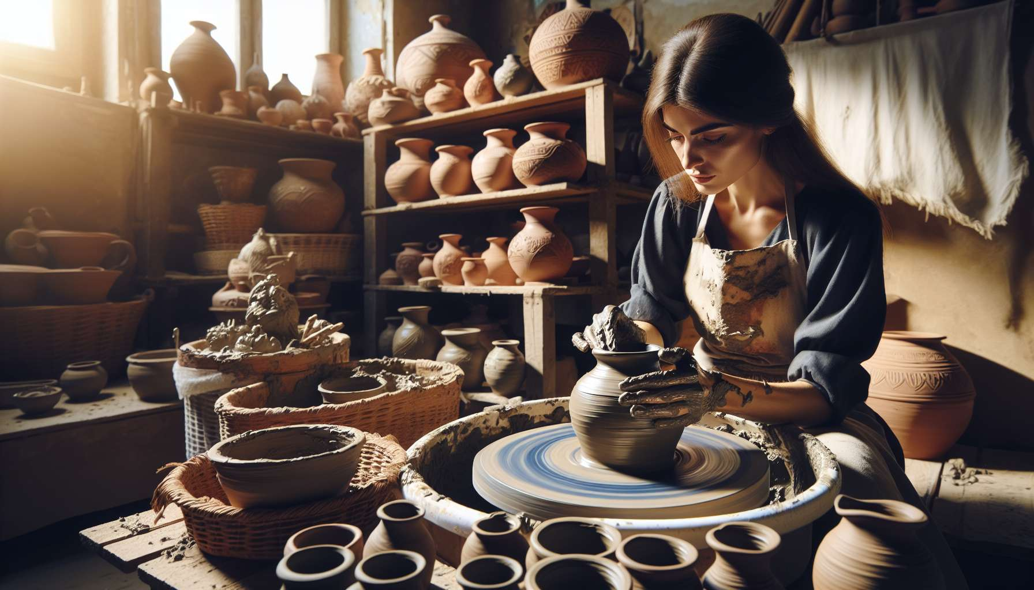

Channel 8, also known as the Channel of Realization, is formed by the connection of gates 20 and 34. This is a channel from the Form matrix, linking the throat center to the sacral center. This channel brings a powerful and constant energy of manifestation, the ability to materialize visions and ideas into physical reality.   
  
When this channel is defined, it gives the individual an innate talent to transform concepts into tangible achievements. Individuals with this defined channel are often builders, creators, entrepreneurs who know how to give shape and substance to their projects. They have a lasting and constant manifestation energy, enabling them to work with perseverance and determination until their visions come to life in the world.   
  
However, this same energy of realization can also manifest as a tendency toward hyperactivity, activism, or dispersion. Individuals with the defined Channel of Realization may struggle to settle down, take a step back, or allow their projects to mature. They may also tend to scatter themselves in too many achievements at once, risking burnout, or not completing what they have started.   
  
Let's look at the example of an artisan with the defined Channel of Realization. He has overflowing creativity and impressive ability to bring his ideas to life through his creations. Whether he works with wood, metal, or ceramics, he knows how to create beautiful and functional objects that carry his unique touch. However, he may also struggle with a certain chronic dissatisfaction, a constant need to create something new without ever resting on his laurels. He needs to learn to appreciate each step of the creative process, to celebrate his accomplishments, and to recharge between projects.   
  
For individuals with this defined channel, learning to channel their manifestation energy in a focused and strategic way is a significant challenge. They need to learn to prioritize their projects, to say no to certain opportunities in order to better say yes to those that are truly aligned with their vision and values. They also need to cultivate their ability to delegate, collaborate, and build on others' achievements, rather than trying to do everything themselves.   
  
This channel is closely related to Channel 4 (Channel of Form) which we previously explored. Together, these two channels form a powerful circuit of materialization and structuring energy in the physical world. The Channel of Realization provides the strength of manifestation and perseverance, while the Channel of Form provides the ability to give solid and functional structure to visions. When these two channels are defined, the individual has an immense potential for creation and concrete achievement.  
  
On the other hand, for individuals with the open Channel of Realization, the challenge is to learn to rely on others' manifestation energy, without being overwhelmed or dispossessed of their own visions. They can be excellent catalysts and supporters for others' projects, bringing their insight and energy to help in their realization. However, they must be careful not to let themselves be diverted from their own creative path, and to find their own pace and their own way to manifest their ideas in the world.   
  
It's interesting to note that the Channel of Realization is linked to the theme of contemplation and action in the I Ching. Gates 20 and 34 are associated with the hexagrams of "Contemplation" and "Power of the Great," which evoke images of attentive observation, inner strength, and the ability to act appropriately and justly. This channel thus carries a deeply creative and transformative energy, knowing how to combine vision and action, reflection and manifestation.  
  
Let's imagine a project manager with the defined Channel of Realization. In her work, she is recognized for her ability to concretize complex and ambitious projects, staying focused and determined despite obstacles. Her clear vision and ability to mobilize teams allow her to transform abstract ideas into tangible and impactful realities. Yet, she may also have a tendency to get involved in too many projects at once, out of passion but also out of fear of missing opportunities. She must learn to trust the process, delegate more and allow herself breaks and celebration time between each completion.  
  
In the end, the Channel of Realization is a valuable source of creative energy and the ability to manifest one’s visions in the world. But like any powerful energy, it demands to be channeled with discernment, focus, and balance. By learning to honor our need for fulfillment while respecting our limits and collaborating with the strengths of others, we can use this channel to build works that are both meaningful, solid, and fulfilling. It is a great asset for those who have this defined channel, and an invitation to reflect on our relationship to action and manifestation in the world for everyone.  
  
Key Points:  
  
- Channel 8, also called the Channel of Realization, connects the throat center to the sacral center. It brings a powerful energy of manifestation and concretization of ideas in reality.  
  
- Individuals with this defined channel have an innate talent for transforming concepts into tangible realizations. They are often persevering builders, creators, and entrepreneurs.  
  
- The energy of realization can also manifest as a tendency towards hyperactivity, dispersion, or exhaustion. It is crucial to learn to channel this energy in a focused and strategic manner.  
  
- The Channel of Realization is linked to Channel 4 (Channel of Form). Together, they form a powerful circuit of materialization and structuring energy in the physical world.  
  
- For those with open Channel 8, the challenge is to learn to rely on others' manifestation energy without getting overwhelmed, all while finding their own unique way to manifest their ideas.  
  
- This channel is associated with the theme of contemplation and action in the I Ching. It carries a profoundly creative and transformative energy, merging vision and action, reflection, and manifestation.  
  
- The energy of the Channel of Realization calls for being channeled with discernment, focus, and balance. It is important to honor one's need for realization while respecting one's limits and collaborating with the strengths of others.