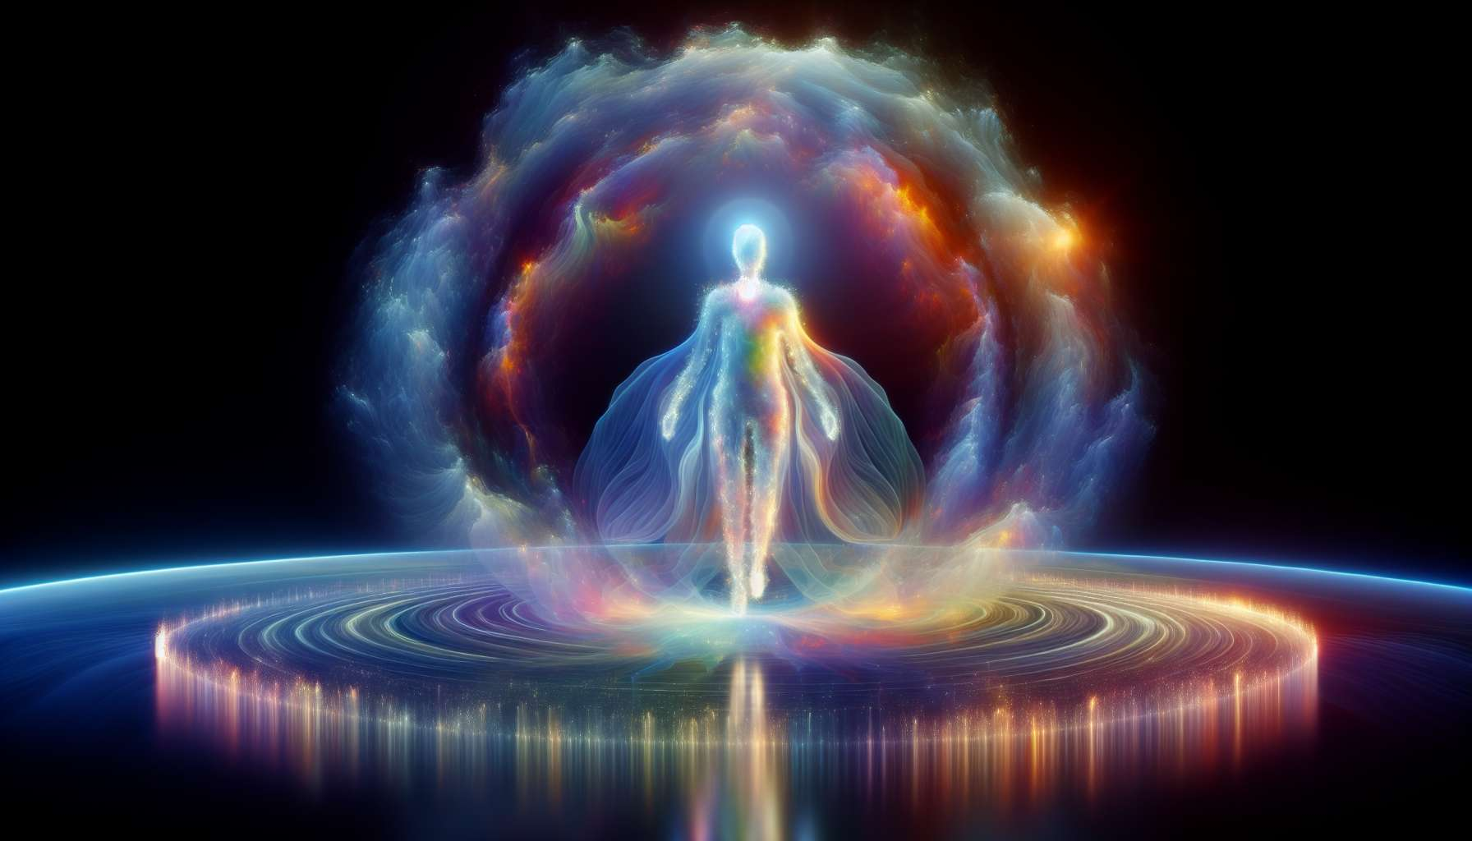

Reflectors are the rarest type in Human Design, representing less than 1% of the population. They are the "evaluators" of the world, designed to reflect the state of humanity and their environment. Reflectors are endowed with a unique ability to sample and reflect the energies that surround them, offering a valuable perspective on the health and balance of a system.  
  
The main characteristic of Reflectors is that they have no defined center in their BodyGraph. All their centers are open, which means they are like "energy mirrors," constantly absorbing and reflecting the energies of people and environments around them. This openness gives them a unique and unbiased perspective, but can also make them very sensitive and easily overwhelmed.  
  
Unlike other types that have a more fixed energy identity, the energy of Reflectors constantly changes depending on their environment. They may feel very different from one day to the next, even from one hour to the next, depending on the energies they absorb. This can make it difficult for them to know who they really are and what they want in life.  
  
However, this energy sensitivity is also their greatest asset. Reflectors have an unmatched ability to read the "energy temperature" of a room or group and identify what is healthy or unhealthy in a system. They can see imbalances and potentials that are often invisible to others, and offer reflections that can catalyze deep transformation.  
  
Take, for example, a Reflector working in a company. Just by being present in different departments and meetings, they can absorb and reflect the energy dynamics of the organization. They can sense where there is harmony and disharmony, where energy is blocked or stagnant. By sharing their reflections with leaders, they can help them see the areas that need attention and change.  
  
On the other hand, imagine a Reflector in an intimate relationship. Their ability to reflect can be a powerful catalyst for growth and healing. By reflecting their partner's energy patterns, often unconsciously, the Reflector can help them see aspects of themselves that they were unable to see before. This can sometimes be uncomfortable, but also incredibly transformative.  
  
For Reflectors, the key is to learn to manage their energy sensitivity and use their reflections in a wise and strategic way. This involves taking time to sample energies before making decisions, and carefully choosing the environments and people they engage with. Reflectors often need more alone time than other types to discharge and refocus.  
  
Learning to trust their reflections is another key skill for Reflectors. Since they don't have a fixed energy "self," they can doubt their perceptions and be influenced by others' opinions. But when a Reflector learns to trust the wisdom of their reflections, they become an incredibly powerful and insightful guide.  
  
Reflectors have a lot to learn from other types about definition and direction. Generators can teach them the value of responding to what truly resonates with them. Manifestors can show them the power of initiating change. And Projectors can guide them toward recognition and appreciation of their unique gifts.  
  
In the end, Reflectors are here to help us see the truth of who we are and what we create together. They are the guardians of our collective health and balance, constantly reminding us of what needs to be healed, balanced, or celebrated. By learning to embrace and channel their unique nature, they can offer incredibly valuable gifts to the world.  
  
Whether you're a Reflector learning to navigate your openness, or someone interacting with Reflectors, understanding and honoring this unique type is essential for unlocking their full potential. With the right support and understanding, Reflectors can be incredibly wise and transformative guides, helping us see what is often hidden in plain sight.  
  
Let's take a moment to appreciate the beauty and complexity of the Reflector's BodyGraph. With all their centers open, they are like energetic blank canvases, constantly painted by the colors of their surroundings. It's a design that is both vulnerable and powerful, requiring great self-mastery and sensitivity to navigate.  
  
But it's precisely this openness that allows Reflectors to offer us their unique gifts. By being "non-self" energetically, they can reflect our humanity in a way that no one else can. They are the mirrors that show us both our shadow and our light, inviting us to embrace the totality of who we are.  
  
So, the next time you encounter a Reflector, take a moment to appreciate the rare and precious gift they are. And if you're a Reflector yourself, know that your openness is not a weakness but a strength. By learning to master your sensitivity and trust your wisdom, you can offer reflections that transform lives and change the world.  
  
Points to remember:  
  
1. Reflectors are the rarest type in Human Design, representing less than 1% of the population. They are the "evaluators" of the world, designed to reflect the state of humanity and their environment.  
  
2. The main characteristic of Reflectors is that they have no defined center in their BodyGraph. All their centers are open, which allows them to absorb and reflect the energies that surround them, but can also make them very sensitive and easily overwhelmed.  
  
3. Reflectors have a unique ability to read the "energy temperature" of a group or environment, and to identify what is healthy or unhealthy in a system. They can see imbalances and potentials that are often invisible to others.  
  
4. For Reflectors, learning to manage their energy sensitivity, trust their reflections and carefully choose the environments and people they engage with is essential. They often need more alone time than other types to recharge.  
  
5. Reflectors have a lot to learn from other types about definition and direction. Each type can teach them valuable skills for navigating their unique design.  
  
6. In the end, Reflectors are here to help us see the truth of who we are and what we create together. They are the guardians of our collective health and balance.  
  
7. Understanding and honoring Reflectors is crucial for unlocking their full potential. With the right support, they can be incredibly wise and transformative guides.