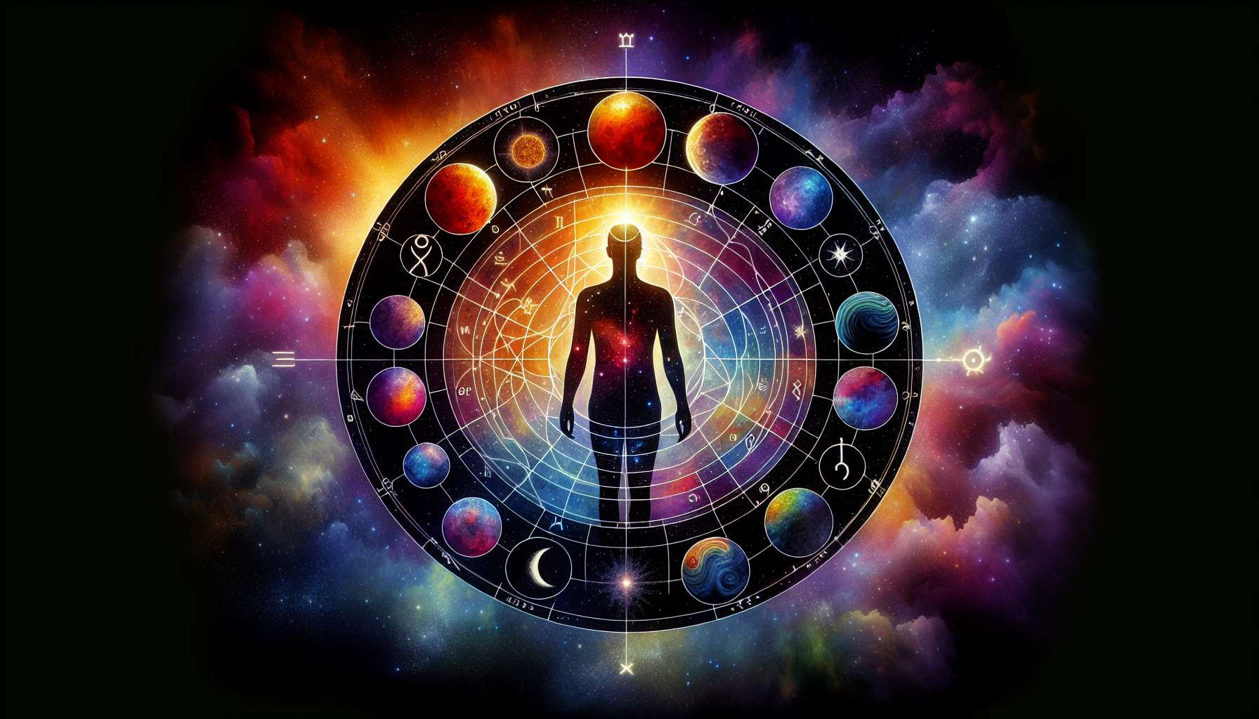

Astrology plays a fundamental role in Human Design, providing the basic data necessary to calculate an individual BodyGraph. Indeed, it is the precise position of the planets at the time of our birth that determines our type, our profile, our gates, and our channels.  
  
In Human Design, we primarily use the following planets: the Sun, the Moon, Mercury, Venus, Mars, Jupiter, Saturn, Uranus, Neptune, Pluto, and the North Node. Each of these planets has a specific meaning and influences different aspects of our design.  
  
For example, the Sun represents our conscious identity, while the Moon reflects our unconscious identity. Venus and Mars are linked to the way we interact in relationships, Jupiter and Saturn influence our growth and personal structure, while Uranus, Neptune, and Pluto bring transformative energies.  
  
The North Node, for its part, is a key point in Human Design. It represents our life direction, our path of personal evolution. Its position in our BodyGraph indicates where we are invited to develop and express our uniqueness.  
  
It is important to note that in Human Design, astrology is used in a unique way. Rather than interpreting the planets in signs and houses as in traditional astrology, Human Design focuses on the gates activated by the planets. Each of the 64 gates corresponds to an I Ching hexagram and has a specific energy.  
  
When a planet activates a gate in our BodyGraph, it means that we have access to the energy of that gate. If two connected gates are activated, this creates a defined channel, bringing constant energy into our lives. The activated gates and channels form the key aspects of our unique design.  
  
By understanding the basics of astrology in Human Design, we begin to see how cosmic influences shape our being. It's a complex and nuanced system, but it offers a fascinating perspective on ourselves and our place in the universe. Mastering these astrological concepts is essential for any serious student of Human Design.  
  
  
Points to remember:  
  
- Astrology is fundamental in Human Design, the position of the planets at birth determines an individual's type, profile, gates, and channels.  
  
- The main planets used are: Sun, Moon, Mercury, Venus, Mars, Jupiter, Saturn, Uranus, Neptune, Pluto, and North Node. Each has a specific meaning.  
  
- The North Node represents the life direction and the path of personal evolution.  
  
- In Human Design, astrology focuses on the gates activated by planets, each of the 64 gates corresponding to an I Ching hexagram.  
  
- When two connected gates are activated, it creates a defined channel, bringing constant energy.  
  
- Understanding the astrological basics is essential to mastering Human Design and having a unique perspective on oneself and one's place in the universe.