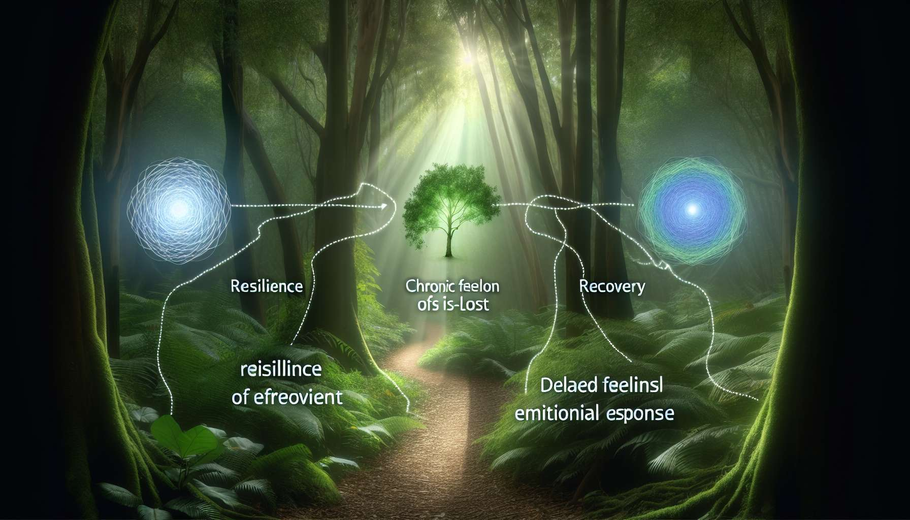

Submodule 4.4 - The Grief Trajectory Model by George Bonanno  
  
The grief trajectory model, developed by psychologist George Bonanno, sheds new light on the variety of reactions faced with the loss of a loved one. Countering the prevalent idea that grief follows a universal and linear path, Bonanno has identified four distinct trajectories that bereaved individuals may follow: resilience, chronic grief, delayed grief, and recovery. This model emphasizes the importance of recognizing and respecting individual differences in the grief process.  
  
The resilience trajectory is characterized by an ability to cope with loss with relative emotional stability and maintaining normal functioning in various areas of life. Resilient individuals indeed experience sadness and grief, but manage to handle them properly and gradually regain balance. They can rely on their internal resources, such as their emotional regulation skills or their sense of coherence, as well as their external resources, like their social support network. For example, a resilient person who has lost their spouse may continue to work, take care of their children, and maintain social relationships, while privately and personally grieving.  
  
The chronic grief trajectory, however, is characterized by intense and persistent distress that hinders daily functioning and long-term wellbeing. Those experiencing chronic grief may feel overwhelming emotions such as crushing sadness, uncontrollable anger, or intrusive guilt, which do not diminish over time. They may struggle to accept the reality of the loss, to make sense of their life without the deceased, and to reinvest in new projects. For instance, someone with chronic grief who has lost their child may sink into severe depression, withdraw from social interaction, and struggle to fulfill their professional and familial responsibilities.  
  
The delayed grief trajectory is characterized by late and unexpected grieving reactions. Those with delayed grief may seem to function normally at first, even showing a seeming absence of emotional distress. However, after a more or less long latency period, they may unexpectedly experience intense distress and acute grief symptoms. This delay could be due to initial avoidance of painful emotions, lack of social support, or an accumulation of stressors. As an example, someone with delayed grief who has lost a sibling may immerse themselves in work for several months, then suddenly emotionally collapse during a trigger event, like the anniversary of the sibling's death.  
  
Finally, the recovery trajectory is characterized by initially high distress that gradually diminishes over time to give way to a return to normal functioning. Individuals in the recovery phase can experience intense and painful emotions early in their bereavement, but they gradually manage these emotions appropriately and regain balance. They may go through ups and downs, but generally follow an upward curve towards well-being. For example, someone in recovery who has lost their best friend may cry heavily at first, have trouble sleeping and focusing, but then gradually rediscover the joy of life, reconnect with their activities, and build new relationships.  
  
Bonanno's grief trajectory model invites GRIEF COACHES to adopt a nuanced and personalized approach when supporting bereaved individuals. The aim is to recognize and validate the diversity of loss reactions, without imposing rigid norms or expectations. The GRIEF COACH can assist individuals in identifying their own grief trajectory, mobilizing their resources, and finding coping strategies suited to their needs. For instance, for someone with chronic grief, the GRIEF COACH could suggest more sustained therapeutic follow-ups, emotion regulation techniques, and exploration of factors maintaining distress. For someone with delayed grief, the GRIEF COACH can offer a safe space for unpacking late emotions and assist in making sense of the experience.  
  
Importantly, these trajectories are not fixed, and an individual can transition from one to another during their grief journey. Furthermore, some people may exhibit characteristics of several trajectories simultaneously. The role of the GRIEF COACH is to provide flexible and tailored support, taking into account the uniqueness of each grieving journey. Drawing on Bonanno’s model, the GRIEF COACH can help bereaved individuals find their own path to healing, respecting their pace and valorizing their resources.  
  
Key Takeaways:  
  
1. George Bonanno's grief trajectory model highlights the variety of reactions to the loss of a loved one, challenging the idea of a universal and linear grief progression.  
  
2. Bonanno identified four distinct trajectories: resilience, chronic grief, delayed grief, and recovery. Each trajectory has specific characteristics in terms of emotional reaction, daily functioning, and timing.  
  
3. The resilience trajectory is characterized by an ability to cope with loss with relative emotional stability, relying on internal and external resources.  
  
4. The chronic grief trajectory is marked by intense and persistent distress, impairing daily functioning and long-term well-being.  
  
5. The delayed grief trajectory manifests through late and unexpected grief reactions, following a latency period and seemingly normal functioning.  
  
6. The recovery trajectory is characterized by initially high distress decreasing gradually, allowing a return to normal functioning.  
  
7. Bonanno's model encourages GRIEF COACHes to adopt a nuanced and personalized approach when supporting bereaved individuals, recognizing and validating the diversity of reactions.  
  
8. The GRIEF COACH can help individuals identify their own trajectory, mobilize their resources, and find coping strategies suitable for their specific needs.  
  
9. The trajectories are not fixed and an individual can transition from one to another throughout their grief journey. The GRIEF COACH should offer flexible and tailored support, considering the uniqueness of each grieving journey.